Family Math Studio Lesson 1.3 · 5.NBT.B.7

Math is In My World
Draw a problem as a tape diagram, then solve it with decimals.
Name Date

Tonight's spark
A bus ticket says $2.75 each way. Jaylen rides to the rec center and back home. How much does the whole round trip cost? Make a guess first: is the round trip more or less than $5?
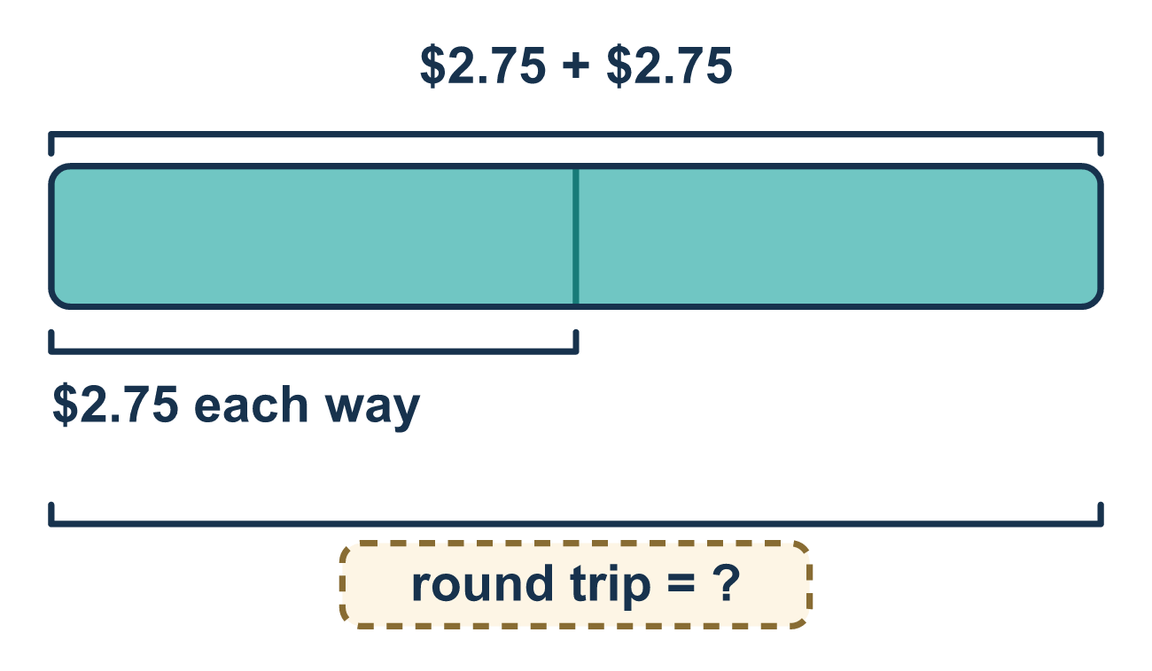
Our class model: the tape diagram

Try it
Work it out on paper. Write one answer on each line.
- A bus ride costs $2.75 each way. What does a round trip mean?
A. One ride only B. Going and coming back, which is two rides C. Three rides in a row
My answer
- What is $2.75 + $2.75?
A. $5.50 B. $4.50 C. $5.25
My answer
- A snack costs $1.35. What do 3 snacks cost?
A. $3.15 B. $1.38 C. $4.05 D. $40.50
My answer
- $10.00 is shared equally among 4 friends. How much does each friend get?
A. $40.00 B. $6.00 C. $0.25 D. $2.50
My answer
- One bus ride takes 8.5 minutes. How many minutes do 10 rides take?
A. 0.85 B. 85 C. 18.5 D. 850
My answer
- A round trip costs $2.75 each way. Lena makes 2 round trips. How much does she spend?
A. $5.50 B. $8.25 C. $11.00 D. $2.75
My answer

Talk about it
How many equal parts does your tape diagram have, and what does the whole tape stand for?

Home mission
A different situation: pick a snack price like $1.50. Ask your student to draw a tape with 4 equal parts of $1.50. What does the whole tape stand for? How much is it?

If we get stuck, ask
- Can you draw the problem before you solve it?
- What is one part, and how many parts are there?
- Are your decimal points lined up?

Do it on a screen

Scan or type the link. Same lesson, with hints. eduwonderlab.com/lessons/1-3/homework.html
How did it feel? (optional) ☐ Tricky ☐ Getting there ☐ Got it

Family Math Studio · For grown-ups Lesson 1.3 · 5.NBT.B.7

Answers and talk notes
Math is In My World

What your student is learning
Tonight we draw a real-world money problem as a tape diagram or a table, and then solve it with decimals.

Answers
Ask your student to explain before you look.
- B. Going and coming back, which is two rides. Going and coming back, which is two rides. A round trip costs two fares.
- A. $5.50. 75 cents + 75 cents is 150 cents, which is $1.50. $2 + $2 + $1.50 = $5.50.
- C. $4.05. 3 × $1.35 = $4.05, because 3 × $1 = $3 and 3 × 35 cents = $1.05.
- D. $2.50. $10.00 ÷ 4 = $2.50, because 4 × $2.50 = $10.00.
- B. 85. 8.5 × 10 = 85. Multiplying by 10 moves every digit one place to the left.
- C. $11.00. One round trip is $2.75 + $2.75 = $5.50. Two round trips are $5.50 × 2 = $11.00.

Talk about it
How many equal parts does your tape diagram have, and what does the whole tape stand for?

When they are stuck, ask
- Can you draw the problem before you solve it?
- What is one part, and how many parts are there?
- Are your decimal points lined up?

Try not to say
- Don't bother drawing it, just do the math.
- Ignore the decimal point and put it back later.
- The picture is for little kids.

Home mission
A different situation: pick a snack price like $1.50. Ask your student to draw a tape with 4 equal parts of $1.50. What does the whole tape stand for? How much is it?

