Family Math Studio Lesson 1.4 · Session 2 · 5.MD.C.5

Math is Explaining and Sharing
Compare two boxes by volume. If the volumes are equal, give a second reason.
Name Date

Tonight's spark
A community garden map shows two soil beds. Bed A is 6 ft long, 4 ft wide, and 2 ft deep. Bed B is 8 ft long, 3 ft wide, and 2 ft deep. Which bed holds more soil? Make a guess first: does Bed A or Bed B hold more soil?
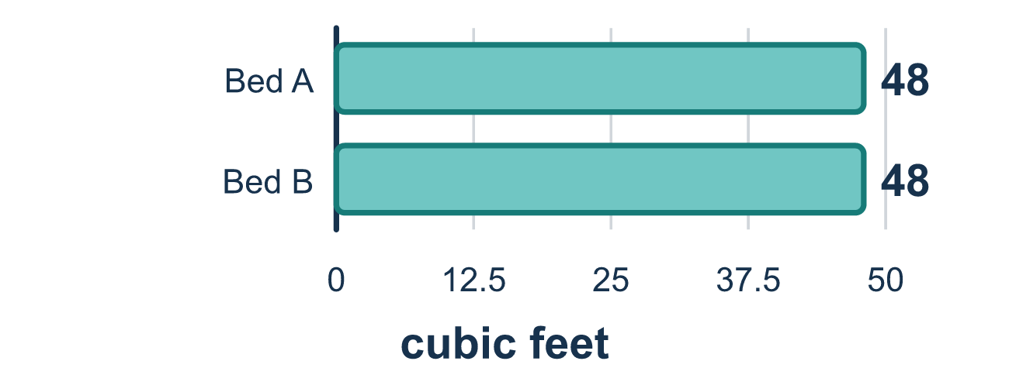
Our class model: a recommendation with two halves

Try it
Work it out on paper. Write one answer on each line.
- Which unit fits the volume of a garden bed?
A. feet B. square feet C. inches D. cubic feet
My answer
- A bed is 5 ft long, 2 ft wide, and 2 ft deep. What is its volume?
A. 20 cubic feet B. 9 cubic feet C. 10 cubic feet D. 20 square feet
My answer
- Two garden beds each hold 24 cubic feet of soil. What can you say?
A. Bed A holds more B. Bed B holds more C. The volumes are equal, so you need another reason to choose
My answer
- Bed A is 3 ft by 3 ft by 2 ft. Bed B is 4 ft by 2 ft by 2 ft. Which holds more?
A. Bed B, because it is longer B. Bed A, because 18 cubic feet is more than 16 cubic feet C. They are equal
My answer
- A math recommendation has two parts. Which pair is correct?
A. A guess and a feeling B. Only a number C. Only an opinion D. A number you computed and a reason it settles the question
My answer

Talk about it
Do the two boxes hold the same amount? What other reason could help you choose?

Home mission
A different situation: use 12 blocks, dice, or ice cubes. Build a box 3 long, 2 wide, and 2 tall. Then build one that is 4 long, 3 wide, and 1 tall. Do they hold the same amount? Which would your student recommend?

If we get stuck, ask
- What number did you find, and what question does it answer?
- Is soil filling a space, covering a surface, or going along a line?
- Can you say your recommendation in one sentence that includes the number?

Do it on a screen

Scan or type the link. Same lesson, with hints. eduwonderlab.com/lessons/1-4-part2/homework.html
How did it feel? (optional) ☐ Tricky ☐ Getting there ☐ Got it

Family Math Studio · For grown-ups Lesson 1.4 · Session 2 · 5.MD.C.5

Answers and talk notes
Math is Explaining and Sharing

What your student is learning
Tonight we do not just compute — we recommend. We compare two garden bed designs by their volume and then say, in words, which one we would build and why.

Answers
Ask your student to explain before you look.
- D. cubic feet. The unit is cubic feet. Volume counts cubes that fill the space inside the bed.
- A. 20 cubic feet. 5 × 2 × 2 = 20 cubic feet.
- C. The volumes are equal, so you need another reason to choose. The volumes are equal, so you need another reason to choose.
- B. Bed A, because 18 cubic feet is more than 16 cubic feet. Bed A, because 18 cubic feet is more than 16 cubic feet. Bed A: 3 × 3 × 2 = 18. Bed B: 4 × 2 × 2 = 16.
- D. A number you computed and a reason it settles the question. A number you computed and a reason it settles the question.

Talk about it
Do the two boxes hold the same amount? What other reason could help you choose?

When they are stuck, ask
- What number did you find, and what question does it answer?
- Is soil filling a space, covering a surface, or going along a line?
- Can you say your recommendation in one sentence that includes the number?

Try not to say
- The units do not matter as long as the number is right.
- Just pick the bigger one, that is always better.
- You do not have to explain, the answer speaks for itself.

Home mission
A different situation: use 12 blocks, dice, or ice cubes. Build a box 3 long, 2 wide, and 2 tall. Then build one that is 4 long, 3 wide, and 1 tall. Do they hold the same amount? Which would your student recommend?

