Family Math Studio Lesson 1.4 · 5.MD.C.5

Math is Explaining and Sharing
Use volume to compare boxes and defend your choice with numbers.
Name Date

Tonight's spark
A corner store sells cereal at one price: three large boxes or two jumbo boxes. A large box is 8 by 3 by 10 inches. A jumbo box is 10 by 4 by 10 inches. Which deal holds more cereal? Make a guess first: three large boxes or two jumbo boxes?
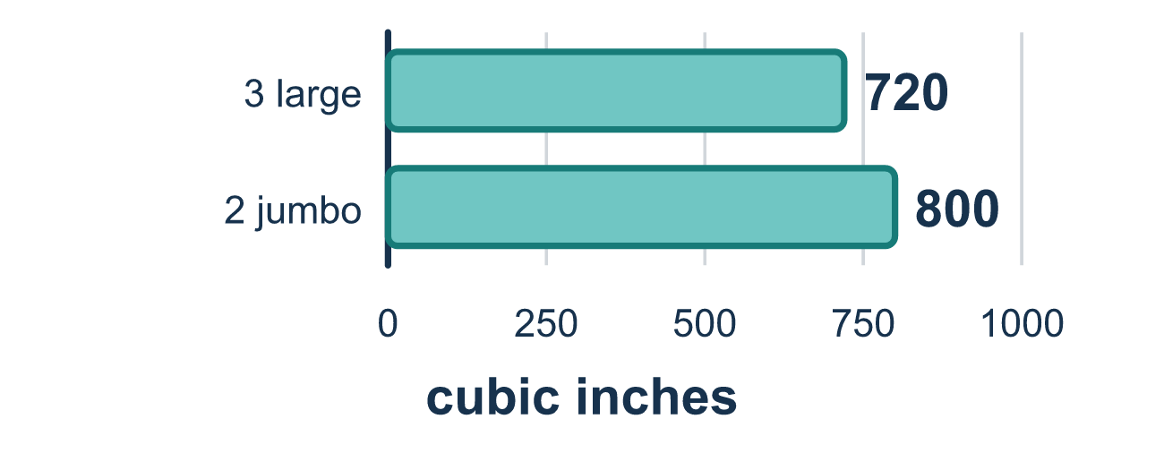
Our class model: multiply the three sides

Try it
Work it out on paper. Write one answer on each line.
- Volume is measured in which kind of unit?
A. Square units B. Cubic units C. Units of length
My answer
- What is the volume of a box that is 2 inches long, 3 inches wide, and 4 inches tall?
A. 24 cubic inches B. 9 cubic inches C. 24 square inches
My answer
- Which number sentence finds the volume of a box 5 in by 2 in by 6 in?
A. 5 + 2 + 6 B. 5 × 2 C. 5 × 2 × 6 D. (5 × 2) + 6
My answer
- A box is 6 inches long, 5 inches wide, and 2 inches tall. What is its volume?
A. 13 cubic inches B. 30 cubic inches C. 600 cubic inches D. 60 cubic inches
My answer
- Box A holds 90 cubic inches. Box B holds 120 cubic inches. Which statement is true?
A. Box A holds more, because 90 is smaller B. Box B holds more, because 120 is greater than 90 C. They hold the same amount
My answer

Talk about it
Which box holds more, and what numbers prove it?

Home mission
Find a cereal box and a snack box. Measure each side in inches with a ruler. Multiply to find each volume. Can your student say which box holds more and finish the sentence with "because"?

If we get stuck, ask
- What are the three measurements of this box?
- Which total is bigger — and how do you know?
- Can you say your answer starting with "because"?

Do it on a screen

Scan or type the link. Same lesson, with hints. eduwonderlab.com/lessons/1-4/homework.html
How did it feel? (optional) ☐ Tricky ☐ Getting there ☐ Got it

Family Math Studio · For grown-ups Lesson 1.4 · 5.MD.C.5

Answers and talk notes
Math is Explaining and Sharing

What your student is learning
Tonight we build a math argument. We use volume — the space inside a box — to defend a recommendation with numbers instead of opinions.

Answers
Ask your student to explain before you look.
- B. Cubic units. Cubic units. Volume counts the unit cubes that fill the space inside a box.
- A. 24 cubic inches. 2 × 3 × 4 = 24 cubic inches.
- C. 5 × 2 × 6. Volume is length × width × height, so 5 × 2 × 6 = 60 cubic inches.
- D. 60 cubic inches. 6 × 5 × 2 = 60 cubic inches.
- B. Box B holds more, because 120 is greater than 90. Box B holds more, because 120 is greater than 90.

Talk about it
Which box holds more, and what numbers prove it?

When they are stuck, ask
- What are the three measurements of this box?
- Which total is bigger — and how do you know?
- Can you say your answer starting with "because"?

Try not to say
- Just look at it — the bigger one is obvious.
- You don't need to explain your answer.
- Add the three measurements together.

Home mission
Find a cereal box and a snack box. Measure each side in inches with a ruler. Multiply to find each volume. Can your student say which box holds more and finish the sentence with "because"?

