Family Math Studio Lesson 1.5 · Session 2 · 5.OA.B.3

Math is Finding Patterns
Use a pattern rule to predict how many steps it takes to reach a goal.
Name Date

Tonight's spark
A growth chart tracks a baby sei whale. It is 4.5 meters long at birth and grows 2.5 centimeters each day. The goal is 15 meters. How many days will it take? Make a guess first: more or less than 100 days?
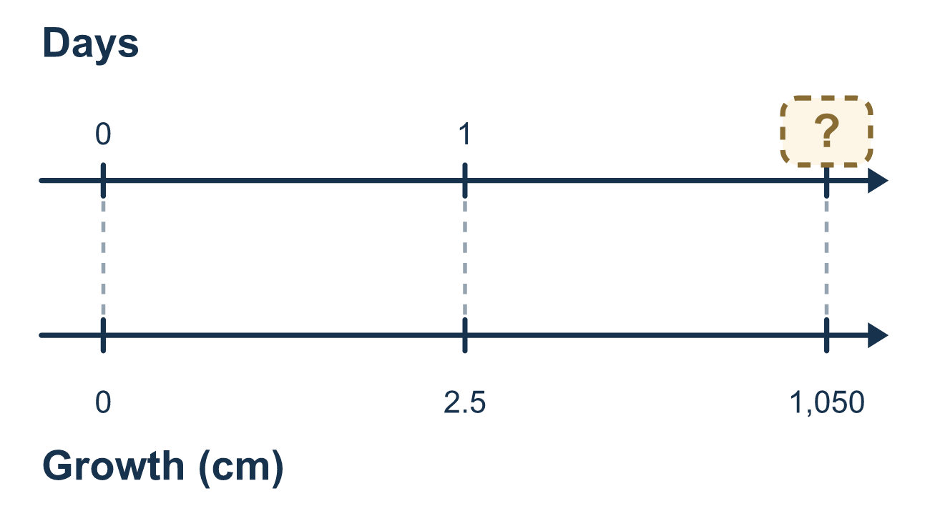
Our class model: the growth left ÷ one step

Try it
Work it out on paper. Write one answer on each line.
- A puppy gains 2 pounds each month. After 3 months, how many pounds has it gained in all?
A. 6 B. 5 C. 23 D. 1
My answer
- A plant is 10 cm tall and grows 2 cm each week. How tall is it after 4 weeks?
A. 8 cm B. 12 cm C. 18 cm
My answer
- A sapling is 4 m tall and will stop growing at 10 m. How much more will it grow?
A. 14 m B. 40 m C. 10 m D. 6 m
My answer
- A pattern adds 5 each step. How many steps does it take to go from 0 to 40?
A. 35 B. 8 C. 200 D. 45
My answer
- How many centimeters are in 3 meters?
A. 300 B. 30 C. 3,000 D. 103
My answer

Talk about it
How much is left to grow, and how many steps of the same size does it take?

Home mission
A different situation: hold a ruler. Pretend a seedling is 5 cm tall and grows 2 cm each day. Ask your student how many days until it is 15 cm tall. Say first how much growth is left.

If we get stuck, ask
- How much does it change in one step? And how many steps do we need?
- Are both numbers in the same unit right now?
- Where does it start? Does it start at zero, or somewhere already?

Do it on a screen

Scan or type the link. Same lesson, with hints. eduwonderlab.com/lessons/1-5-part2/homework.html
How did it feel? (optional) ☐ Tricky ☐ Getting there ☐ Got it

Family Math Studio · For grown-ups Lesson 1.5 · Session 2 · 5.OA.B.3

Answers and talk notes
Math is Finding Patterns

What your student is learning
Tonight we take a pattern that grows by the same amount every time and use it to predict something far in the future — how long a baby whale takes to reach full length.

Answers
Ask your student to explain before you look.
- A. 6. 3 months with 2 pounds each is 3 × 2 = 6 pounds.
- C. 18 cm. 4 weeks of growth is 4 × 2 = 8 cm, and 10 + 8 = 18 cm.
- D. 6 m. 10 − 4 = 6 m is left to grow.
- B. 8. 40 ÷ 5 = 8 steps.
- A. 300. 1 meter is 100 centimeters, so 3 meters is 3 × 100 = 300 centimeters.

Talk about it
How much is left to grow, and how many steps of the same size does it take?

When they are stuck, ask
- How much does it change in one step? And how many steps do we need?
- Are both numbers in the same unit right now?
- Where does it start? Does it start at zero, or somewhere already?

Try not to say
- Just divide the big number by the small number.
- Units are just labels, ignore them.
- Count it out one day at a time, that is safest.

Home mission
A different situation: hold a ruler. Pretend a seedling is 5 cm tall and grows 2 cm each day. Ask your student how many days until it is 15 cm tall. Say first how much growth is left.

