Family Math Studio Lesson 1.5 · 5.OA.B.3

Math is Finding Patterns
Find a pattern rule and use a table of values to check your answers.
Name Date

Tonight's spark
A jar label says 100 dimes. Each dime is worth $0.10. How much money is in the jar? Make a guess first: more or less than $5?
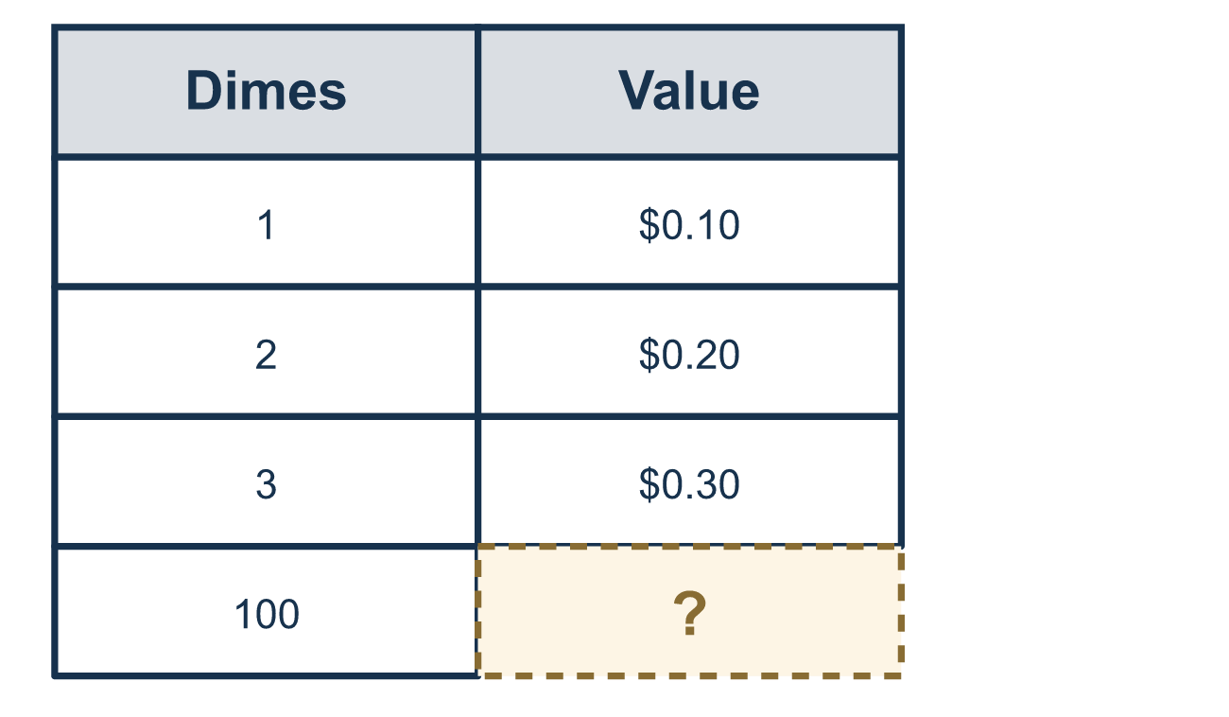
Our class model: the pattern rule

Try it
Work it out on paper. Write one answer on each line.
- What is the value of one nickel?
A. $0.01 B. $0.05 C. $0.10 D. $0.25
My answer
- What is the value of 10 dimes?
A. $10.00 B. $0.10 C. $0.20 D. $1.00
My answer
- A table shows 1 → 5, 2 → 10, 3 → 15. What is the pattern rule?
A. Multiply the number by 5 B. Add 4 to the number C. Add 5 to the number D. Multiply the number by 15
My answer
- Using the rule 'multiply by 5', what is the output for 7?
A. 12 B. 75 C. 35 D. 57
My answer
- Each quarter is worth $0.25. What are 4 quarters worth?
A. $0.29 B. $1.00 C. $10.00 D. $4.25
My answer

Talk about it
What do you do to the number of coins to get their total value?

Home mission
Gather any coins and pull out the dimes. Count them. Ask your student to use the pattern rule to say what the dimes are worth. Then count by 10 cents to check.

If we get stuck, ask
- What changes from one row to the next?
- Can you say the rule as a sentence?
- Does that answer seem reasonable?

Do it on a screen

Scan or type the link. Same lesson, with hints. eduwonderlab.com/lessons/1-5/homework.html
How did it feel? (optional) ☐ Tricky ☐ Getting there ☐ Got it

Family Math Studio · For grown-ups Lesson 1.5 · 5.OA.B.3

Answers and talk notes
Math is Finding Patterns

What your student is learning
Tonight we look for a pattern, write the pattern rule in words, and use a table of values to check that our answers are reasonable.

Answers
Ask your student to explain before you look.
- B. $0.05. A nickel is worth $0.05.
- D. $1.00. 10 × $0.10 = $1.00.
- A. Multiply the number by 5. Multiply the number by 5. It works on every row: 1 × 5 = 5, 2 × 5 = 10, 3 × 5 = 15.
- C. 35. 7 × 5 = 35.
- B. $1.00. 4 × $0.25 = $1.00, because 4 quarters make one dollar.

Talk about it
What do you do to the number of coins to get their total value?

When they are stuck, ask
- What changes from one row to the next?
- Can you say the rule as a sentence?
- Does that answer seem reasonable?

Try not to say
- Just keep adding until you get there.
- The rule doesn't matter, only the answer.
- Memorize the table.

Home mission
Gather any coins and pull out the dimes. Count them. Ask your student to use the pattern rule to say what the dimes are worth. Then count by 10 cents to check.

