Family Math Studio Unit 1 · Practice · 6.NOS.1

Unit 1 Practice
Divide with fractions and mixed numbers, and tell what the answer means.
Name Date

Tonight's spark
A craft table sells one ribbon that is 1 1/2 yards long. Each hair bow needs 1/4 yard. How many bows can one ribbon make? Make a guess first: will there be more than 2 bows, or fewer?
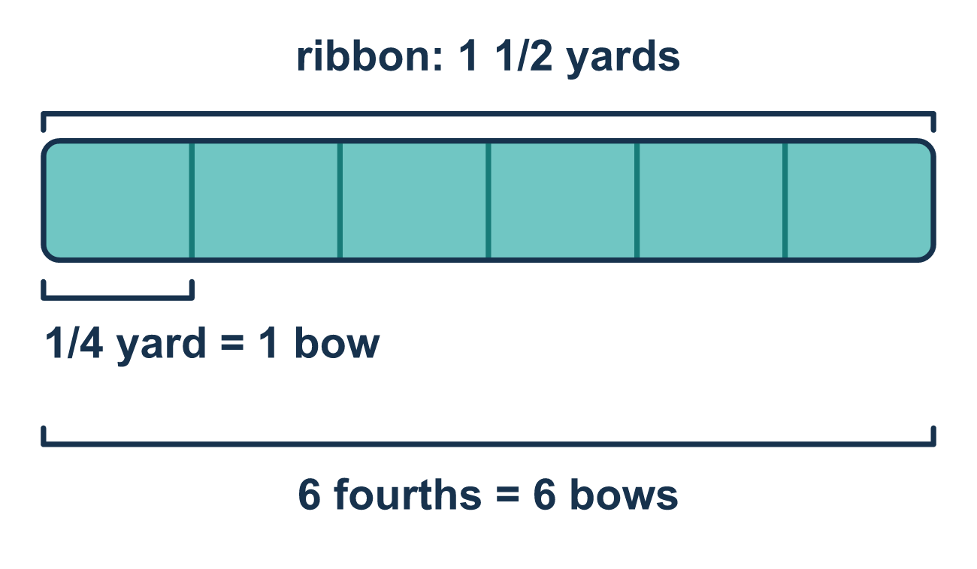
Our class model: the tape diagram strip

Try it
Work it out on paper. Write one answer on each line.
- What is the reciprocal of 3/4?
A. 4/3 B. 3/4 C. 1/4 D. 7/4
My answer
- Write 1 1/2 as an improper fraction.
A. 1/2 B. 11/2 C. 3/2 D. 2/3
My answer
- How many 1/4s are in 1 whole?
A. 1 B. 4 C. 1/4 D. 2
My answer
- What is 5 ÷ 1/2?
A. 2 1/2 B. 1/10 C. 5 1/2 D. 10
My answer
- What is 8 ÷ 2/3?
A. 12 B. 5 1/3 C. 7 1/3 D. 24
My answer

Talk about it
How many pieces of size 1/3 fit in 2 wholes, and why is the number bigger than 2?

Home mission
Cut two paper strips. Make one a whole length and the other half as long. Call them 1 1/2 yards of ribbon. Fold the long strip into 4 equal parts and the short strip into 2 equal parts. Count the parts. How many bows? Write the division sentence together.

If we get stuck, ask
- Can you draw the amount and cut it into the small pieces? How many sections do you get?
- Is there a mixed number here? What do we always do to it first?
- You have a number — now what does it mean in the story? Whole ones, or whole ones and part of another?

Do it on a screen

Scan or type the link. Same lesson, with hints. eduwonderlab.com/lessons/1-practice/homework.html
How did it feel? (optional) ☐ Tricky ☐ Getting there ☐ Got it

Family Math Studio · For grown-ups Unit 1 · Practice · 6.NOS.1

Answers and talk notes
Unit 1 Practice

What your student is learning
Tonight is practice for the Unit 1 test. Almost every question is dividing with fractions, and the biggest one asks your student to explain a picture — not just write an answer.

Answers
Ask your student to explain before you look.
- A. 4/3. The reciprocal flips the numerator and denominator, so the reciprocal of 3/4 is 4/3.
- C. 3/2. 1 × 2 + 1 = 3, so 1 1/2 = 3/2.
- B. 4. Four fourths make 1 whole, so there are 4 fourths in 1.
- D. 10. There are 2 halves in each whole, so 5 ÷ 1/2 = 5 × 2 = 10.
- A. 12. Multiply by the reciprocal: 8 × 3/2 = 24/2 = 12.

Talk about it
How many pieces of size 1/3 fit in 2 wholes, and why is the number bigger than 2?

When they are stuck, ask
- Can you draw the amount and cut it into the small pieces? How many sections do you get?
- Is there a mixed number here? What do we always do to it first?
- You have a number — now what does it mean in the story? Whole ones, or whole ones and part of another?

Try not to say
- Flip the first fraction instead of the second.
- Leave the answer as 28/6 — an improper fraction is close enough.
- The leftover half means half a cup.

Home mission
Cut two paper strips. Make one a whole length and the other half as long. Call them 1 1/2 yards of ribbon. Fold the long strip into 4 equal parts and the short strip into 2 equal parts. Count the parts. How many bows? Write the division sentence together.

