Family Math Studio Lesson 2.1 · Session 2 · 6.DS.1

Understand Statistical Questions
Draw every answer as a dot on a number line and describe the shape.
Name Date

Tonight's spark
At the library, twelve students told how many books they finished: 0, 2, 1, 2, 3, 2, 4, 1, 2, 3, 0, 2. Which number of books did the most students say? Make a guess first: was it 0, 2, or 4 books?
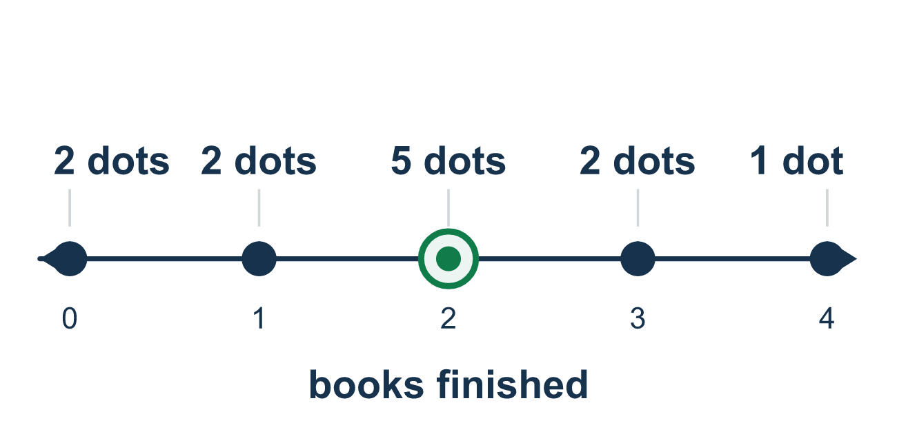
Our class model: one dot for every answer

Try it
Work it out on paper. Write one answer on each line.
- In a dot plot, what does each dot stand for?
A. One answer from the data B. The total of all the answers C. The name of a group D. The tallest stack
My answer
- Data: 1, 2, 2, 2, 4. How many dots go above the number 2?
A. 1 B. 2 C. 3 D. 5
My answer
- The tallest stack of dots is above 5. What does that tell you?
A. 5 is the greatest value B. 5 is the most common answer C. There are only 5 dots D. 5 is the middle of the number line
My answer
- A dot plot has stacks of 2, 4, and 3 dots. How many students answered?
A. 9 B. 3 C. 4 D. 24
My answer
- The data are 3, 5, 5, 8. Which number line is the best start for a dot plot?
A. Only 3, 5, and 8 labeled B. From 0 to 100 by tens C. From 3 to 5 D. From 3 to 8, with every whole number labeled
My answer

Talk about it
Which answer has the tallest stack, and what does that tell us about the group?

Home mission
A different situation: Ask each person at home how many glasses of water they drank today. Lay a paper strip numbered 0 to 5 on the table. Use a coin as a dot for each answer, stacked above its number. Which number has the tallest stack?

If we get stuck, ask
- What does one dot on this plot stand for?
- Which stack is tallest? What does that tell us?
- Do the two sides of the peak look about the same?

Do it on a screen

Scan or type the link. Same lesson, with hints. eduwonderlab.com/lessons/2-1-part2/homework.html
How did it feel? (optional) ☐ Tricky ☐ Getting there ☐ Got it

Family Math Studio · For grown-ups Lesson 2.1 · Session 2 · 6.DS.1

Answers and talk notes
Understand Statistical Questions

What your student is learning
Tonight we take the answers collected from a statistical question and draw them as a dot plot, then describe the shape the dots make.

Answers
Ask your student to explain before you look.
- A. One answer from the data. Each dot stands for one answer from the data. So the answer is: One answer from the data.
- C. 3. The value 2 appears 3 times, so 3 dots go above the number 2.
- B. 5 is the most common answer. The tallest stack is the answer that happened most often, so 5 is the most common answer.
- A. 9. Each dot is one student, so add the stacks: 2 + 4 + 3 = 9.
- D. From 3 to 8, with every whole number labeled. The line must cover the least (3) to the greatest (8) value, with every whole number labeled: From 3 to 8, with every whole number labeled.

Talk about it
Which answer has the tallest stack, and what does that tell us about the group?

When they are stuck, ask
- What does one dot on this plot stand for?
- Which stack is tallest? What does that tell us?
- Do the two sides of the peak look about the same?

Try not to say
- One dot can stand for two or three students to save space.
- Skip the values that nobody chose, do not label them.
- Any plot with a tall middle is symmetric.

Home mission
A different situation: Ask each person at home how many glasses of water they drank today. Lay a paper strip numbered 0 to 5 on the table. Use a coin as a dot for each answer, stacked above its number. Which number has the tallest stack?

