Family Math Studio Lesson 2.1 · 6.DS.1

Understand Statistical Questions
Tell a question with one fixed answer from a question that needs data that vary.
Name Date

Tonight's spark
A coach asks two questions. One: How many points did our top player score last night? Two: How many points does each player score per game? Which question needs a whole list of answers? Make a guess first: which question has only one answer?
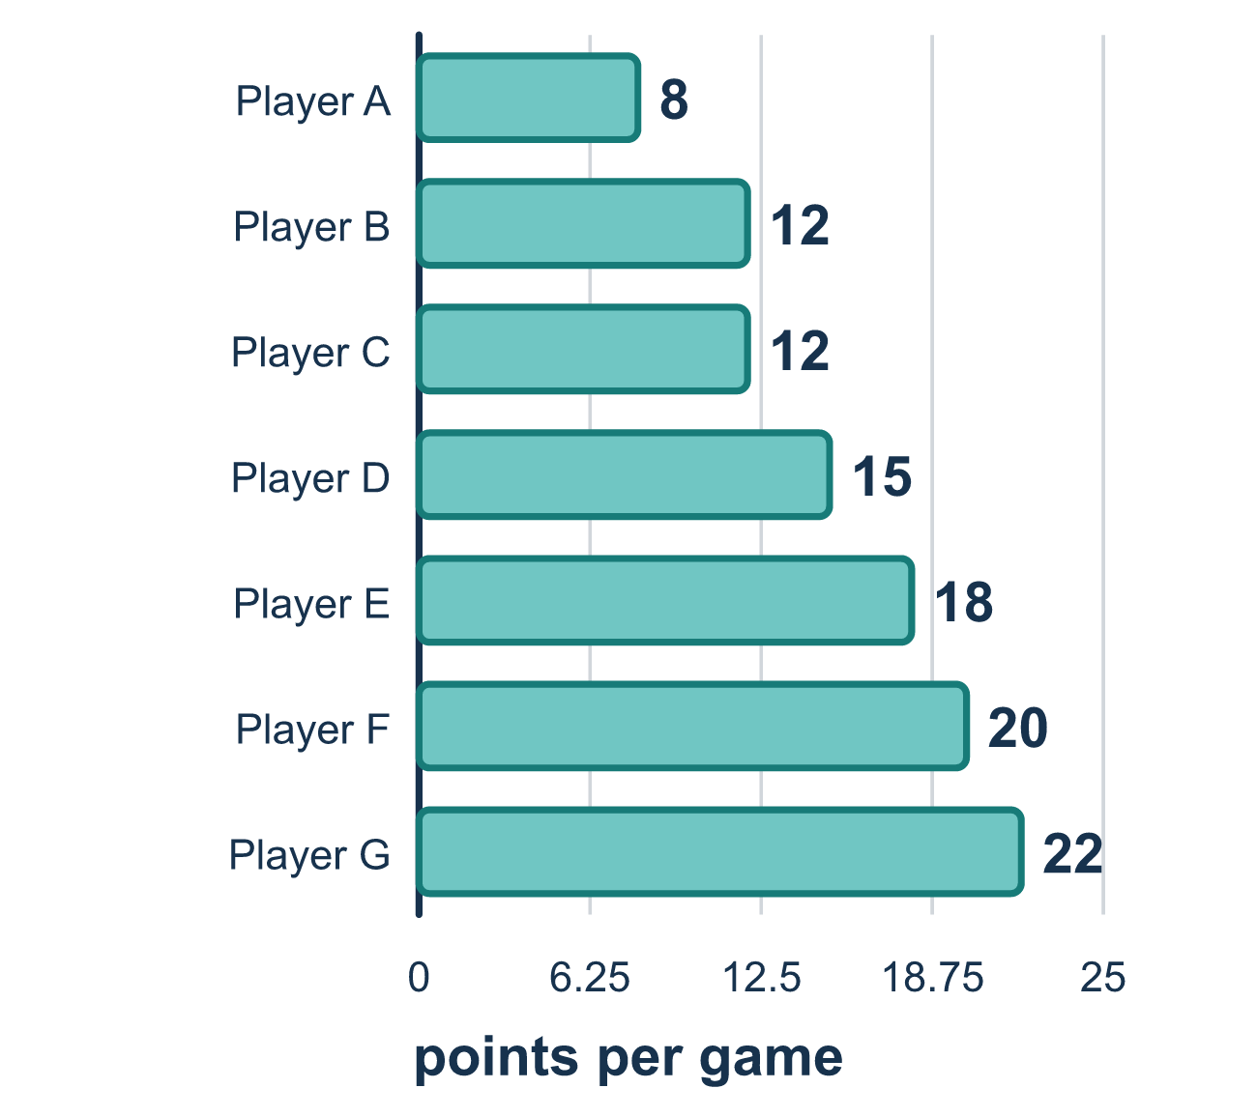
Our class model: the "will the answers vary?" check

Try it
Work it out on paper. Write one answer on each line.
- Which question expects different answers from different students?
A. How many pets does each student in our class have? B. How many pets does Ana have? C. How many days are in March? D. What day comes after Monday?
My answer
- What makes a question statistical?
A. The answer is a number B. You collect data, and the answers are expected to vary C. The question starts with "how many" D. Only one person can answer it
My answer
- Which question is NOT a statistical question?
A. How tall are the students in our class? B. How many minutes do students in our grade spend on homework? C. How tall is the door of our classroom? D. How much do the backpacks in our class weigh?
My answer
- What is variability in a set of data?
A. The data values are different from one another B. The total of all the data values C. The question that was asked D. A number that never changes
My answer

Talk about it
How many different answers do you expect for that question?

Home mission
Think of a game you both know. Ask your student: How many points did the winning team score last night? Then ask: How many points did each player score? Which question has answers that vary? Take turns making up one more pair.

If we get stuck, ask
- What would you collect, and from whom or across which observations?
- Does the question anticipate answers that could vary? Why?
- Does it ask for one fixed fact, or a set of data?

Do it on a screen

Scan or type the link. Same lesson, with hints. eduwonderlab.com/lessons/2-1/homework.html
How did it feel? (optional) ☐ Tricky ☐ Getting there ☐ Got it

Family Math Studio · For grown-ups Lesson 2.1 · 6.DS.1

Answers and talk notes
Understand Statistical Questions

What your student is learning
Tonight we learn to tell the difference between a statistical question and a question with just one fixed answer.

Answers
Ask your student to explain before you look.
- A. How many pets does each student in our class have?. How many pets does each student in our class have? asks about every student, so the answers will vary. It is the choice that expects different answers.
- B. You collect data, and the answers are expected to vary. A statistical question is answered by collecting data, and the answers are expected to vary. So the answer is: You collect data, and the answers are expected to vary.
- C. How tall is the door of our classroom?. The door is one object with one height, so one fixed answer settles it. How tall is the door of our classroom? is not statistical.
- A. The data values are different from one another. Variability means the data values are different from one another. So the answer is: The data values are different from one another.

Talk about it
How many different answers do you expect for that question?

When they are stuck, ask
- What would you collect, and from whom or across which observations?
- Does the question anticipate answers that could vary? Why?
- Does it ask for one fixed fact, or a set of data?

Try not to say
- If the answer is a number, the question is statistical.
- A question about one person can never be statistical.
- Any question about sports or school counts as statistical.

Home mission
Think of a game you both know. Ask your student: How many points did the winning team score last night? Then ask: How many points did each player score? Which question has answers that vary? Take turns making up one more pair.

