Family Math Studio Lesson 2.10 · Session 2 · 6.DS.6d

Choose Appropriate Measures
Match the mean with the MAD, or the median with the IQR. Look at the shape first.
Name Date

Tonight's spark
Two stores list five used-bike prices in dollars. Store 1: 60, 62, 64, 66, 68. Store 2: 60, 62, 64, 66, 210. Both want to post one typical price. Which number is fair for Store 2? Guess first: is Store 2's mean closer to $64 or to $90?
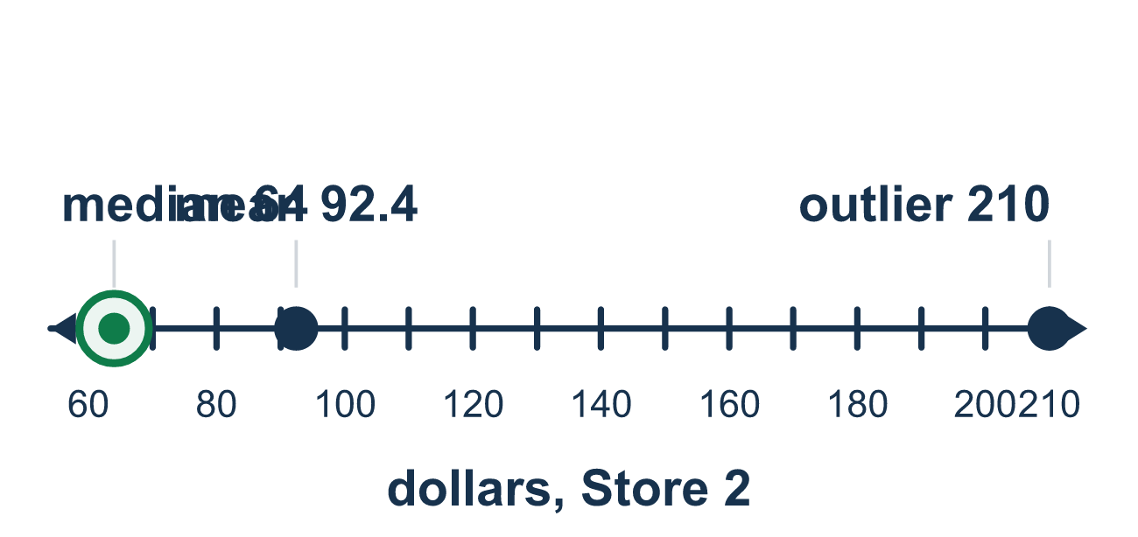
Our class model: matching center and spread

Try it
Work it out on paper. Write one answer on each line.
- A symmetric data set with no outlier is best described by which pair?
A. Mean and MAD B. Median and IQR C. Mode and range D. Mean and IQR
My answer
- Which spread measure goes with the median?
A. The MAD B. The IQR C. The mean D. The outlier
My answer
- The data 30, 32, 34, 36, 38 are symmetric with no outlier. Which pair should you report?
A. Median and IQR B. Range only C. Mean and MAD D. Greatest value and least value
My answer
- Which data set should be described with the median and the IQR?
A. 10, 11, 12, 13, 14 B. 20, 22, 24, 26, 28 C. 7, 8, 9, 10, 11 D. 3, 4, 4, 5, 60
My answer
- The data 5, 6, 7, 8, 90 has an outlier. Which pair should you report?
A. Median and IQR B. Mean and MAD C. Mean and IQR D. Median and MAD
My answer
- Why use the median and IQR when a data set has an outlier?
A. They are easier to calculate B. They use every value, including the outlier C. An outlier does not pull them very far, so they still show the typical group D. The mean cannot be calculated with an outlier
My answer

Talk about it
How did the outlier change the mean but not the median?

Home mission
Write five small numbers on sticky notes, like the ages of cousins. Add one huge note, like 100. Put the notes in order. Ask which is fairer to report: the middle note or the mean.

If we get stuck, ask
- Before we compute — is there a value far from all the others?
- Would the mean here describe a typical value, or get dragged?
- Which measure of spread goes with the center you chose?

Do it on a screen

Scan or type the link. Same lesson, with hints. eduwonderlab.com/lessons/2-10-part2/homework.html
How did it feel? (optional) ☐ Tricky ☐ Getting there ☐ Got it

Family Math Studio · For grown-ups Lesson 2.10 · Session 2 · 6.DS.6d

Answers and talk notes
Choose Appropriate Measures

What your student is learning
Tonight we learn which measures go TOGETHER: mean with MAD for symmetric data, median with IQR when there is an outlier.

Answers
Ask your student to explain before you look.
- A. Mean and MAD. For symmetric data with no outlier, use the mean for center and the MAD for spread: Mean and MAD.
- B. The IQR. The median goes with the IQR, because both depend on the order of the values, not on an outlier. So the answer is: The IQR.
- C. Mean and MAD. No value is far from the others, so report the mean and the MAD. So the answer is: Mean and MAD.
- D. 3, 4, 4, 5, 60. The 60 is an outlier, so use the median and IQR for 3, 4, 4, 5, 60.
- A. Median and IQR. The 90 is an outlier, so report the median and the IQR. So the answer is: Median and IQR.
- C. An outlier does not pull them very far, so they still show the typical group. An outlier does not pull the median or IQR very far, so they still show the typical group. So the answer is: An outlier does not pull them very far, so they still show the typical group.

Talk about it
How did the outlier change the mean but not the median?

When they are stuck, ask
- Before we compute — is there a value far from all the others?
- Would the mean here describe a typical value, or get dragged?
- Which measure of spread goes with the center you chose?

Try not to say
- Use the mean, it always uses all the data so it is better.
- Center and spread are separate choices, mix and match.
- Just throw the outlier away.

Home mission
Write five small numbers on sticky notes, like the ages of cousins. Add one huge note, like 100. Put the notes in order. Ask which is fairer to report: the middle note or the mean.

