Family Math Studio Lesson 2.10 · 6.DS.6d

Choose Appropriate Measures
Choose the mean or the median for a typical value. Look at the shape of the data.
Name Date

Tonight's spark
A top scorer had 22, 24, 20, 25, 23, 21 and 58 points in seven games. Her mean is 27.6. Is that a fair picture of a typical game? Guess first: how many of the seven games were above 27.6?
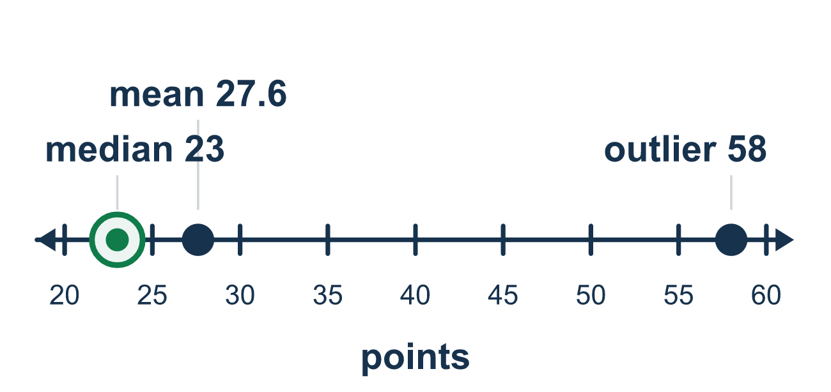
Our class model: the outlier check

Try it
Work it out on paper. Write one answer on each line.
- What is an outlier in a data set?
A. A value that is far from the rest of the values B. The middle value C. The value that appears most D. Any value that is greater than the mean
My answer
- Which number is an outlier in 12, 14, 13, 15, 60?
A. 12 B. 60 C. 15 D. There is no outlier
My answer
- An outlier mostly pulls which measure of center toward it?
A. The median B. The mode C. The mean D. None of them
My answer
- Text messages sent each day: 8, 10, 9, 11, 95. Which measure of center better shows a typical day?
A. The median, 10 B. The mean, 26.6 C. The greatest value, 95 D. The least value, 8
My answer
- The data 20, 21, 22, 23, 24 have no outlier. Which statement is true?
A. Only the median can be used B. The mean and the median are both 22, so either describes a typical value C. The mean is 24, the greatest value D. The median is 20, the least value
My answer
- The mean of 2, 3, 4, 5, 36 is 10. Which statement is true?
A. The mean, 10, describes a typical value better because it uses every value B. The median is 5 C. Both measures are 10 D. The median, 4, describes a typical value better than the mean
My answer

Talk about it
How many of the seven games look close to that number?

Home mission
Write five prices from a receipt. Change the biggest price to a huge number, like $90. Does the middle price change? Does the mean change?

If we get stuck, ask
- Is there a number that is much bigger or smaller than the rest?
- Would that one number pull the mean up or down?
- Which answer better matches most of the numbers?

Do it on a screen

Scan or type the link. Same lesson, with hints. eduwonderlab.com/lessons/2-10/homework.html
How did it feel? (optional) ☐ Tricky ☐ Getting there ☐ Got it

Family Math Studio · For grown-ups Lesson 2.10 · 6.DS.6d

Answers and talk notes
Choose Appropriate Measures

What your student is learning
Tonight we decide which measure of center, the mean or the median, best describes a "typical" value for a data set.

Answers
Ask your student to explain before you look.
- A. A value that is far from the rest of the values. An outlier is a value that is far from the rest of the values. So the answer is: A value that is far from the rest of the values.
- B. 60. Four values are between 12 and 15, and 60 is far above them, so 60 is the outlier.
- C. The mean. The mean adds every value, so a far value pulls the mean toward it.
- A. The median, 10. In order: 8, 9, 10, 11, 95. The median is 10, which matches a typical day. The median, 10.
- B. The mean and the median are both 22, so either describes a typical value. The sum is 110 and 110 ÷ 5 = 22, and the middle value is 22 too: the mean and the median are both 22, so either describes a typical value. So the answer is: The mean and the median are both 22, so either describes a typical value.
- D. The median, 4, describes a typical value better than the mean. The 36 is an outlier, so the median, 4, describes a typical value better than the mean. So the answer is: The median, 4, describes a typical value better than the mean.

Talk about it
How many of the seven games look close to that number?

When they are stuck, ask
- Is there a number that is much bigger or smaller than the rest?
- Would that one number pull the mean up or down?
- Which answer better matches most of the numbers?

Try not to say
- The mean is always the best way to show a typical value.
- An outlier does not change the mean.
- Just pick whichever number is bigger.

Home mission
Write five prices from a receipt. Change the biggest price to a huge number, like $90. Does the middle price change? Does the mean change?

