Family Math Studio Lesson 2.11 · Session 2 · 6.NOS.3

Add and Subtract Decimals
Add and subtract decimals in several steps, keeping a running total.
Name Date

Tonight's spark
A cargo scale reads 342.6 kg. The crew unloads 128.75 kg of food, then loads 56.4 kg of samples. What does the scale read now? Guess first: will the scale read more or less than 342.6 kg at the end?
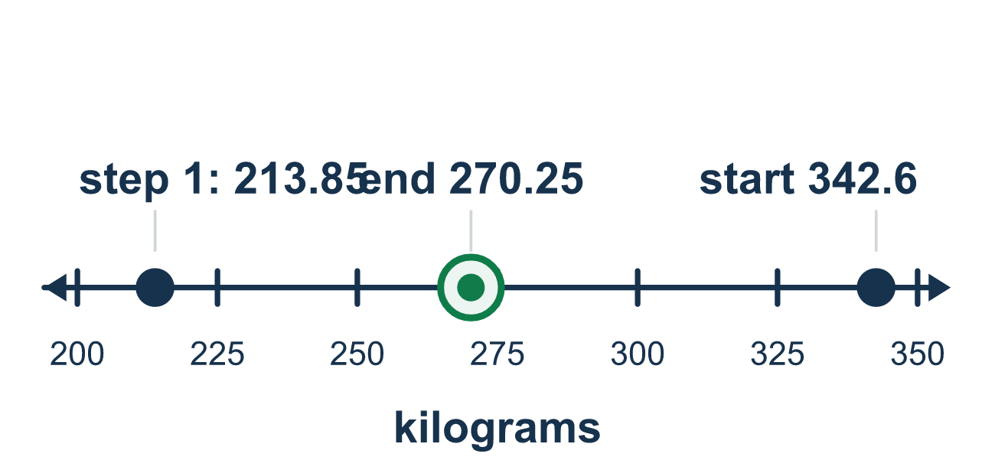
Our class model: the running log

Try it
Work it out on paper. Write one answer on each line.
- A scale reads 150 kg. The crew unloads 15.5 kg. Which calculation finds the new reading?
A. Add B. Subtract C. Multiply D. Divide
My answer
- To add 25.3 and 4.75, how should you write the numbers?
A. 25.3 and 4.75, with the right edges lined up B. 253 and 475, with no decimal points C. 25.30 and 4.75, with the decimal points lined up D. 25.3 and 4.75, with the left edges lined up
My answer
- What is 50.2 − 18.75?
A. 31.55 B. 32.55 C. 68.95 D. 31.45
My answer
- A scale reads 120.5 kg. The crew unloads 40.25 kg, then loads 15.5 kg. What is the final reading?
A. 64.75 kg B. 95.75 kg C. 176.25 kg D. 80.25 kg
My answer
- A scale reads 200 kg. The crew unloads 75.5 kg, then loads 20.25 kg. What is the final reading?
A. 144.75 kg B. 104.25 kg C. 255.25 kg D. 295.75 kg
My answer

Talk about it
For each step, did the balance go up or down, and how did you line up the numbers?

Home mission
Pick a bag of rice or flour at home. Say it weighs 4.5 kg. Pretend you use 1.25 kg, then add 0.8 kg. Write a running log with the decimal points in a line.

If we get stuck, ask
- Are the decimal points lined up in a straight column?
- Does this step add to the total or take away from it?
- Is the answer bigger or smaller than where we started? Should it be?

Do it on a screen

Scan or type the link. Same lesson, with hints. eduwonderlab.com/lessons/2-11-part2/homework.html
How did it feel? (optional) ☐ Tricky ☐ Getting there ☐ Got it

Family Math Studio · For grown-ups Lesson 2.11 · Session 2 · 6.NOS.3

Answers and talk notes
Add and Subtract Decimals

What your student is learning
Tonight we use decimal adding and subtracting in a running log — a weight that goes down when something is unloaded and up when something is loaded.

Answers
Ask your student to explain before you look.
- B. Subtract. Unloading takes weight away, so subtract. So the answer is: Subtract.
- C. 25.30 and 4.75, with the decimal points lined up. Write 25.3 as 25.30 and line up the decimal points: 25.30 and 4.75. So the answer is: 25.30 and 4.75, with the decimal points lined up.
- D. 31.45. 50.20 − 18.75 = 31.45.
- B. 95.75 kg. 120.50 − 40.25 = 80.25, then 80.25 + 15.50 = 95.75 kg.
- A. 144.75 kg. 200.00 − 75.50 = 124.50, then 124.50 + 20.25 = 144.75 kg.

Talk about it
For each step, did the balance go up or down, and how did you line up the numbers?

When they are stuck, ask
- Are the decimal points lined up in a straight column?
- Does this step add to the total or take away from it?
- Is the answer bigger or smaller than where we started? Should it be?

Try not to say
- Just line up the last digits on the right.
- Adding a zero at the end changes the number, so do not.
- Do both steps at once to save time.

Home mission
Pick a bag of rice or flour at home. Say it weighs 4.5 kg. Pretend you use 1.25 kg, then add 0.8 kg. Write a running log with the decimal points in a line.

