Family Math Studio Lesson 2.11 · 6.NOS.3

Add and Subtract Decimals
Add and subtract decimals by lining up the decimal points.
Name Date

Tonight's spark
A fuel tank holds 128.75 liters. A truck adds 46.8 liters. Then 19.35 liters are used. How much fuel is in the tank now? Guess first: is it more or less than 150 liters?
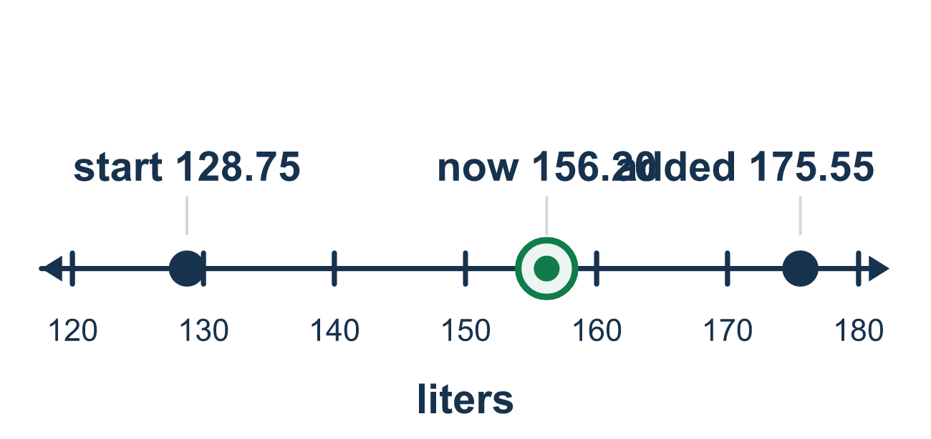
Our class model: lining up the decimal points

Try it
Work it out on paper. Write one answer on each line.
- What is 3.4 + 2.5?
A. 5.9 B. 59 C. 5.09 D. 0.9
My answer
- To add 4.5 + 0.25, how should 4.5 be rewritten so the places match?
A. 4.05 B. 4.50 C. 45.0 D. 0.45
My answer
- What is 12.75 + 6.4?
A. 13.39 B. 19.1 C. 19.15 D. 25.15
My answer
- What is 9.2 − 3.45?
A. 6.25 B. 5.65 C. 12.65 D. 5.75
My answer
- What is 50 − 18.6?
A. 32.4 B. 31.4 C. 41.4 D. 31.6
My answer
- You have $20. You buy items costing $6.75 and $4.50. How much money is left?
A. $8.75 B. $9.20 C. $13.25 D. $11.25
My answer

Talk about it
Do the decimal points sit in a straight line in your stack?

Home mission
Find two prices with cents on a receipt, like $3.50 and $2.75. Write one under the other with the dots in a line. Ask your student to add them, then check with a round estimate.

If we get stuck, ask
- Are the decimal points lined up in a straight line?
- Does one number need a zero added so both have the same places?
- Let's estimate with round numbers. Is our answer close to that?

Do it on a screen

Scan or type the link. Same lesson, with hints. eduwonderlab.com/lessons/2-11/homework.html
How did it feel? (optional) ☐ Tricky ☐ Getting there ☐ Got it

Family Math Studio · For grown-ups Lesson 2.11 · 6.NOS.3

Answers and talk notes
Add and Subtract Decimals

What your student is learning
Tonight we add and subtract decimals. The key is to line up the decimal points so the same place values match.

Answers
Ask your student to explain before you look.
- A. 5.9. 3 + 2 = 5 and 0.4 + 0.5 = 0.9, so 3.4 + 2.5 = 5.9.
- B. 4.50. Adding a zero at the end does not change the value: 4.5 = 4.50.
- C. 19.15. 12.75 + 6.40 = 19.15.
- D. 5.75. 9.20 − 3.45 = 5.75.
- B. 31.4. 50.0 − 18.6 = 31.4.
- A. $8.75. 6.75 + 4.50 = 11.25 spent, and 20.00 − 11.25 = $8.75 left.

Talk about it
Do the decimal points sit in a straight line in your stack?

When they are stuck, ask
- Are the decimal points lined up in a straight line?
- Does one number need a zero added so both have the same places?
- Let's estimate with round numbers. Is our answer close to that?

Try not to say
- Just line up the numbers on the right edge.
- Adding a zero at the end changes the number.
- You can ignore the decimal point while you add.

Home mission
Find two prices with cents on a receipt, like $3.50 and $2.75. Write one under the other with the dots in a line. Ask your student to add them, then check with a round estimate.

