Family Math Studio Lesson 2.12 · Session 2 · 6.NOS.3

Multiply Decimals
Multiply decimals to find a cost, and check that the answer makes sense.
Name Date

Tonight's spark
At the market, apples cost $3.40 per kilogram. You buy 2.5 kilograms. The receipt prints a total of $85.00. Does that make sense? Make a guess first: is the real total more or less than $10?
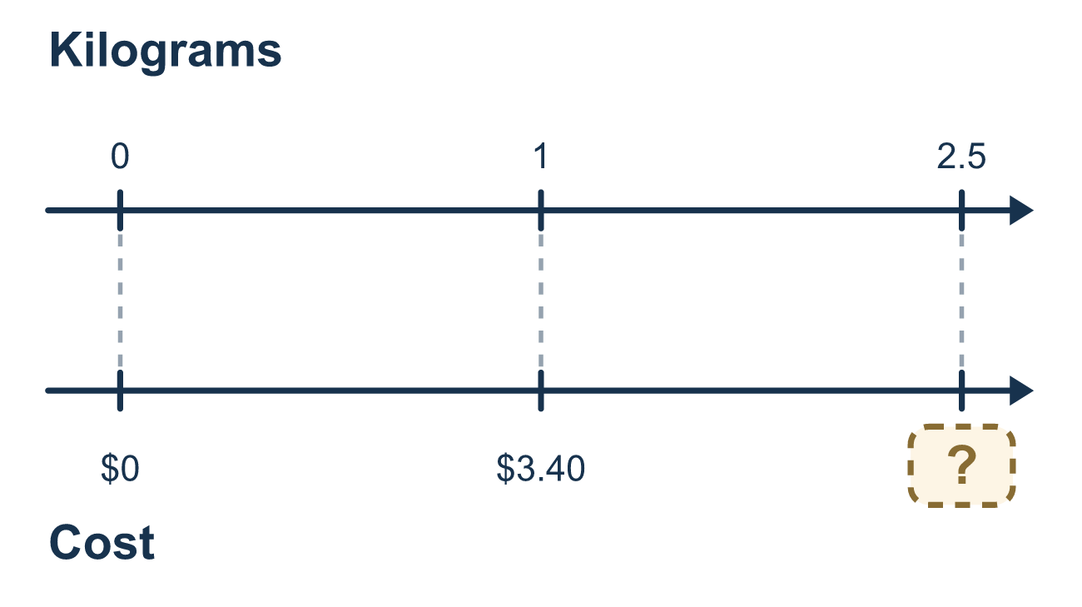
Our class model: estimate, then count the places

Try it
Work it out on paper. Write one answer on each line.
- About how much is 4.1 × $2.95?
A. About $1.20 B. About $12 C. About $120 D. About $7
My answer
- How many decimal places does the product of 1.6 × 0.25 have?
A. 2 B. 1 C. 3 D. 4
My answer
- What is 2.5 × 4.2?
A. 10.5 B. 105 C. 1.05 D. 6.7
My answer
- Grapes cost $4.20 per kilogram. What is the cost of 1.5 kilograms?
A. $63.00 B. $6.30 C. $0.63 D. $5.70
My answer
- Ribbon costs $3.25 per meter. Which total is reasonable for 2.4 meters?
A. $780 B. $78.00 C. $7.80 D. $0.78
My answer

Talk about it
How did your estimate help you place the decimal point?

Home mission
Next time you shop, pick something sold by weight. Ask, "About how much for 2.5 kilograms?" Then ask, "Does the number on the scale make sense?"

If we get stuck, ask
- About how much should this be? Estimate before you multiply.
- How many decimal places in the first factor? And in the second?
- Does your answer match your estimate, or is it ten times off?

Do it on a screen

Scan or type the link. Same lesson, with hints. eduwonderlab.com/lessons/2-12-part2/homework.html
How did it feel? (optional) ☐ Tricky ☐ Getting there ☐ Got it

Family Math Studio · For grown-ups Lesson 2.12 · Session 2 · 6.NOS.3

Answers and talk notes
Multiply Decimals

What your student is learning
Tonight we multiply decimals to find a total cost, and we check whether the answer is reasonable before we trust it.

Answers
Ask your student to explain before you look.
- B. About $12. Round 4.1 to 4 and $2.95 to $3: 4 × $3 = $12. About $12.
- C. 3. 1.6 has 1 place and 0.25 has 2 places, so 1 + 2 = 3.
- A. 10.5. 25 × 42 = 1,050 with 2 decimal places is 10.50, so 2.5 × 4.2 = 10.5.
- B. $6.30. 15 × 420 = 6,300 with 1 + 2 = 3 decimal places is 6.300, which is $6.30.
- C. $7.80. Estimate: about 2.4 × $3 = $7 to $9. The exact product is 240 × 325 = 78,000 with 3 decimal places, $7.80.

Talk about it
How did your estimate help you place the decimal point?

When they are stuck, ask
- About how much should this be? Estimate before you multiply.
- How many decimal places in the first factor? And in the second?
- Does your answer match your estimate, or is it ten times off?

Try not to say
- Count the decimal places in the bigger number only.
- Line up the decimal points like you do when adding.
- Skip the estimate, it just takes extra time.

Home mission
Next time you shop, pick something sold by weight. Ask, "About how much for 2.5 kilograms?" Then ask, "Does the number on the scale make sense?"

