Family Math Studio Lesson 2.12 · 6.NOS.3

Multiply Decimals
Multiply decimals and place the decimal point correctly.
Name Date

Tonight's spark
A sign says rope costs $12.60 per meter. Maya buys 4.5 meters. The screen shows $567.00. Does that look right? Estimate first: 5 meters at about $13 each. Is that near $567?
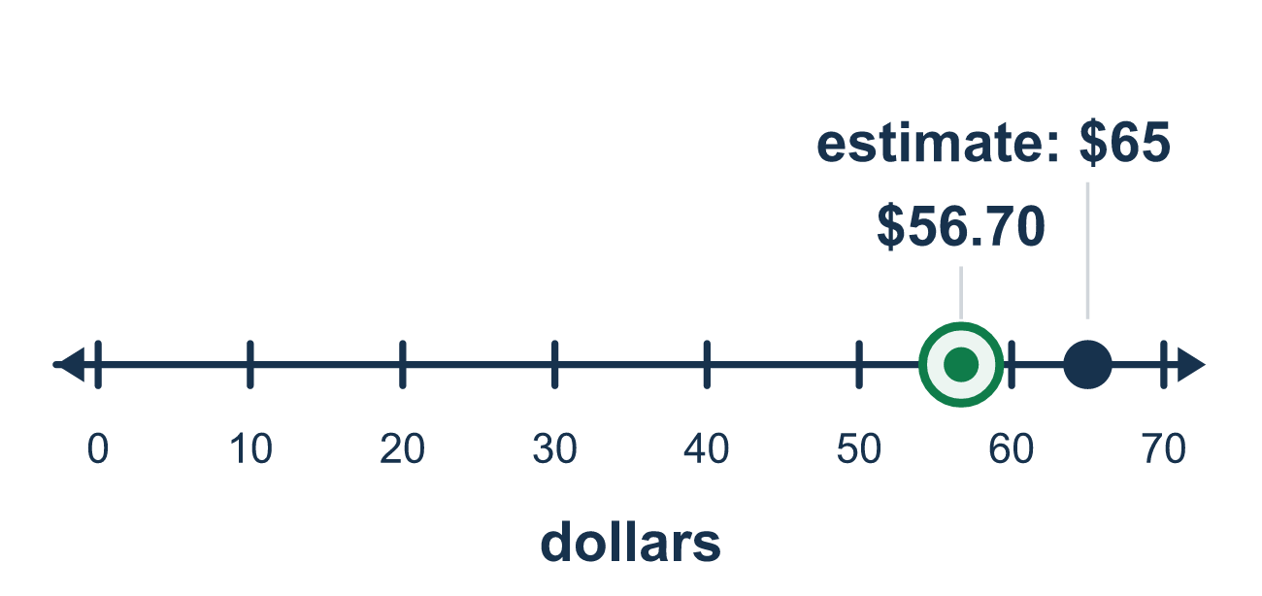
Our class model: count the decimal places

Try it
Work it out on paper. Write one answer on each line.
- What is 0.3 × 0.2?
A. 0.06 B. 0.6 C. 0.5 D. 6
My answer
- How many decimal places will the product of 2.5 × 0.04 have?
A. 2 B. 3 C. 1 D. 5
My answer
- What is 2.5 × 6?
A. 1.5 B. 150 C. 15 D. 8.5
My answer
- What is 0.8 × 0.9?
A. 7.2 B. 0.72 C. 0.072 D. 1.7
My answer
- What is 3.2 × 1.5?
A. 48 B. 0.48 C. 4.7 D. 4.8
My answer
- Notebooks cost $2.40 each. What is the cost of 6 notebooks?
A. $14.40 B. $144 C. $1.44 D. $8.40
My answer

Talk about it
How many decimal places does 12.60 have? And 4.5?

Home mission
Find a price per pound on a food label. Pick a weight like 2.5 pounds. Can your student estimate the total out loud, then say how many decimal places the exact answer needs?

If we get stuck, ask
- First multiply like whole numbers. What do you get?
- How many decimal places do both factors have together?
- Let's estimate with round numbers. Does the point look right?

Do it on a screen

Scan or type the link. Same lesson, with hints. eduwonderlab.com/lessons/2-12/homework.html
How did it feel? (optional) ☐ Tricky ☐ Getting there ☐ Got it

Family Math Studio · For grown-ups Lesson 2.12 · 6.NOS.3

Answers and talk notes
Multiply Decimals

What your student is learning
Tonight we multiply decimals. We multiply like whole numbers first, then count decimal places to put the point in the answer.

Answers
Ask your student to explain before you look.
- A. 0.06. 3 × 2 = 6 and there are 1 + 1 = 2 decimal places, so 0.3 × 0.2 = 0.06.
- B. 3. 2.5 has 1 decimal place and 0.04 has 2, so the product has 1 + 2 = 3 decimal places.
- C. 15. 25 × 6 = 150 with 1 decimal place is 15.0, so 2.5 × 6 = 15.
- B. 0.72. 8 × 9 = 72, and 1 + 1 = 2 decimal places, so 0.8 × 0.9 = 0.72.
- D. 4.8. 32 × 15 = 480 with 2 decimal places is 4.80, so 3.2 × 1.5 = 4.8.
- A. $14.40. 240 × 6 = 1,440 with 2 decimal places is $14.40.

Talk about it
How many decimal places does 12.60 have? And 4.5?

When they are stuck, ask
- First multiply like whole numbers. What do you get?
- How many decimal places do both factors have together?
- Let's estimate with round numbers. Does the point look right?

Try not to say
- Line up the decimal points like you do when adding.
- The answer always has the same number of decimal places as one factor.
- You do not need to count places; just guess where the point goes.

Home mission
Find a price per pound on a food label. Pick a weight like 2.5 pounds. Can your student estimate the total out loud, then say how many decimal places the exact answer needs?

