Family Math Studio Lesson 2.2 · Session 2 · 6.DS.5

Represent and Describe Data in a Histogram
Describe the shape of a histogram: where the peak is and whether the sides match.
Name Date

Tonight's spark
A poster shows quiz scores in a histogram. The bars over 60–69, 70–79 and 80–89 have heights 2, 4 and 2. Do the two sides of the tallest bar look alike? Make a guess first: will the shape look balanced or lean to one side?
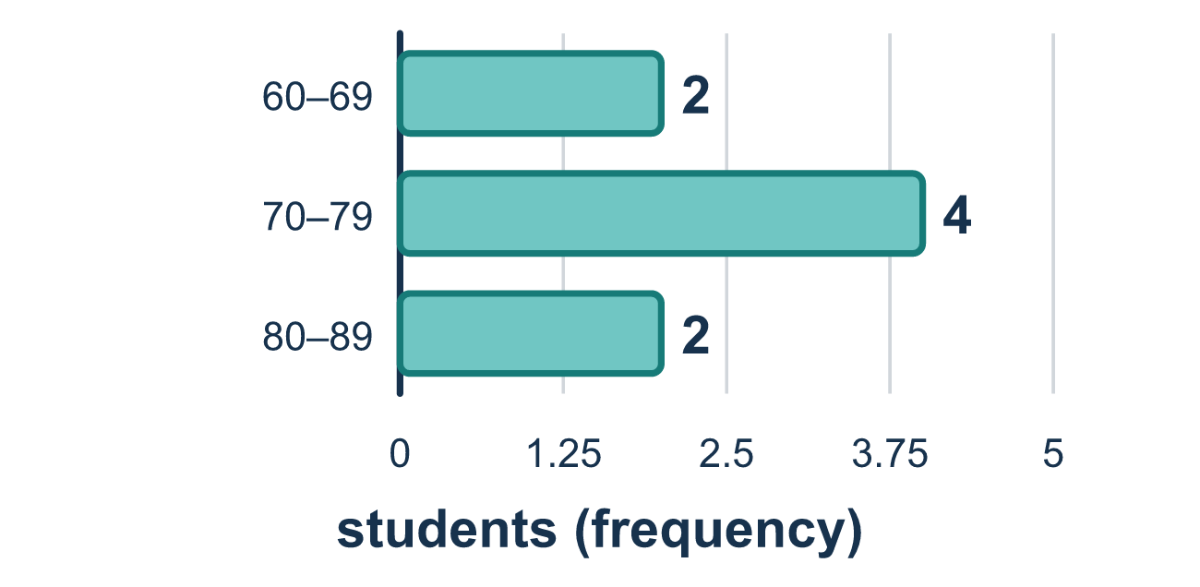
Our class model: reading the shape

Try it
Work it out on paper. Write one answer on each line.
- What is the tallest bar in a histogram called?
A. The peak B. The interval C. The frequency table D. The total
My answer
- Bars over 0–9, 10–19, and 20–29 have heights 3, 5, and 2. Where is the peak?
A. 0–9 B. 20–29 C. 10–19 D. At the height 5 on the side
My answer
- The bars on the left and right of the peak match. What is the shape of the data?
A. Skewed to the left B. Symmetric C. Skewed to the right D. Flat
My answer
- A histogram has its peak on the left, and the bars get shorter with a long tail to the right. Which shape is it?
A. Skewed to the left B. Symmetric C. No shape D. Skewed to the right
My answer
- Bars over 10–19, 20–29, and 30–39 have heights 3, 6, and 3. In which interval is a typical value?
A. 20–29 B. 10–19 C. 30–39 D. All three are equally typical
My answer
- A histogram has bars of height 1, 4, 3, and 2. How many values does it show in all?
A. 4 B. 24 C. 10 D. 2
My answer

Talk about it
Where is the peak, and which side, if any, has a long tail?

Home mission
Stack coins in three columns on the table: 2, 4 and 2. Ask your student if the two sides match. Now add a fourth column with 1 coin. Which way does the tail stretch now?

If we get stuck, ask
- Which bar is tallest, and what interval does it cover?
- Does the left side of the peak look like the right side?
- Which direction does the long tail point?

Do it on a screen

Scan or type the link. Same lesson, with hints. eduwonderlab.com/lessons/2-2-part2/homework.html
How did it feel? (optional) ☐ Tricky ☐ Getting there ☐ Got it

Family Math Studio · For grown-ups Lesson 2.2 · Session 2 · 6.DS.5

Answers and talk notes
Represent and Describe Data in a Histogram

What your student is learning
Tonight we read a histogram we already know how to build, and say in words what its shape tells us about the data.

Answers
Ask your student to explain before you look.
- A. The peak. The tallest bar is called the peak. So the answer is: The peak.
- C. 10–19. The tallest bar has height 5, and it sits over 10–19.
- B. Symmetric. When the two sides of the peak match, the data is symmetric. So the answer is: Symmetric.
- D. Skewed to the right. The long tail points right, so the data is skewed to the right. So the answer is: Skewed to the right.
- A. 20–29. The peak is over 20–29, so most values are there and a typical value is in 20–29.
- C. 10. Add the heights: 1 + 4 + 3 + 2 = 10 values.

Talk about it
Where is the peak, and which side, if any, has a long tail?

When they are stuck, ask
- Which bar is tallest, and what interval does it cover?
- Does the left side of the peak look like the right side?
- Which direction does the long tail point?

Try not to say
- A tall bar in the middle always means symmetric.
- Skewed right means the tall bars are on the right.
- Leave a space between the bars so it looks neater.

Home mission
Stack coins in three columns on the table: 2, 4 and 2. Ask your student if the two sides match. Now add a fourth column with 1 coin. Which way does the tail stretch now?

