Family Math Studio Lesson 2.2 · 6.DS.5

Represent and Describe Data in a Histogram
Group numbers into equal ranges and draw a histogram to show how many values are in each.
Name Date

Tonight's spark
A coach lists the points six players scored: 3, 7, 12, 15, 18, 24. She sorts them into groups: 0–9, 10–19 and 20–29. Which group holds the most players? Make a guess first: 0–9, 10–19, or 20–29?
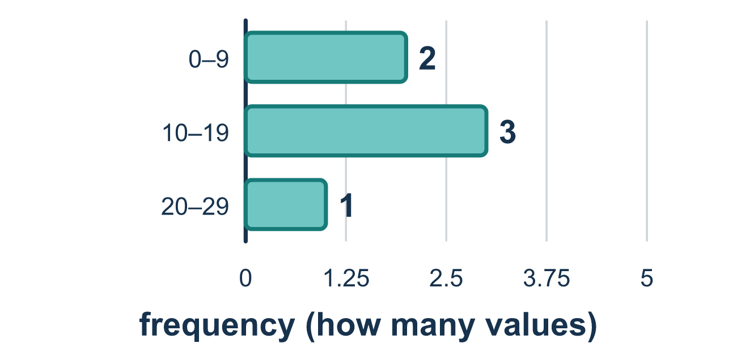
Our class model: sorting into equal intervals

Try it
Work it out on paper. Write one answer on each line.
- In a histogram, what does the height of a bar show?
A. The largest value in the interval B. The width of the interval C. The frequency: how many values fall in that interval D. The middle value of the data
My answer
- Data: 2, 5, 9, 11, 14. Intervals are 0–9 and 10–19. How many values are in 0–9?
A. 3 B. 2 C. 5 D. 9
My answer
- Which interval does the value 23 belong in?
A. 10–19 B. 20–29 C. 30–39 D. 0–9
My answer
- A frequency table shows 0–4: 2, 5–9: 6, 10–14: 3. Which interval has the tallest bar?
A. 0–4 B. 10–14 C. They are all the same height D. 5–9
My answer
- A histogram has bars of height 2, 5, 4, and 1. How many values are in the data set?
A. 5 B. 12 C. 4 D. 8
My answer

Talk about it
What does the height of a bar count?

Home mission
Write 3, 7, 12, 15, 18 and 24 on six small papers. Make three piles labeled 0–9, 10–19 and 20–29. Sort the papers into the piles. Which pile is the tallest? Line the piles up side by side. Do they touch?

If we get stuck, ask
- Which interval does this number belong in?
- How many numbers landed in this interval? That is the bar's height.
- Which interval has the most numbers? That bar is the tallest.

Do it on a screen

Scan or type the link. Same lesson, with hints. eduwonderlab.com/lessons/2-2/homework.html
How did it feel? (optional) ☐ Tricky ☐ Getting there ☐ Got it

Family Math Studio · For grown-ups Lesson 2.2 · 6.DS.5

Answers and talk notes
Represent and Describe Data in a Histogram

What your student is learning
Tonight we make a histogram: a bar graph that groups numbers into equal ranges so a big set of data is easy to read.

Answers
Ask your student to explain before you look.
- C. The frequency: how many values fall in that interval. The height of a bar is the frequency: how many values fall in that interval. So the answer is: The frequency: how many values fall in that interval.
- A. 3. The values 2, 5, and 9 are in 0–9, so the frequency is 3.
- B. 20–29. 23 is between 20 and 29, so it belongs in 20–29.
- D. 5–9. The frequency 6 is the greatest, so the interval 5–9 has the tallest bar.
- B. 12. Each bar counts its values, so add the heights: 2 + 5 + 4 + 1 = 12.

Talk about it
What does the height of a bar count?

When they are stuck, ask
- Which interval does this number belong in?
- How many numbers landed in this interval? That is the bar's height.
- Which interval has the most numbers? That bar is the tallest.

Try not to say
- In a histogram, leave spaces between the bars.
- The bar's height is the biggest number in the interval.
- You can use intervals of different sizes for the same histogram.

Home mission
Write 3, 7, 12, 15, 18 and 24 on six small papers. Make three piles labeled 0–9, 10–19 and 20–29. Sort the papers into the piles. Which pile is the tallest? Line the piles up side by side. Do they touch?

