Family Math Studio Lesson 2.3 · Session 2 · 6.DS.4

Describe the Data Using the Median
Find the median when a data set has an even number of values.
Name Date

Tonight's spark
A trail sign wants one number for a typical bike ride. Six rides lasted 52, 67, 58, 62, 55 and 70 minutes. What number should the sign show? Make a guess first: will it be one of the six ride times, or not?
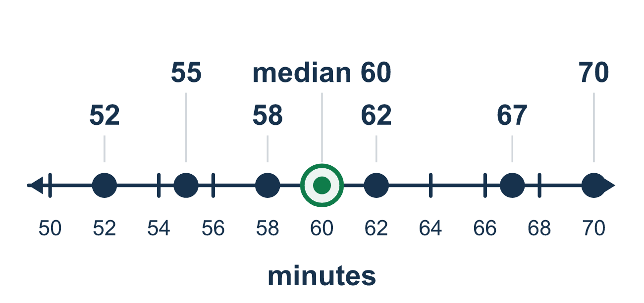
Our class model: halfway between the two middle numbers

Try it
Work it out on paper. Write one answer on each line.
- What is the median of 4 and 8?
A. 4 B. 6 C. 12 D. 8
My answer
- What is the median of 1, 3, 7, 13?
A. 3 B. 7 C. 5 D. 6
My answer
- What is the median of 9, 3, 7, 5?
A. 5 B. 8 C. 12 D. 6
My answer
- Can the median of an even number of values be a number that is not in the data?
A. Yes, it can fall halfway between two values B. No, the median is always one of the data values C. No, the median is always a whole number D. Only if all the values are equal
My answer
- What is the median of 10, 12, 16, 18, 20, 30?
A. 34 B. 17 C. 16 D. 18
My answer
- Six dogs weigh 40, 52, 38, 44, 60, 46 pounds. What is the median weight?
A. 44 lb B. 46 lb C. 45 lb D. 90 lb
My answer

Talk about it
Why are there two middle numbers, and how did you find the number halfway between them?

Home mission
Write 52, 55, 58, 62, 67 and 70 on six small papers and mix them up. Ask your student to put them in order and touch the two middle ones. Then ask: what number is halfway between them? Is there a paper with that number?

If we get stuck, ask
- Is the list in order from least to greatest yet?
- How many values are there — odd or even?
- Which two numbers share the middle, and what is halfway between them?

Do it on a screen

Scan or type the link. Same lesson, with hints. eduwonderlab.com/lessons/2-3-part2/homework.html
How did it feel? (optional) ☐ Tricky ☐ Getting there ☐ Got it

Family Math Studio · For grown-ups Lesson 2.3 · Session 2 · 6.DS.4

Answers and talk notes
Describe the Data Using the Median

What your student is learning
Tonight we find the median when the data set has an EVEN number of values — so there is no single number sitting in the middle.

Answers
Ask your student to explain before you look.
- B. 6. Halfway between 4 and 8 is (4 + 8) ÷ 2 = 6.
- C. 5. The middle numbers are 3 and 7: (3 + 7) ÷ 2 = 5.
- D. 6. In order: 3, 5, 7, 9. The middle values are 5 and 7, so the median is (5 + 7) ÷ 2 = 6.
- A. Yes, it can fall halfway between two values. Yes, it can fall halfway between two values, like the median of 2 and 5, which is 3.5.
- B. 17. The middle values are 16 and 18: (16 + 18) ÷ 2 = 17.
- C. 45 lb. In order: 38, 40, 44, 46, 52, 60. The median is (44 + 46) ÷ 2 = 45 lb.

Talk about it
Why are there two middle numbers, and how did you find the number halfway between them?

When they are stuck, ask
- Is the list in order from least to greatest yet?
- How many values are there — odd or even?
- Which two numbers share the middle, and what is halfway between them?

Try not to say
- Just take the number in the middle of the list as it was written.
- The median must be one of the numbers in the data.
- With an even count, pick either middle number, it hardly matters.

Home mission
Write 52, 55, 58, 62, 67 and 70 on six small papers and mix them up. Ask your student to put them in order and touch the two middle ones. Then ask: what number is halfway between them? Is there a paper with that number?

