Family Math Studio Lesson 2.3 · 6.DS.4

Describe the Data Using the Median
Find the median: put the numbers in order and find the middle value.
Name Date

Tonight's spark
Five students counted the books they read: 4, 9, 2, 6, 4. A poster asks for the middle number. What is it? Make a guess first: is the middle number bigger or smaller than 5?
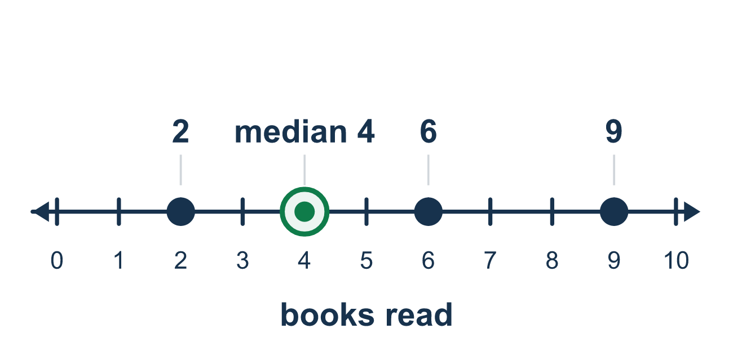
Our class model: order first, then find the middle

Try it
Work it out on paper. Write one answer on each line.
- What is the median of a data set?
A. The value that appears most often B. The middle value when the numbers are in order C. The greatest value D. All the values added up
My answer
- What is the median of 3, 5, 9?
A. 5 B. 3 C. 9 D. 17
My answer
- What is the median of 7, 2, 9, 4, 5?
A. 9 B. 7 C. 4 D. 5
My answer
- What is the median of 12, 15, 11, 20, 18?
A. 11 B. 15 C. 20 D. 18
My answer
- What is the median of 1, 1, 4, 9, 10?
A. 1 B. 5 C. 4 D. 10
My answer
- A student walked a dog for 6, 3, 8, 5, 7 miles over five days. What is the median number of miles?
A. 6 B. 8 C. 3 D. 5.8
My answer

Talk about it
What should you do to the list before you look for the middle?

Home mission
Write 4, 9, 2, 6 and 4 on five small papers and mix them up. Can your student put them in order and point to the middle one? Then ask what changes if you take away the 9.

If we get stuck, ask
- Are the numbers in order yet?
- How many numbers are there — odd or even?
- Which number is exactly in the middle?

Do it on a screen

Scan or type the link. Same lesson, with hints. eduwonderlab.com/lessons/2-3/homework.html
How did it feel? (optional) ☐ Tricky ☐ Getting there ☐ Got it

Family Math Studio · For grown-ups Lesson 2.3 · 6.DS.4

Answers and talk notes
Describe the Data Using the Median

What your student is learning
Tonight we describe a data set using the median — the middle value when the numbers are put in order.

Answers
Ask your student to explain before you look.
- B. The middle value when the numbers are in order. The median is the middle value when the numbers are in order. So the answer is: The middle value when the numbers are in order.
- A. 5. The numbers are in order and the middle one is 5.
- D. 5. In order: 2, 4, 5, 7, 9. The middle value is 5.
- B. 15. In order: 11, 12, 15, 18, 20. The middle value is 15.
- C. 4. The numbers are in order and the middle one is 4.
- A. 6. In order: 3, 5, 6, 7, 8. The median is 6 miles.

Talk about it
What should you do to the list before you look for the middle?

When they are stuck, ask
- Are the numbers in order yet?
- How many numbers are there — odd or even?
- Which number is exactly in the middle?

Try not to say
- Add them all up and divide — that is the median.
- Just take the middle number of the list as it was written.
- With an even count there is no median.

Home mission
Write 4, 9, 2, 6 and 4 on five small papers and mix them up. Can your student put them in order and point to the middle one? Then ask what changes if you take away the 9.

