Family Math Studio Lesson 2.4 · Session 2 · 6.DS.5

Represent and Describe Data in a Box Plot
Compare two box plots by their centers and by how spread out they are.
Name Date

Tonight's spark
Two rec-center teams post their game scores as box plots. Team A: median 53, box 12 wide. Team B: median 57, box 11 wide. Which team scores higher, and which is steadier? Make a guess first: which team is typically higher, A or B?
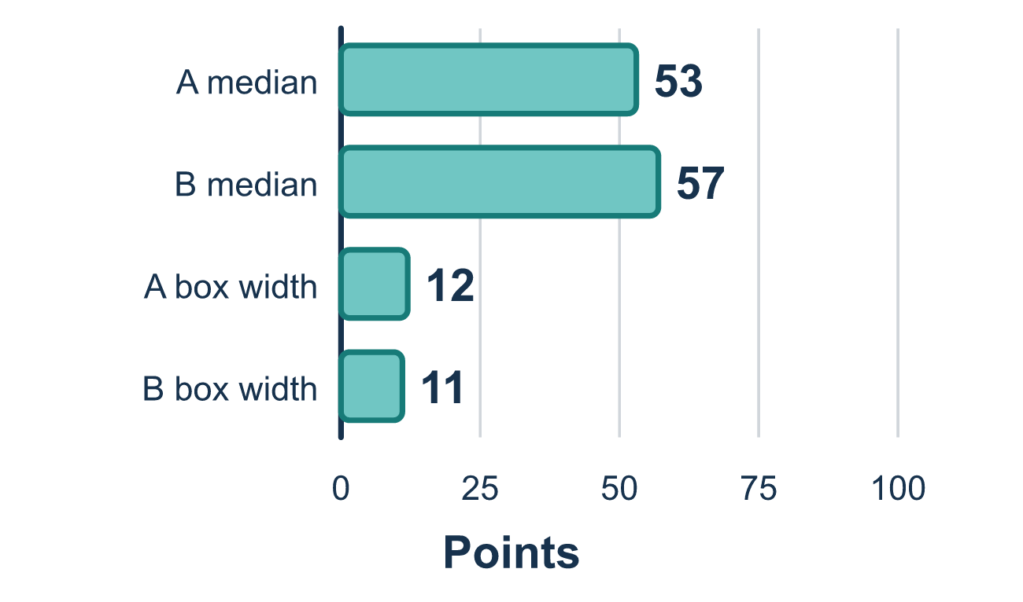
Our class model: two looks at two boxes

Try it
Work it out on paper. Write one answer on each line.
- Which part of a box plot tells you which group is typically higher?
A. The median line B. The length of the whiskers C. The width of the box D. The title of the graph
My answer
- Group A has median 40 and Group B has median 52. Which group is typically higher?
A. Group A B. Group B C. They are the same D. You cannot tell
My answer
- Class X has a box from 30 to 60. Class Y has a box from 38 to 52. Which class has a more consistent middle half?
A. Class X, because its box is wider B. They are equally consistent C. Class Y, because its box is narrower D. Class Y, because its box is farther to the right
My answer
- A box plot has Q1 = 25 and Q3 = 41. How wide is the box?
A. 66 B. 8 C. 41 D. 16
My answer

Talk about it
Which week has the higher median, and which has the narrower box?

Home mission
Think of two bus routes you know. Which is typically faster? Which is more on time every day? Can one route win one question and lose the other?

If we get stuck, ask
- Which median line sits higher on the scale?
- Which box is wider? What does the width tell us?
- Can you compare center and spread in the same sentence?

Do it on a screen

Scan or type the link. Same lesson, with hints. eduwonderlab.com/lessons/2-4-part2/homework.html
How did it feel? (optional) ☐ Tricky ☐ Getting there ☐ Got it

Family Math Studio · For grown-ups Lesson 2.4 · Session 2 · 6.DS.5

Answers and talk notes
Represent and Describe Data in a Box Plot

What your student is learning
Tonight we put two box plots side by side and compare two groups — first by their centers, then by how spread out they are.

Answers
Ask your student to explain before you look.
- A. The median line. The median line is the typical value, so compare the median lines.
- B. Group B. 52 is greater than 40, so Group B is typically higher.
- C. Class Y, because its box is narrower. Class Y has a narrower box (52 − 38 = 14 versus 60 − 30 = 30), so Class Y, because its box is narrower.
- D. 16. The width is Q3 − Q1 = 41 − 25 = 16.

Talk about it
Which week has the higher median, and which has the narrower box?

When they are stuck, ask
- Which median line sits higher on the scale?
- Which box is wider? What does the width tell us?
- Can you compare center and spread in the same sentence?

Try not to say
- The bigger box means the bigger numbers.
- Just look at which plot is longer overall.
- If the medians are the same, the groups are the same.

Home mission
Think of two bus routes you know. Which is typically faster? Which is more on time every day? Can one route win one question and lose the other?

