Family Math Studio Lesson 2.4 · 6.DS.5

Represent and Describe Data in a Box Plot
Make and read a box plot from five key numbers.
Name Date

Tonight's spark
A rec-center coach lists 11 game scores in order: 4, 6, 8, 10, 12, 14, 15, 18, 22, 24, 28. She wants one picture of the middle and the spread. Which five numbers draw it? Make a guess first: is the middle score closer to 4 or closer to 28?
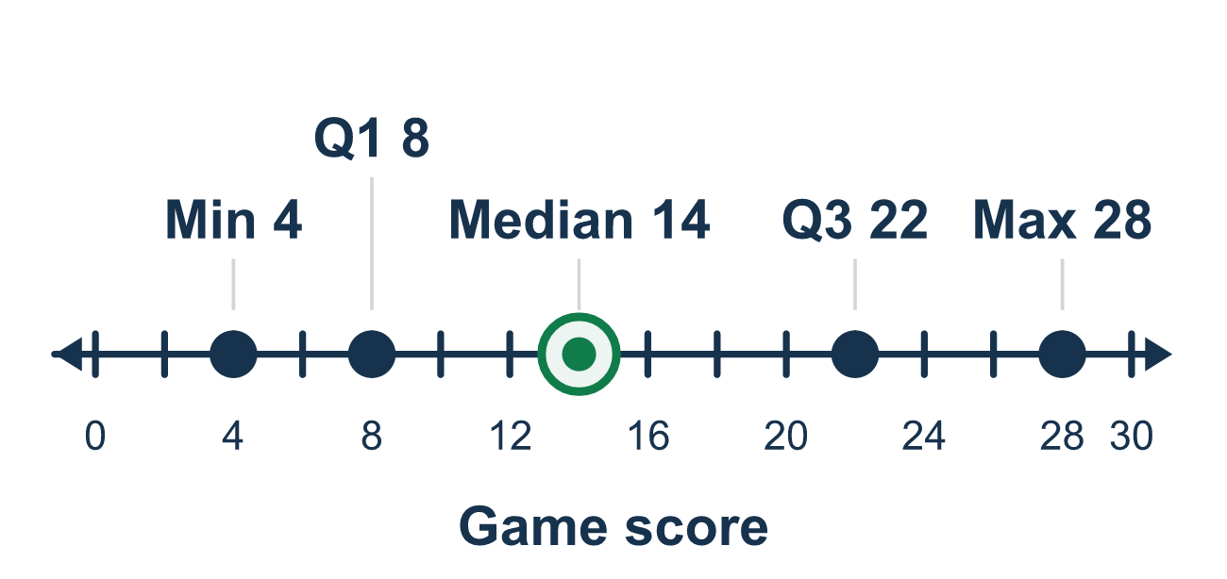
Our class model: the five-number box

Try it
Work it out on paper. Write one answer on each line.
- Which list names the five numbers used in a box plot?
A. Least, Q1, median, Q3, greatest B. Least, mean, mode, range, greatest C. Q1, Q2, Q3, Q4, Q5 D. Q1, Q3, mean, mode, range
My answer
- What does the line inside the box of a box plot show?
A. The mean B. The greatest value C. The median D. The least value
My answer
- What part of the data is inside the box of a box plot?
A. All of the data B. The lower half C. Just the median D. The middle half
My answer
- Data in order: 1, 3, 5, 7, 9, 11, 13. What is Q1?
A. 3 B. 1 C. 5 D. 7
My answer
- Data in order: 6, 8, 10, 12, 14, 16, 18. What is Q3?
A. 12 B. 16 C. 18 D. 14
My answer
- Data in order: 4, 5, 7, 8, 10, 12, 15. Which is the five-number summary (least, Q1, median, Q3, greatest)?
A. 4, 5, 8, 12, 15 B. 4, 5, 7, 12, 15 C. 4, 7, 8, 10, 15 D. 4, 5, 8, 12
My answer

Talk about it
Is the median halfway between the two ends, or the middle score in order?

Home mission
Pick five snack prices from a store flyer. Say them in order out loud. Can your student name the median, then the lowest and the highest?

If we get stuck, ask
- Did we put the numbers in order first?
- What is the median? That splits the data into two halves.
- What is the middle of the lower half, and of the upper half?

Do it on a screen

Scan or type the link. Same lesson, with hints. eduwonderlab.com/lessons/2-4/homework.html
How did it feel? (optional) ☐ Tricky ☐ Getting there ☐ Got it

Family Math Studio · For grown-ups Lesson 2.4 · 6.DS.5

Answers and talk notes
Represent and Describe Data in a Box Plot

What your student is learning
Tonight we build a box plot, a simple picture that shows how data is spread out using five key numbers.

Answers
Ask your student to explain before you look.
- A. Least, Q1, median, Q3, greatest. The five numbers are the least, Q1, the median, Q3, and the greatest. So the answer is: Least, Q1, median, Q3, greatest.
- C. The median. The line inside the box marks the median. So the answer is: The median.
- D. The middle half. The box runs from Q1 to Q3, which holds the middle half of the data. So the answer is: The middle half.
- A. 3. The median is 7. The lower half is 1, 3, 5, and its middle is 3, so Q1 = 3.
- B. 16. The median is 12. The upper half is 14, 16, 18, and its middle is 16, so Q3 = 16.
- A. 4, 5, 8, 12, 15. Least 4, median 8 (the 4th value), Q1 = 5 (middle of 4, 5, 7), Q3 = 12 (middle of 10, 12, 15), greatest 15: 4, 5, 8, 12, 15.

Talk about it
Is the median halfway between the two ends, or the middle score in order?

When they are stuck, ask
- Did we put the numbers in order first?
- What is the median? That splits the data into two halves.
- What is the middle of the lower half, and of the upper half?

Try not to say
- You can find the quartiles without ordering the numbers first.
- The box shows all of the data, not just the middle half.
- The line inside the box is the mean.

Home mission
Pick five snack prices from a store flyer. Say them in order out loud. Can your student name the median, then the lowest and the highest?

