Family Math Studio Lesson 2.5 · Session 2 · 6.DS.3

Describe Data by Range and Interquartile Range
Use the range and the IQR together to say which group is more consistent.
Name Date

Tonight's spark
Two classes took the same quiz. Class A scores run from 52 to 89. Class B scores run from 57 to 83. Which class has scores closer together? Make a guess first: Class A or Class B?
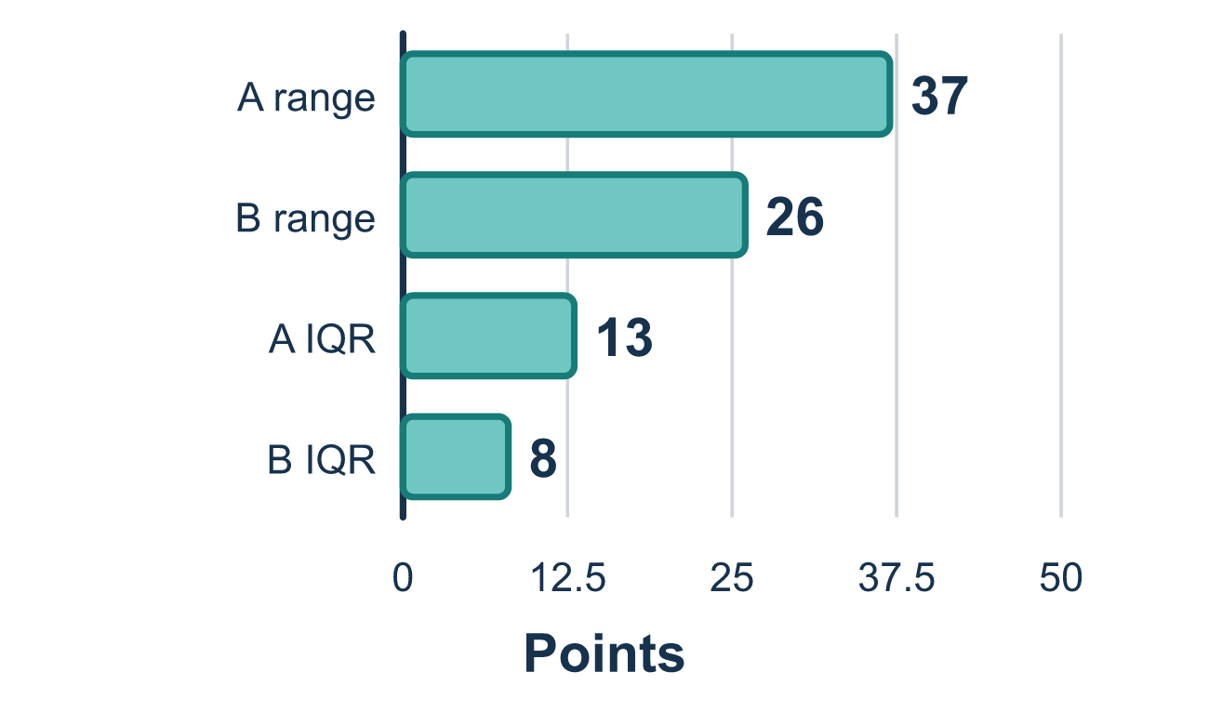
Our class model: range and IQR side by side

Try it
Work it out on paper. Write one answer on each line.
- A smaller range or IQR means the data values are...
A. Closer together, so more consistent B. Farther apart, so more consistent C. Greater in value D. Always equal
My answer
- Class A has a range of 20 and Class B has a range of 12. Which class is more consistent?
A. Class A B. Class B C. They are equally consistent D. You cannot tell
My answer
- Team R has an IQR of 6 and Team S has an IQR of 10. Whose middle half is more spread out?
A. Team R B. Both are the same C. Team S D. Neither, because IQR is not about spread
My answer
- A class has least 50, Q1 58, median 65, Q3 70, greatest 90. Which gives the range and the IQR?
A. Range 40, IQR 70 B. Range 90, IQR 12 C. Range 12, IQR 40 D. Range 40, IQR 12
My answer
- Group X has range 30 and IQR 10. Group Y has range 25 and IQR 14. Which sentence is true?
A. X has the larger range, and Y has the larger IQR B. X is larger in both C. Y is larger in both D. They are the same in both
My answer

Talk about it
Do the range and the IQR point to the same team? What does that tell you?

Home mission
Think of two ways to get to school or the store. Which one always takes about the same time? Which one is sometimes fast and sometimes slow? Which has the smaller spread?

If we get stuck, ask
- Is this measure a subtraction? Which two numbers are we subtracting?
- Could the middle half ever be wider than the whole set?
- Which team's numbers sit closer together?

Do it on a screen

Scan or type the link. Same lesson, with hints. eduwonderlab.com/lessons/2-5-part2/homework.html
How did it feel? (optional) ☐ Tricky ☐ Getting there ☐ Got it

Family Math Studio · For grown-ups Lesson 2.5 · Session 2 · 6.DS.3

Answers and talk notes
Describe Data by Range and Interquartile Range

What your student is learning
Tonight we use range and interquartile range together to say which of two groups is more consistent.

Answers
Ask your student to explain before you look.
- A. Closer together, so more consistent. Smaller spread means the values sit closer together, so the data is more consistent. So the answer is: Closer together, so more consistent.
- B. Class B. 12 is smaller than 20, so Class B is more consistent.
- C. Team S. 10 is greater than 6, so Team S has the more spread out middle half.
- D. Range 40, IQR 12. Range = 90 − 50 = 40 and IQR = 70 − 58 = 12, so Range 40, IQR 12.
- A. X has the larger range, and Y has the larger IQR. 30 > 25, so X has the larger range. 14 > 10, so Y has the larger IQR. So the answer is: X has the larger range, and Y has the larger IQR.

Talk about it
Do the range and the IQR point to the same team? What does that tell you?

When they are stuck, ask
- Is this measure a subtraction? Which two numbers are we subtracting?
- Could the middle half ever be wider than the whole set?
- Which team's numbers sit closer together?

Try not to say
- Add the quartiles to find the IQR.
- A bigger range is always better.
- Range and IQR mean the same thing, just pick one.

Home mission
Think of two ways to get to school or the store. Which one always takes about the same time? Which one is sometimes fast and sometimes slow? Which has the smaller spread?

