Family Math Studio Lesson 2.5 · 6.DS.3

Describe Data by Range and Interquartile Range
Describe how spread out data is with the range and the interquartile range.
Name Date

Tonight's spark
A teacher posts 20 history test scores. The lowest is 68. The highest is 94. How many points apart are the lowest and the highest scores? Make a guess first: is the gap more than 20 points or less?
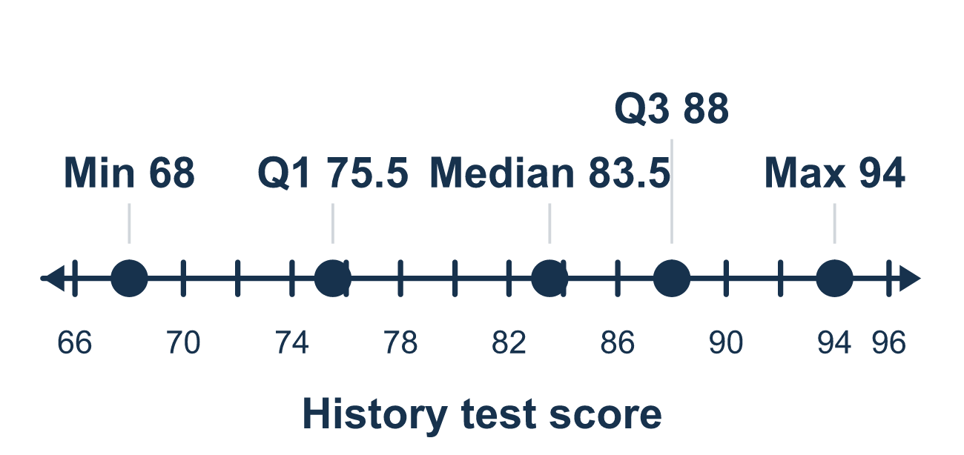
Our class model: two measures of spread

Try it
Work it out on paper. Write one answer on each line.
- What is the range of 3, 8, 14, 20?
A. 23 B. 17 C. 20 D. 6
My answer
- Which measure tells how spread out the middle half of the data is?
A. The interquartile range (IQR) B. The range C. The median D. Q1
My answer
- Q1 = 12 and Q3 = 30. What is the IQR?
A. 42 B. 30 C. 18 D. 21
My answer
- Quiz scores range from a low of 62 to a high of 95. What is the range?
A. 157 B. 95 C. 23 D. 33
My answer
- A box plot shows least 6, Q1 14, median 20, Q3 27, greatest 41. What is the range?
A. 13 B. 35 C. 41 D. 21
My answer
- The same box plot shows least 6, Q1 14, median 20, Q3 27, greatest 41. What is the IQR?
A. 13 B. 35 C. 7 D. 27
My answer

Talk about it
Is the range a place on the number line, or a distance?

Home mission
Ask each person at home how many minutes they need to get ready. Find the longest time and the shortest time. How far apart are they? That distance is the range.

If we get stuck, ask
- What are the least and greatest values?
- Where does the box start and end?
- Is your IQR less than or equal to your range?

Do it on a screen

Scan or type the link. Same lesson, with hints. eduwonderlab.com/lessons/2-5/homework.html
How did it feel? (optional) ☐ Tricky ☐ Getting there ☐ Got it

Family Math Studio · For grown-ups Lesson 2.5 · 6.DS.3

Answers and talk notes
Describe Data by Range and Interquartile Range

What your student is learning
Tonight we measure how spread out a data set is, using the range and the interquartile range (IQR).

Answers
Ask your student to explain before you look.
- B. 17. Range = greatest − least = 20 − 3 = 17.
- A. The interquartile range (IQR). The IQR, the interquartile range, measures the spread of the middle half. So the answer is: The interquartile range (IQR).
- C. 18. IQR = Q3 − Q1 = 30 − 12 = 18.
- D. 33. Range = 95 − 62 = 33 points.
- B. 35. Range = 41 − 6 = 35.
- A. 13. IQR = Q3 − Q1 = 27 − 14 = 13.

Talk about it
Is the range a place on the number line, or a distance?

When they are stuck, ask
- What are the least and greatest values?
- Where does the box start and end?
- Is your IQR less than or equal to your range?

Try not to say
- Add the two quartiles together.
- The range and the IQR are the same thing.
- You need the mean to find the spread.

Home mission
Ask each person at home how many minutes they need to get ready. Find the longest time and the shortest time. How far apart are they? That distance is the range.

