Family Math Studio Lesson 2.6 · Session 2 · 6.NOS.2

Divide Multi-Digit Numbers Using an Algorithm
Use long division more than once in a real problem, then compare the answers.
Name Date

Tonight's spark
A big school district has 621,000 students. Right now there is 1 teacher for every 20 students. The goal is 1 teacher for every 15. How many more teachers must the district hire? Make a guess first: more than 5,000 new teachers, or fewer?
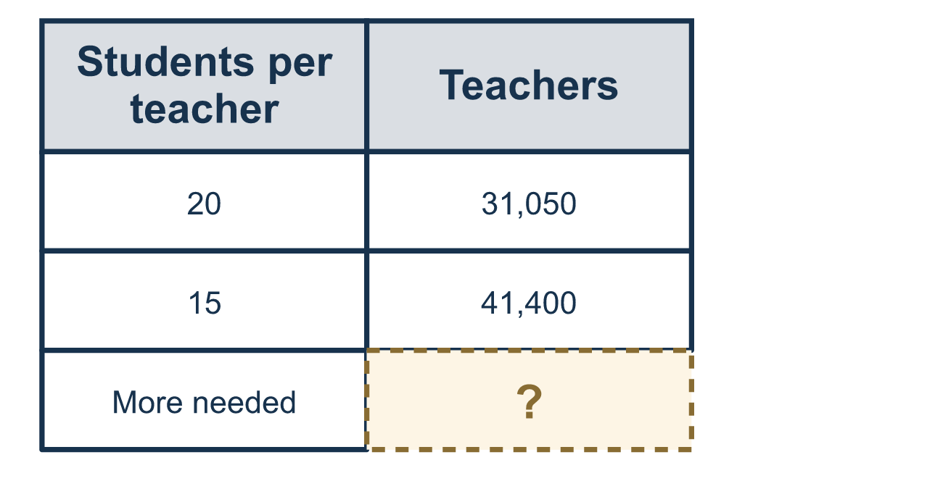
Our class model: two divisions, then subtract

Try it
Work it out on paper. Write one answer on each line.
- What is 400 ÷ 20?
A. 2 B. 20 C. 200 D. 80
My answer
- A district has 8,400 students and 1 teacher for every 20 students. The division 8,400 ÷ 20 = 420 shows what?
A. The number of teachers B. The number of students per teacher C. The number of students D. The number of teachers to hire
My answer
- What is 1,800 ÷ 15?
A. 12 B. 1,200 C. 120 D. 125
My answer
- A school has 600 students. The goal is 1 adult for every 20 students. How many adults does the school need?
A. 20 B. 3 C. 12,000 D. 30
My answer
- A school has 600 students. Now there is 1 adult for every 30 students. The goal is 1 adult for every 20 students. How many MORE adults are needed?
A. 10 B. 30 C. 20 D. 50
My answer

Talk about it
What does each quotient count, and why do you subtract at the end?

Home mission
Say the plan out loud: one teacher for every 20 students, then one for every 15. Which plan needs more teachers? How do you know before you divide?

If we get stuck, ask
- What does this quotient count — students, or adults?
- How many groups of that size fit into the total?
- Does the question ask for the new total, or for how many MORE?

Do it on a screen

Scan or type the link. Same lesson, with hints. eduwonderlab.com/lessons/2-6-part2/homework.html
How did it feel? (optional) ☐ Tricky ☐ Getting there ☐ Got it

Family Math Studio · For grown-ups Lesson 2.6 · Session 2 · 6.NOS.2

Answers and talk notes
Divide Multi-Digit Numbers Using an Algorithm

What your student is learning
Tonight we take the long-division steps from Part 1 and use them on a real staffing problem — how many teachers a district has to hire.

Answers
Ask your student to explain before you look.
- B. 20. 40 ÷ 2 = 20 with one zero left over, so 400 ÷ 20 = 20.
- A. The number of teachers. The total is split into groups of 20, so the quotient 420 is the number of teachers. So the answer is: The number of teachers.
- C. 120. 15 × 100 = 1,500 and 15 × 20 = 300, so 1,800 ÷ 15 = 100 + 20 = 120.
- D. 30. 600 ÷ 20 = 30 adults.
- A. 10. Now: 600 ÷ 30 = 20 adults. Goal: 600 ÷ 20 = 30 adults. 30 − 20 = 10 more.

Talk about it
What does each quotient count, and why do you subtract at the end?

When they are stuck, ask
- What does this quotient count — students, or adults?
- How many groups of that size fit into the total?
- Does the question ask for the new total, or for how many MORE?

Try not to say
- If it will not divide, just skip that digit.
- Smaller groups means you need fewer adults.
- Just do one division and that is the answer.

Home mission
Say the plan out loud: one teacher for every 20 students, then one for every 15. Which plan needs more teachers? How do you know before you divide?

