Family Math Studio Lesson 2.6 · 6.NOS.2

Divide Multi-Digit Numbers Using an Algorithm
Divide big whole numbers and say what the quotient and remainder mean.
Name Date

Tonight's spark
A rec center orders 1,344 granola bars. They pack 12 bars in each box. How many boxes will they fill? Make a guess first: more than 100 boxes, or fewer?
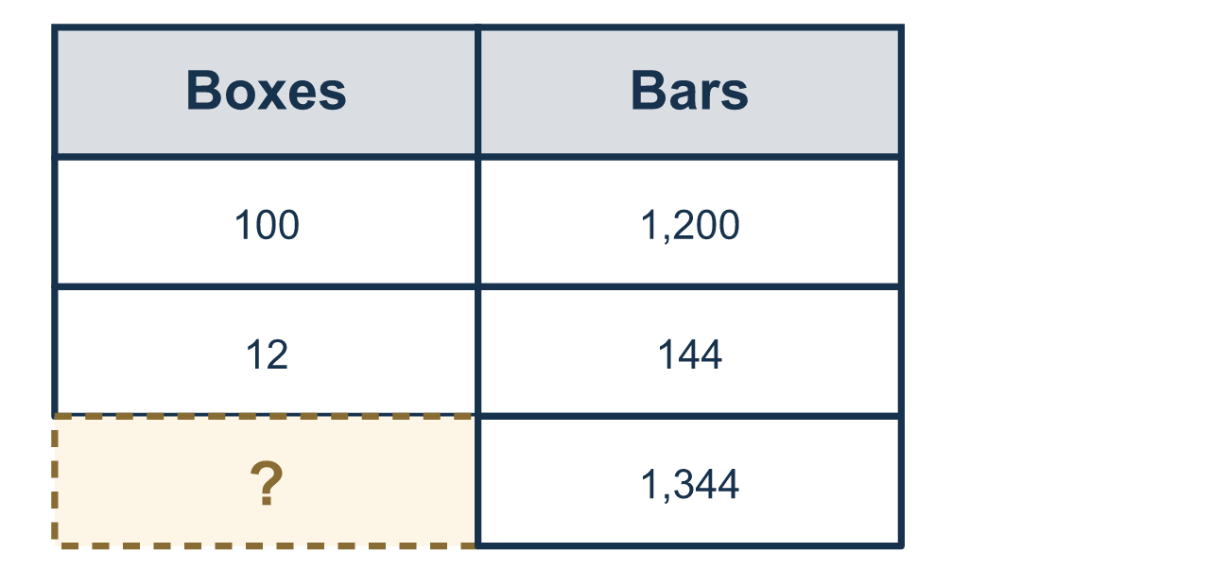
Our class model: taking away easy chunks

Try it
Work it out on paper. Write one answer on each line.
- What is 84 ÷ 4?
A. 21 B. 20 C. 22 D. 336
My answer
- In 156 ÷ 12, which number is the divisor?
A. 156 B. 12 C. 13 D. 168
My answer
- What is 432 ÷ 6?
A. 62 B. 702 C. 72 D. 7.2
My answer
- What is 756 ÷ 18?
A. 32 B. 48 C. 4.2 D. 42
My answer
- What is 2,450 ÷ 25?
A. 90 B. 98 C. 980 D. 9.8
My answer
- What is 100 ÷ 7, written with a remainder?
A. 14 B. 13 R 9 C. 14 R 2 D. 2 R 14
My answer

Talk about it
Which number is the dividend and which is the divisor? How can you check the quotient?

Home mission
Pretend you have 1,344 stickers to put in packs of 12. Can your student take out 12 × 100 first and say how many stickers are left?

If we get stuck, ask
- What is a big, easy chunk of the divisor we can take out first?
- How much is left now? Can we take out another chunk?
- Let's add up all our chunks. Then multiply back to check.

Do it on a screen

Scan or type the link. Same lesson, with hints. eduwonderlab.com/lessons/2-6/homework.html
How did it feel? (optional) ☐ Tricky ☐ Getting there ☐ Got it

Family Math Studio · For grown-ups Lesson 2.6 · 6.NOS.2

Answers and talk notes
Divide Multi-Digit Numbers Using an Algorithm

What your student is learning
Tonight we divide big numbers by taking away easy chunks, then adding up how many we took out.

Answers
Ask your student to explain before you look.
- A. 21. 4 × 20 = 80 and 4 × 1 = 4, so 84 ÷ 4 = 21.
- B. 12. The divisor is the number you divide by, so the divisor is 12.
- C. 72. 6 × 70 = 420 and 6 × 2 = 12, so 432 ÷ 6 = 72.
- D. 42. 18 × 40 = 720 and 18 × 2 = 36, so 756 ÷ 18 = 42.
- B. 98. 25 × 100 = 2,500 is 50 too much, and 50 is 2 groups of 25, so 100 − 2 = 98.
- C. 14 R 2. 7 × 14 = 98 and 100 − 98 = 2, so 100 ÷ 7 is 14 R 2.

Talk about it
Which number is the dividend and which is the divisor? How can you check the quotient?

When they are stuck, ask
- What is a big, easy chunk of the divisor we can take out first?
- How much is left now? Can we take out another chunk?
- Let's add up all our chunks. Then multiply back to check.

Try not to say
- Stop dividing as soon as you take out the first chunk.
- It does not matter if a number is left over.
- Just guess; you do not need to check by multiplying.

Home mission
Pretend you have 1,344 stickers to put in packs of 12. Can your student take out 12 × 100 first and say how many stickers are left?

