Family Math Studio Lesson 2.7 · Session 2 · 6.NOS.3

Divide Decimals Using an Algorithm
Divide by a decimal by sliding both decimal points the same number of places.
Name Date

Tonight's spark
A juice stand has 9.6 liters of juice. Each cup holds 0.4 liter. How many cups can it fill? Make a guess first: will the number of cups be bigger or smaller than 9.6?
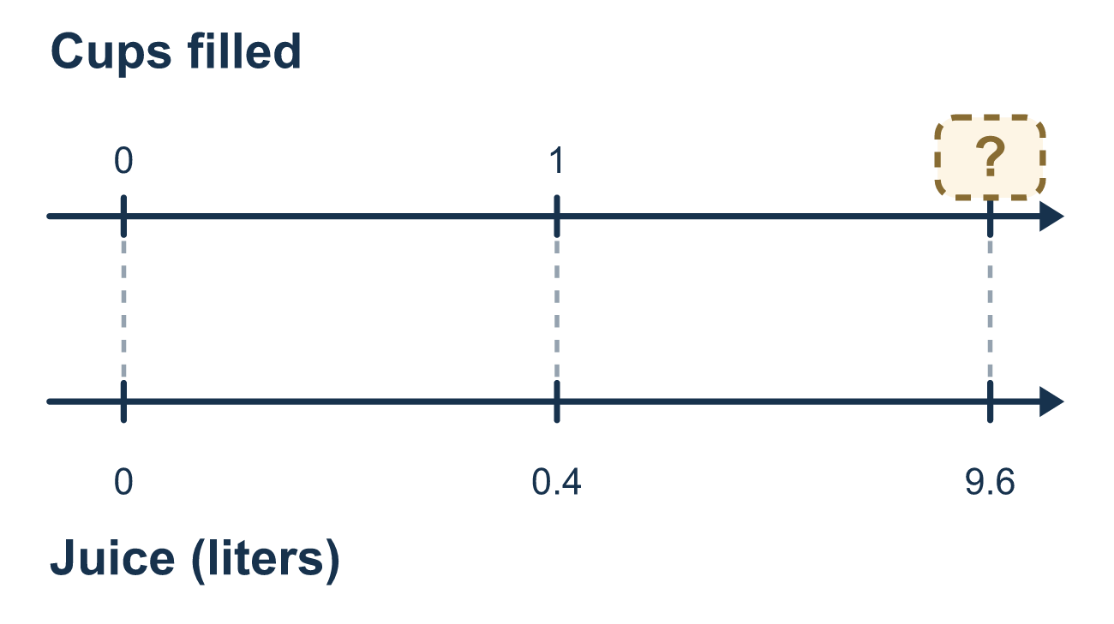
Our class model: dividing by a number less than 1

Try it
Work it out on paper. Write one answer on each line.
- Sliding a decimal point 1 place to the right multiplies a number by what?
A. 10 B. 100 C. 2 D. 0.1
My answer
- To make 0.25 a whole number, how far do you slide its decimal point?
A. 1 place to the right, to make 2.5 B. 2 places to the right, to make 25 C. 3 places to the right, to make 250 D. 2 places to the left, to make 0.0025
My answer
- Which problem has the same answer as 2.4 ÷ 0.6?
A. 2.4 ÷ 6 B. 24 ÷ 0.6 C. 24 ÷ 6 D. 0.24 ÷ 6
My answer
- What is 3.5 ÷ 0.5?
A. 70 B. 0.7 C. 3 D. 7
My answer
- What is 4.5 ÷ 0.15?
A. 3 B. 30 C. 300 D. 0.3
My answer
- How many 0.3-liter cups can be filled from 7.2 liters of water?
A. 2.4 B. 240 C. 24 D. 6.9
My answer

Talk about it
Why do both decimal points slide the same number of places?

Home mission
Pretend a jug holds 9.6 liters and each cup holds 0.4 liter. Before dividing, ask: will there be more cups or fewer cups than 9.6? Why?

If we get stuck, ask
- Which number is the divisor? Is it whole yet?
- How many places did you move the divisor? Did the dividend move the same?
- We are dividing by less than one — should the answer be bigger or smaller?

Do it on a screen

Scan or type the link. Same lesson, with hints. eduwonderlab.com/lessons/2-7-part2/homework.html
How did it feel? (optional) ☐ Tricky ☐ Getting there ☐ Got it

Family Math Studio · For grown-ups Lesson 2.7 · Session 2 · 6.NOS.3

Answers and talk notes
Divide Decimals Using an Algorithm

What your student is learning
Tonight we divide when the DIVISOR is a decimal — like 9.6 ÷ 0.4 — by first turning it into an easier problem with the same answer.

Answers
Ask your student to explain before you look.
- A. 10. Each place the point moves right makes the number 10 times as big, so 10.
- B. 2 places to the right, to make 25. Slide 2 places right: 0.25 becomes 25, a whole number. So the answer is: 2 places to the right, to make 25.
- C. 24 ÷ 6. Slide both points 1 place right: 2.4 ÷ 0.6 = 24 ÷ 6.
- D. 7. 3.5 ÷ 0.5 = 35 ÷ 5 = 7.
- B. 30. Slide both points 2 places right: 4.5 ÷ 0.15 = 450 ÷ 15 = 30.
- C. 24. 7.2 ÷ 0.3 = 72 ÷ 3 = 24 cups.

Talk about it
Why do both decimal points slide the same number of places?

When they are stuck, ask
- Which number is the divisor? Is it whole yet?
- How many places did you move the divisor? Did the dividend move the same?
- We are dividing by less than one — should the answer be bigger or smaller?

Try not to say
- Move the decimal in the divisor and leave the other number alone.
- Dividing always makes the answer smaller.
- Just move one place, that is usually enough.

Home mission
Pretend a jug holds 9.6 liters and each cup holds 0.4 liter. Before dividing, ask: will there be more cups or fewer cups than 9.6? Why?

