Family Math Studio Lesson 2.7 · 6.NOS.3

Divide Decimals Using an Algorithm
Divide with decimals by making the divisor a whole number first.
Name Date

Tonight's spark
A coach has 18.9 liters of sports drink. Each cooler holds 6.3 liters. How many coolers can she fill? Make a guess first: more than 5 coolers, or fewer?
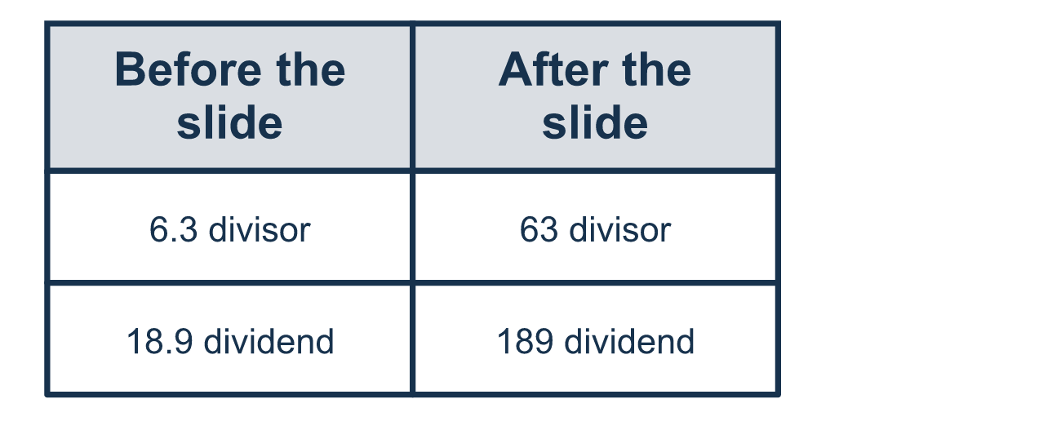
Our class model: slide both points the same way

Try it
Work it out on paper. Write one answer on each line.
- What is 8.4 ÷ 2?
A. 4.2 B. 42 C. 0.42 D. 6.4
My answer
- To make the divisor in 5.2 ÷ 0.4 a whole number, what should you do?
A. Move only the divisor's point 1 place to the right B. Move both decimal points 1 place to the right C. Move both decimal points 1 place to the left D. Move both decimal points 2 places to the right
My answer
- Which problem has the same answer as 4.5 ÷ 0.9?
A. 4.5 ÷ 9 B. 45 ÷ 0.9 C. 45 ÷ 9 D. 0.45 ÷ 9
My answer
- What is 6.4 ÷ 1.6?
A. 40 B. 0.4 C. 10 D. 4
My answer
- What is 12.6 ÷ 0.6?
A. 2.1 B. 21 C. 210 D. 20
My answer
- A rope is 7.2 meters long. It is cut into pieces that are each 0.9 meters long. How many pieces are there?
A. 8 B. 80 C. 0.8 D. 6.3
My answer

Talk about it
Did both numbers get the same change? What happens to the answer if only one changes?

Home mission
Ask: how many 6.3s fit in 18.9? Slide both points one place right. Can your student say how many 63s fit in 189?

If we get stuck, ask
- How many places do we move the point to make the divisor a whole number?
- Did we move the point the same way in both numbers?
- Let's multiply our answer by the divisor. Do we get the original number?

Do it on a screen

Scan or type the link. Same lesson, with hints. eduwonderlab.com/lessons/2-7/homework.html
How did it feel? (optional) ☐ Tricky ☐ Getting there ☐ Got it

Family Math Studio · For grown-ups Lesson 2.7 · 6.NOS.3

Answers and talk notes
Divide Decimals Using an Algorithm

What your student is learning
Tonight we divide with decimals. The trick is to make the number we divide by a whole number first.

Answers
Ask your student to explain before you look.
- A. 4.2. 8 ÷ 2 = 4 and 0.4 ÷ 2 = 0.2, so 8.4 ÷ 2 = 4.2.
- B. Move both decimal points 1 place to the right. Move both points 1 place to the right: 0.4 becomes 4 and 5.2 becomes 52. So the answer is: Move both decimal points 1 place to the right.
- C. 45 ÷ 9. Multiply both numbers by 10: 4.5 ÷ 0.9 = 45 ÷ 9.
- D. 4. 6.4 ÷ 1.6 = 64 ÷ 16 = 4. Check: 1.6 × 4 = 6.4.
- B. 21. 12.6 ÷ 0.6 = 126 ÷ 6 = 21.
- A. 8. 7.2 ÷ 0.9 = 72 ÷ 9 = 8 pieces.

Talk about it
Did both numbers get the same change? What happens to the answer if only one changes?

When they are stuck, ask
- How many places do we move the point to make the divisor a whole number?
- Did we move the point the same way in both numbers?
- Let's multiply our answer by the divisor. Do we get the original number?

Try not to say
- Just move the point in the divisor and leave the other number alone.
- Dividing by a decimal smaller than 1 always makes the answer smaller.
- Where the point lands in the answer does not matter.

Home mission
Ask: how many 6.3s fit in 18.9? Slide both points one place right. Can your student say how many 63s fit in 189?

