Family Math Studio Lesson 2.8 · Session 2 · 6.DS.4

Describe Data Using the Mean
Find a missing value when you know the mean you want.
Name Date

Tonight's spark
A player scored 12, 18, 14 and 16 points in four games. She wants a mean of 16 after five games. How many points must she score in game five? Guess first: will she need more than 16 points, or fewer?
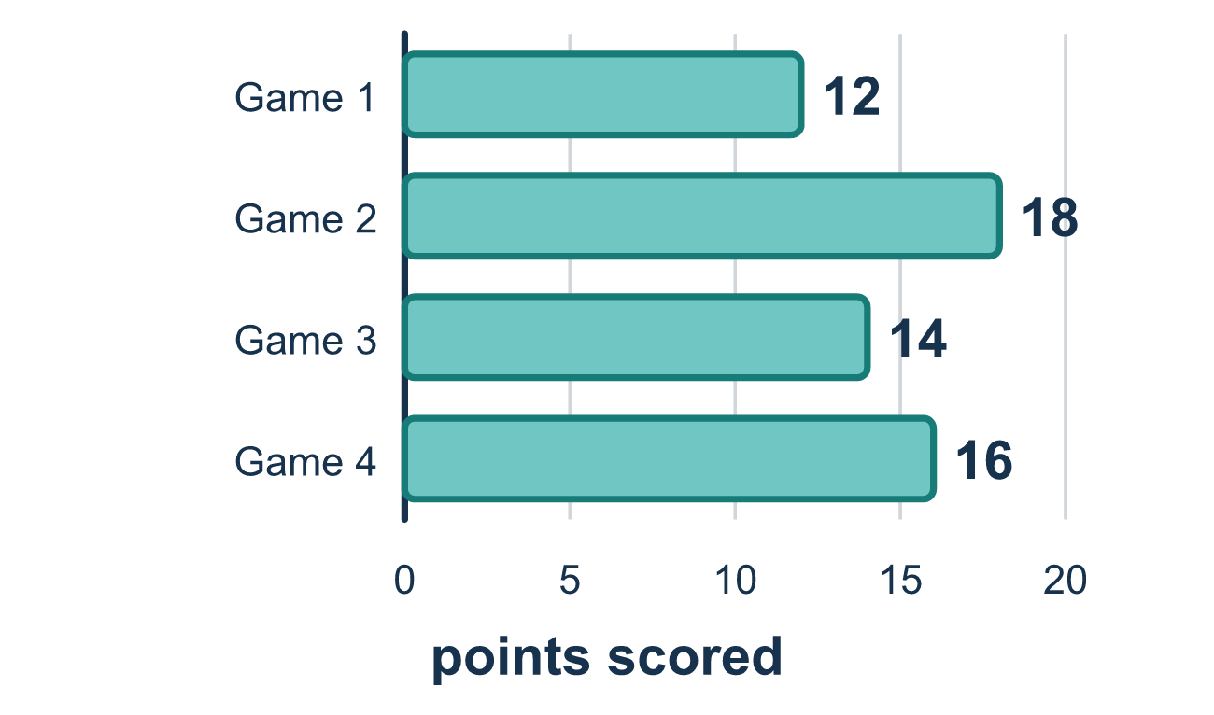
Our class model: the target total

Try it
Work it out on paper. Write one answer on each line.
- You want a mean of 10 over 3 games. What total do you need in all?
A. 30 B. 13 C. 3.3 D. 7
My answer
- The target total is 60 and you already have 45. How much more do you need?
A. 105 B. 15 C. 60 D. 45
My answer
- A student scored 4, 7, 5 and wants a mean of 6 over four quizzes. What does the fourth score need to be?
A. 6 B. 16 C. 8 D. 24
My answer
- A player scored 12, 18, 14, and 16 points. She wants a mean of 16 over five games. How many points must she score in game 5?
A. 16 B. 60 C. 80 D. 20
My answer
- Five numbers need a mean of 12. Four of them are 10, 14, 9, and 13. What is the fifth number?
A. 12 B. 14 C. 46 D. 60
My answer

Talk about it
How does a target mean become a target total?

Home mission
Pretend your family wants a mean of 6 glasses of water a day for 4 days. Days 1 to 3 were 5, 7 and 4. Ask your student how many glasses day 4 needs.

If we get stuck, ask
- If the mean is a fair share, what would the total have to be?
- How many values will there be when we are done — including the new one?
- Put your answer back in. Does the mean come out right?

Do it on a screen

Scan or type the link. Same lesson, with hints. eduwonderlab.com/lessons/2-8-part2/homework.html
How did it feel? (optional) ☐ Tricky ☐ Getting there ☐ Got it

Family Math Studio · For grown-ups Lesson 2.8 · Session 2 · 6.DS.4

Answers and talk notes
Describe Data Using the Mean

What your student is learning
Tonight we work the mean backwards: we know the average we WANT, and we find the score still needed to get there.

Answers
Ask your student to explain before you look.
- A. 30. Target total = mean × count = 10 × 3 = 30.
- B. 15. 60 − 45 = 15 more.
- C. 8. Target total = 6 × 4 = 24. So far 4 + 7 + 5 = 16. 24 − 16 = 8.
- D. 20. Target total = 16 × 5 = 80. So far 12 + 18 + 14 + 16 = 60. 80 − 60 = 20.
- B. 14. Target total = 12 × 5 = 60. 10 + 14 + 9 + 13 = 46. 60 − 46 = 14.

Talk about it
How does a target mean become a target total?

When they are stuck, ask
- If the mean is a fair share, what would the total have to be?
- How many values will there be when we are done — including the new one?
- Put your answer back in. Does the mean come out right?

Try not to say
- Just take the average of the scores he already has.
- Multiply by the number of tests he has taken so far.
- The missing score has to be close to the target, so guess.

Home mission
Pretend your family wants a mean of 6 glasses of water a day for 4 days. Days 1 to 3 were 5, 7 and 4. Ask your student how many glasses day 4 needs.

