Family Math Studio Lesson 2.8 · 6.DS.4

Describe Data Using the Mean
Find the mean of a data set. Explain it as a fair share and a balance point.
Name Date

Tonight's spark
Four kids in a reading club read 8, 12, 10 and 14 books. The club wants one number for a typical reader. What number should it post? Guess first: will the number be above 14, below 8, or in between?
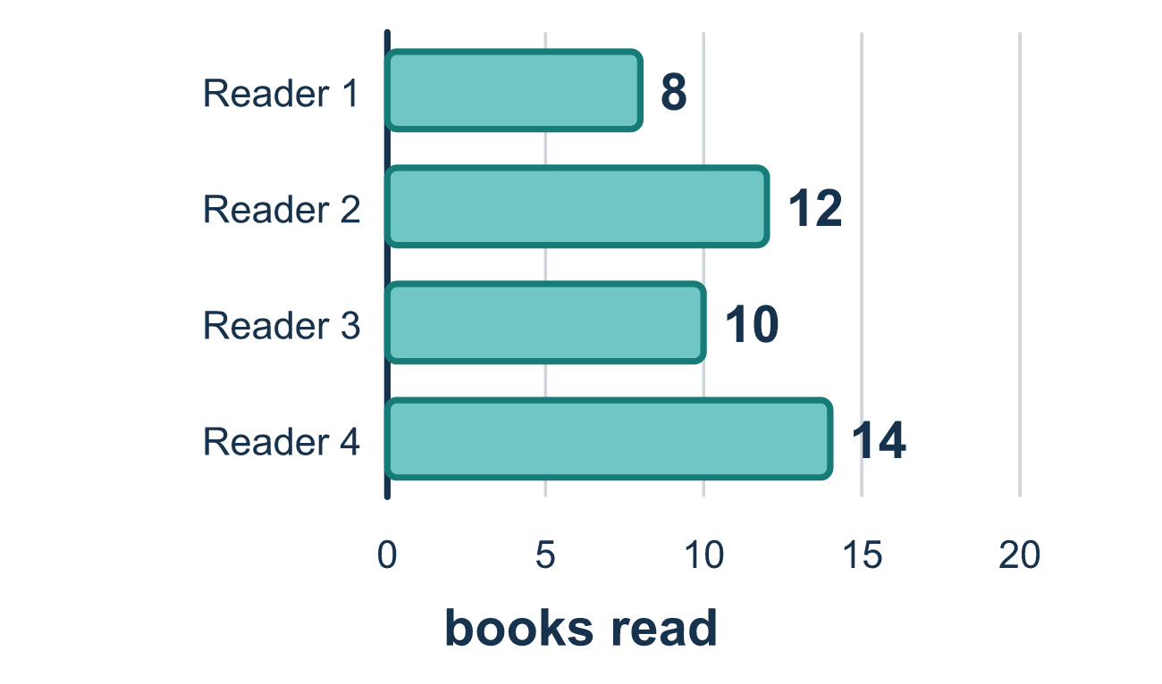
Our class model: the fair share

Try it
Work it out on paper. Write one answer on each line.
- What is the mean of 4, 6, and 8?
A. 6 B. 18 C. 8 D. 3
My answer
- How do you find the mean of a data set?
A. Put the values in order and pick the middle one B. Add all the values, then divide by how many values there are C. Pick the value that appears most D. Subtract the least from the greatest
My answer
- What is the mean of 2, 2, 5, and 7?
A. 3.5 B. 2 C. 4 D. 16
My answer
- Four friends have 3, 5, 6, and 10 cards. If they share all the cards equally, how many does each get?
A. 24 B. 6 C. 5.5 D. 3
My answer
- The mean of 3, 7, and 11 is 7. Which statement describes the mean as a balance point?
A. The amount above 7 and the amount below 7 balance out B. Half of the values are equal to 7 C. 7 appears the most D. 7 is the sum of the values
My answer

Talk about it
Does 44 describe one typical reader, or all four readers together?

Home mission
Make four small piles of crackers or coins: 2, 5, 3 and 6. Ask your student to guess the fair share. Then slide pieces until all four piles match.

If we get stuck, ask
- What is the total of all the values?
- How many values are there?
- If everyone got the same amount, how much would that be?

Do it on a screen

Scan or type the link. Same lesson, with hints. eduwonderlab.com/lessons/2-8/homework.html
How did it feel? (optional) ☐ Tricky ☐ Getting there ☐ Got it

Family Math Studio · For grown-ups Lesson 2.8 · 6.DS.4

Answers and talk notes
Describe Data Using the Mean

What your student is learning
Tonight we find the mean of a data set, and we explain the mean two ways: as the fair share and as the balance point of the data.

Answers
Ask your student to explain before you look.
- A. 6. 4 + 6 + 8 = 18 and 18 ÷ 3 = 6.
- B. Add all the values, then divide by how many values there are. To find the mean, add all the values, then divide by how many values there are. So the answer is: Add all the values, then divide by how many values there are.
- C. 4. 2 + 2 + 5 + 7 = 16 and 16 ÷ 4 = 4.
- B. 6. 3 + 5 + 6 + 10 = 24 cards, and 24 ÷ 4 = 6 each. The fair share is the mean.
- A. The amount above 7 and the amount below 7 balance out. 3 is 4 below 7 and 11 is 4 above 7, so the amount above and below balance out. So the answer is: The amount above 7 and the amount below 7 balance out.

Talk about it
Does 44 describe one typical reader, or all four readers together?

When they are stuck, ask
- What is the total of all the values?
- How many values are there?
- If everyone got the same amount, how much would that be?

Try not to say
- The mean is the middle number.
- Divide by the biggest value.
- You do not need to add them all first.

Home mission
Make four small piles of crackers or coins: 2, 5, 3 and 6. Ask your student to guess the fair share. Then slide pieces until all four piles match.

