Family Math Studio Lesson 2.9 · Session 2 · 6.DS.6c

Describe Data by Mean Absolute Deviation
Use the MAD to compare two data sets that have the same mean.
Name Date

Tonight's spark
Two cities both have an average high of 52 degrees. City A highs: 46, 50, 54, 58. City B highs: 36, 48, 56, 68. You pack one jacket. Which city is easier to pack for? Guess first: which city has highs that stay closer to 52?
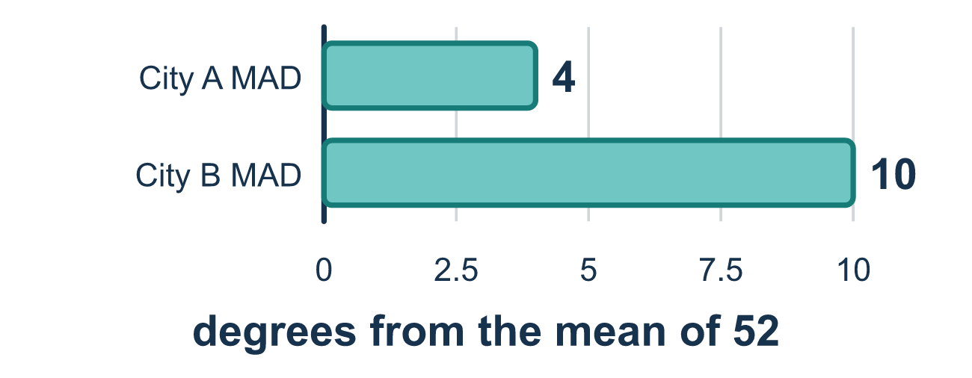
Our class model: comparing with the MAD

Try it
Work it out on paper. Write one answer on each line.
- A large MAD means the values are...
A. Scattered far from the mean B. Close to the mean C. All equal D. Greater than the mean
My answer
- Set A is 9, 10, 11. Set B is 1, 10, 19. Both have mean 10. Which statement is true?
A. The sets are the same because the means match B. Set B is more spread out than Set A, even with the same mean C. Set A is more spread out than Set B D. Neither set has any spread
My answer
- Set M is 7, 9, 11, 13 with mean 10. What is its MAD?
A. 8 B. 10 C. 2 D. 3
My answer
- Set N is 4, 8, 12, 16 with mean 10. What is its MAD?
A. 4 B. 16 C. 2 D. 12
My answer
- Set M has MAD 2 and Set N has MAD 4, and both have mean 10. Which statement is true?
A. Set M varies more because its MAD is smaller B. Set N varies more because its MAD is larger C. They vary equally because the means are equal D. The sets cannot be compared
My answer

Talk about it
The means match. How does the MAD show the difference?

Home mission
Two bus routes both average 20 minutes. Route 1 takes 19, 20, 20, 21. Route 2 takes 10, 15, 25, 30. Ask your student which route they want on a school morning, and why.

If we get stuck, ask
- How far is this value from the mean? Distances cannot be negative. A value equal to the mean has distance 0.
- Did you average the distances, or the original values?
- Same mean — does that mean the two sets look the same?

Do it on a screen

Scan or type the link. Same lesson, with hints. eduwonderlab.com/lessons/2-9-part2/homework.html
How did it feel? (optional) ☐ Tricky ☐ Getting there ☐ Got it

Family Math Studio · For grown-ups Lesson 2.9 · Session 2 · 6.DS.6c

Answers and talk notes
Describe Data by Mean Absolute Deviation

What your student is learning
Tonight we use MAD — mean absolute deviation — to compare two groups that have the SAME average but do not behave the same at all.

Answers
Ask your student to explain before you look.
- A. Scattered far from the mean. A large MAD means the values are scattered far from the mean. So the answer is: Scattered far from the mean.
- B. Set B is more spread out than Set A, even with the same mean. Set B's values are 9 away from 10, while Set A's are 1 away, so Set B is more spread out than Set A, even with the same mean.
- C. 2. The distances are 3, 1, 1, 3. Their sum is 8 and 8 ÷ 4 = 2.
- A. 4. The distances are 6, 2, 2, 6. Their sum is 16 and 16 ÷ 4 = 4.
- B. Set N varies more because its MAD is larger. A larger MAD means more variation, so Set N varies more because its MAD is larger.

Talk about it
The means match. How does the MAD show the difference?

When they are stuck, ask
- How far is this value from the mean? Distances cannot be negative. A value equal to the mean has distance 0.
- Did you average the distances, or the original values?
- Same mean — does that mean the two sets look the same?

Try not to say
- Add the deviations with their minus signs, they will work out.
- If the means match, the data sets match.
- A MAD of 0 just means you did it fast.

Home mission
Two bus routes both average 20 minutes. Route 1 takes 19, 20, 20, 21. Route 2 takes 10, 15, 25, 30. Ask your student which route they want on a school morning, and why.

