Family Math Studio Lesson 2.9 · 6.DS.6c

Describe Data by Mean Absolute Deviation
Find the mean absolute deviation to show how spread out data is.
Name Date

Tonight's spark
A corner store delivers groceries. Four deliveries took 6, 8, 10 and 12 minutes. The mean is 9 minutes. About how far is a typical delivery from 9? Guess first: is a typical gap more than 4 minutes, or less?
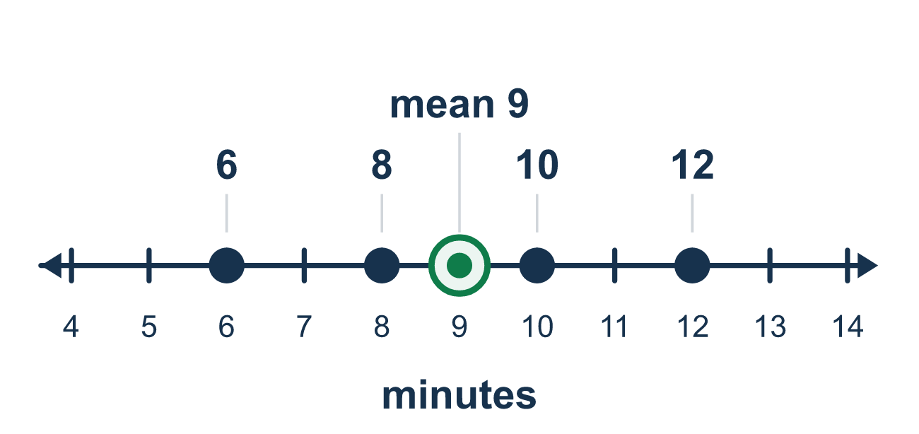
Our class model: MAD, the average gap

Try it
Work it out on paper. Write one answer on each line.
- What does the mean absolute deviation (MAD) tell you about a data set?
A. How far the values are from the mean, on average B. The middle value C. The value that appears most D. The greatest value minus the least
My answer
- The mean of a data set is 10. How far is the value 14 from the mean?
A. 24 B. 4 C. 10 D. 14
My answer
- The absolute deviations of a data set are 4, 0, 2, 2. What is the MAD?
A. 8 B. 4 C. 2 D. 0
My answer
- The data are 6, 12, and 18, and the mean is 12. What is the MAD?
A. 4 B. 12 C. 6 D. 0
My answer
- The data are 2, 2, 6, 10, and the mean is 5. What is the MAD?
A. 12 B. 3 C. 5 D. 8
My answer
- Which data set has the smaller MAD?
A. 5, 20, 35 B. They have the same MAD C. You cannot compare MADs D. 20, 21, 22
My answer

Talk about it
Can a distance from the mean be negative?

Home mission
Pick four whole-dollar prices on a receipt. Find their mean together. Then say how far each price is from the mean. Is the MAD small or big?

If we get stuck, ask
- What is the mean first? We need it before anything else.
- How far is each number from the mean? Count the distance.
- Is this MAD small or large? What does that say about the data?

Do it on a screen
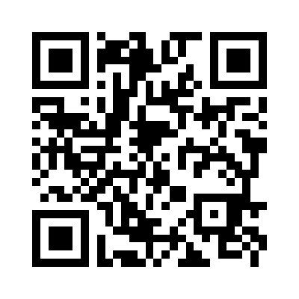
Scan or type the link. Same lesson, with hints. eduwonderlab.com/lessons/2-9/homework.html
How did it feel? (optional) ☐ Tricky ☐ Getting there ☐ Got it

Family Math Studio · For grown-ups Lesson 2.9 · 6.DS.6c

Answers and talk notes
Describe Data by Mean Absolute Deviation

What your student is learning
Tonight we find the mean absolute deviation (MAD): the average distance of each number from the mean. It tells us how spread out the data is.

Answers
Ask your student to explain before you look.
- A. How far the values are from the mean, on average. MAD tells how far the values are from the mean, on average. So the answer is: How far the values are from the mean, on average.
- B. 4. The distance is 14 − 10 = 4.
- C. 2. 4 + 0 + 2 + 2 = 8 and 8 ÷ 4 = 2.
- A. 4. The distances are 6, 0, 6. Their sum is 12 and 12 ÷ 3 = 4.
- B. 3. The distances are 3, 3, 1, 5. Their sum is 12 and 12 ÷ 4 = 3.
- D. 20, 21, 22. The values 20, 21, 22 sit close to their mean, so they have the smaller MAD.

Talk about it
Can a distance from the mean be negative?

When they are stuck, ask
- What is the mean first? We need it before anything else.
- How far is each number from the mean? Count the distance.
- Is this MAD small or large? What does that say about the data?

Try not to say
- Keep the minus signs when you average the deviations.
- A bigger mean means a bigger MAD.
- You can skip finding the mean and just guess the spread.

Home mission
Pick four whole-dollar prices on a receipt. Find their mean together. Then say how far each price is from the mean. Is the MAD small or big?

