Family Math Studio Lesson 3.1 · Session 2 · 6.AT.1

Understand Ratios
Make an equivalent ratio by multiplying both amounts by the same number.
Name Date

Tonight's spark
Tahira's dressing uses 1 spoon of vinegar for every 3 spoons of olive oil. She wants 4 spoons of vinegar for a block party. A friend says: add 3 to the oil too, so use 6. Will that taste right? Make a guess first: does she need more than 6 spoons of oil, or fewer?
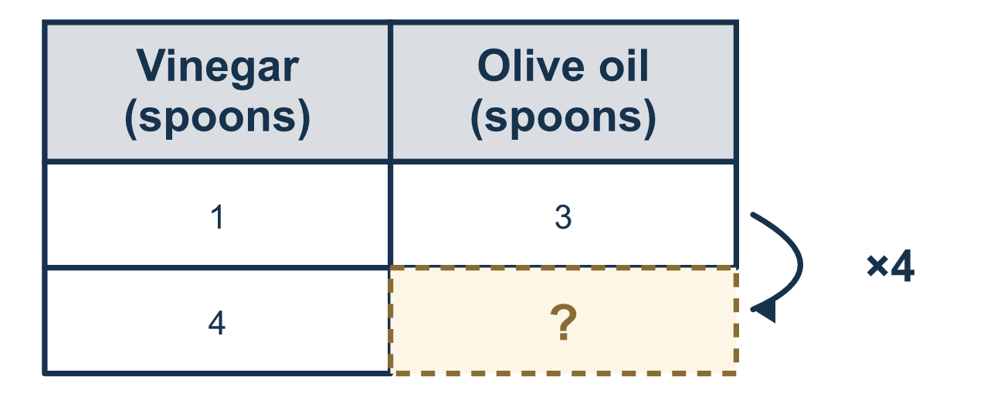
Our class model: the scale factor

Try it
Work it out on paper. Write one answer on each line.
- Multiply both numbers in the ratio 2:3 by 4. What is the new ratio?
A. 6:7 B. 8:12 C. 8:3 D. 2:12
My answer
- What is the scale factor from 3:5 to 12:20?
A. 9 B. 15 C. 4
My answer
- Which ratio is equivalent to 1:3?
A. 4:12 B. 2:4 C. 3:1 D. 1:6
My answer
- A mix uses 2 cups of flour for every 5 cups of milk. How much milk goes with 6 cups of flour?
A. 9 B. 30 C. 10 D. 15
My answer
- To go from 6:9 down to 2:3, divide both numbers by what?
A. 2 B. 3 C. 4 D. 6
My answer
- Are 5:8 and 15:24 equivalent?
A. No, the numbers are all different B. Yes, 5 × 3 = 15 and 8 × 3 = 24 C. No, 15 is bigger than 8 D. Yes, because both are bigger numbers
My answer

Talk about it
What number did you multiply by, and did you do the same thing to both parts?

Home mission
Use dry beans as spoons. Put 1 bean for vinegar and 3 beans for oil. Ask your student to make the dressing with 4 beans of vinegar. How many oil beans? Then ask: what did you do to both piles?

If we get stuck, ask
- What number was the first quantity multiplied by?
- Now do exactly that to the other quantity.
- Can you divide both new numbers back down to the ratio you started with?

Do it on a screen

Scan or type the link. Same lesson, with hints. eduwonderlab.com/lessons/3-1-part2/homework.html
How did it feel? (optional) ☐ Tricky ☐ Getting there ☐ Got it

Family Math Studio · For grown-ups Lesson 3.1 · Session 2 · 6.AT.1

Answers and talk notes
Understand Ratios

What your student is learning
Tonight we make a ratio bigger without changing what it compares. Multiply BOTH quantities by the same number — the scale factor — and you get an equivalent ratio.

Answers
Ask your student to explain before you look.
- B. 8:12. 2 × 4 = 8 and 3 × 4 = 12, so the new ratio is 8:12.
- C. 4. 3 × 4 = 12 and 5 × 4 = 20, so the scale factor is 4.
- A. 4:12. 1 × 4 = 4 and 3 × 4 = 12, so 4:12 is equivalent to 1:3.
- D. 15. The flour went from 2 to 6, so the scale factor is 3. Milk: 5 × 3 = 15 cups.
- B. 3. 6 ÷ 3 = 2 and 9 ÷ 3 = 3, so divide both by 3.
- B. Yes, 5 × 3 = 15 and 8 × 3 = 24. Yes, 5 × 3 = 15 and 8 × 3 = 24, so both numbers use the scale factor 3.

Talk about it
What number did you multiply by, and did you do the same thing to both parts?

When they are stuck, ask
- What number was the first quantity multiplied by?
- Now do exactly that to the other quantity.
- Can you divide both new numbers back down to the ratio you started with?

Try not to say
- Just add the same amount to both numbers.
- Close enough — a little extra of one will not matter.
- Only the first number has to change.

Home mission
Use dry beans as spoons. Put 1 bean for vinegar and 3 beans for oil. Ask your student to make the dressing with 4 beans of vinegar. How many oil beans? Then ask: what did you do to both piles?

