Family Math Studio Lesson 3.1 · 6.AT.1

Understand Ratios
Write a ratio that compares two amounts, and keep them in the right order.
Name Date

Tonight's spark
The rec center's punch sign says apple juice to sparkling water is 3:2. A helper reads it backward and pours 3 cups of water for 2 of juice. Does the punch taste the same? Make a guess first: will the new punch have more apple juice, or less?
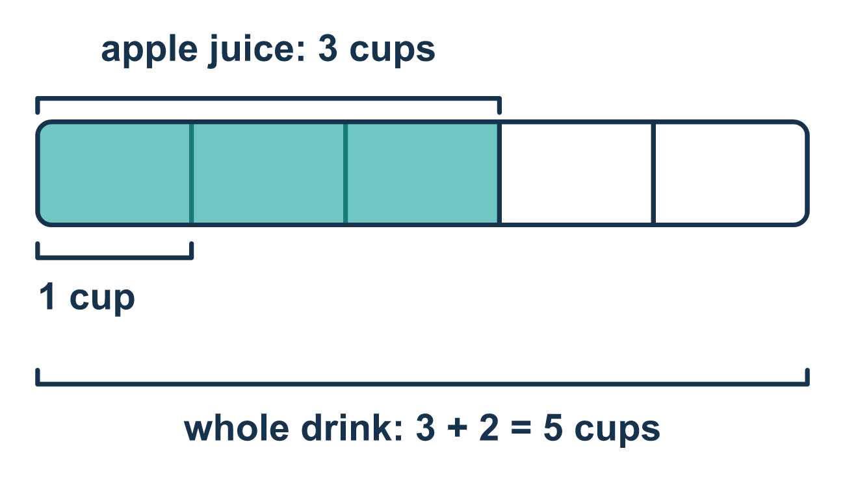
Our class model: the tape diagram of one batch

Try it
Work it out on paper. Write one answer on each line.
- A bowl has 4 red grapes and 3 green grapes. What is the ratio of red grapes to green grapes?
A. 3:4 B. 4:3 C. 4:7 D. 7:3
My answer
- Which is another way to write the ratio 5 to 2?
A. 5:2 B. 2:5 C. 52 D. 7
My answer
- A team has 6 girls and 4 boys. What is the ratio of girls to ALL the players?
A. 6:4 B. 4:10 C. 10:6 D. 6:10
My answer
- The ratio of cats to dogs is 2:5. Which sentence is correct?
A. For every 5 cats there are 2 dogs B. There are 7 cats in all C. For every 2 cats there are 5 dogs D. The ratio of dogs to cats is 2:5
My answer
- A tape diagram shows juice with 3 equal parts and water with 2 equal parts. What is the ratio of juice to the whole drink?
A. 3:2 B. 2:5 C. 3:5 D. 5:3
My answer

Talk about it
Which kind did you name first, and how does the order change what the ratio says?

Home mission
Mix a tiny punch at the table: 3 spoons of juice for every 2 spoons of water. Ask your student: what is the ratio of juice to water? Juice to the whole drink? Now switch the order. What would 2:3 taste like?

If we get stuck, ask
- Which amount is named first? Let's write that number first.
- Are we comparing one group to another group, or one group to the total?
- Read it out loud. What two things are being compared?

Do it on a screen

Scan or type the link. Same lesson, with hints. eduwonderlab.com/lessons/3-1/homework.html
How did it feel? (optional) ☐ Tricky ☐ Getting there ☐ Got it

Family Math Studio · For grown-ups Lesson 3.1 · 6.AT.1

Answers and talk notes
Understand Ratios

What your student is learning
Tonight we learn to write a ratio. A ratio is a way to compare two amounts, like 3 cups of apple juice to 2 cups of sparkling water.

Answers
Ask your student to explain before you look.
- B. 4:3. The ratio of red to green is 4:3. Red is named first, so 4 is written first.
- A. 5:2. 5 to 2 can be written 5:2 with a colon. The order stays the same.
- D. 6:10. There are 6 + 4 = 10 players in all, so girls to all players is 6:10.
- C. For every 2 cats there are 5 dogs. For every 2 cats there are 5 dogs. Cats are named first, so 2 goes with cats.
- C. 3:5. There are 3 + 2 = 5 parts in all, so juice to the whole drink is 3:5.

Talk about it
Which kind did you name first, and how does the order change what the ratio says?

When they are stuck, ask
- Which amount is named first? Let's write that number first.
- Are we comparing one group to another group, or one group to the total?
- Read it out loud. What two things are being compared?

Try not to say
- The order does not matter, just write the two numbers.
- Just one number, like "12 cookies," is a ratio.
- Add the two numbers together to get the ratio.

Home mission
Mix a tiny punch at the table: 3 spoons of juice for every 2 spoons of water. Ask your student: what is the ratio of juice to water? Juice to the whole drink? Now switch the order. What would 2:3 taste like?

