Family Math Studio Lesson 3.10 · Session 2 · 6.AT.3c

Convert Measurement Units
Choose whether to multiply or divide when you change customary units.
Name Date

Tonight's spark
A flour sack says 96 ounces. The bakery orders by the pound, and 1 pound = 16 ounces. How many pounds of flour are in the sack? Make a guess first: will the answer be more than 96, or less?
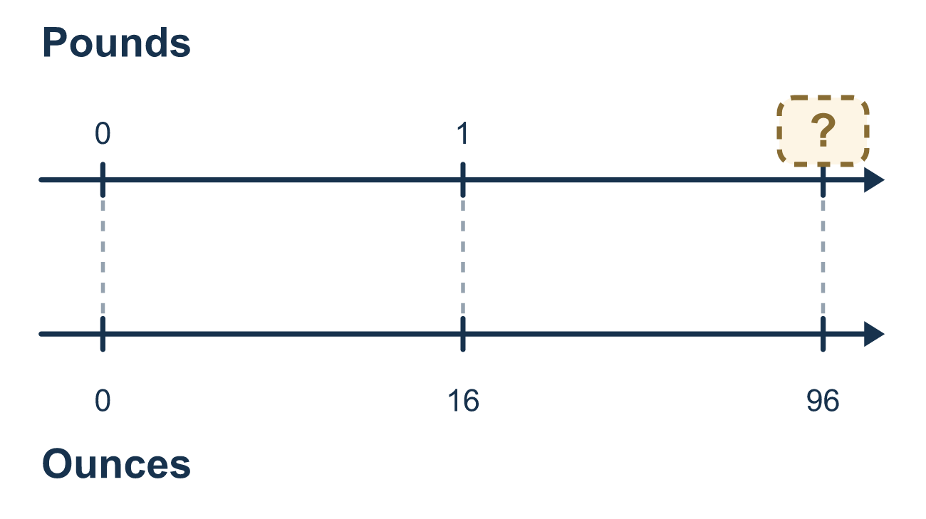
Our class model: bigger unit, fewer; smaller unit, more

Try it
Work it out on paper. Write one answer on each line.
- You change 18 feet to yards, and 1 yard = 3 feet. Which is correct?
A. Multiply, because yards are smaller B. Divide, because yards are bigger C. Multiply, because yards are bigger D. Divide, because yards are smaller
My answer
- Change 18 feet to yards.
A. 54 B. 15 C. 6 D. 21
My answer
- Change 8 yards to feet.
A. 2⅔ B. 5 C. 11 D. 24
My answer
- Change 64 ounces to pounds. (1 pound = 16 ounces)
A. 4 B. 48 C. 80 D. 1,024
My answer
- Change 3 pounds to ounces. (1 pound = 16 ounces)
A. 0.19 B. 19 C. 48 D. 13
My answer
- Convert 10,560 feet to miles. (1 mile = 5,280 feet)
A. 15,840 B. 2 C. 5,280 D. 1
My answer

Talk about it
Are you changing to a smaller or a bigger unit, and will your answer be more or less than the starting number?

Home mission
Find a bag of flour, rice, or sugar with ounces on the label. Ask your student: how many ounces are in 3 pounds? If a bag says 64 ounces, how many pounds is that? Say "bigger or smaller?" before you calculate.

If we get stuck, ask
- Which unit is bigger — the one you have or the one you want?
- Will the number get bigger or smaller? Decide before you calculate.
- Can you multiply back to check?

Do it on a screen

Scan or type the link. Same lesson, with hints. eduwonderlab.com/lessons/3-10-part2/homework.html
How did it feel? (optional) ☐ Tricky ☐ Getting there ☐ Got it

Family Math Studio · For grown-ups Lesson 3.10 · Session 2 · 6.AT.3c

Answers and talk notes
Convert Measurement Units

What your student is learning
Tonight we convert customary units — feet to yards, ounces to pounds — and the whole skill is picking multiply or divide correctly.

Answers
Ask your student to explain before you look.
- B. Divide, because yards are bigger. Divide, because yards are bigger, so there are fewer yards than feet.
- C. 6. 18 ÷ 3 = 6, so 18 feet = 6 yards.
- D. 24. 8 × 3 = 24, so 8 yards = 24 feet.
- A. 4. 64 ÷ 16 = 4, so 64 ounces = 4 pounds.
- C. 48. 3 × 16 = 48, so 3 pounds = 48 ounces.
- B. 2. 10,560 ÷ 5,280 = 2, so 10,560 feet = 2 miles.

Talk about it
Are you changing to a smaller or a bigger unit, and will your answer be more or less than the starting number?

When they are stuck, ask
- Which unit is bigger — the one you have or the one you want?
- Will the number get bigger or smaller? Decide before you calculate.
- Can you multiply back to check?

Try not to say
- Conversions always multiply.
- Divide when the number looks too big, multiply when it looks too small.
- You do not need the conversion fact, just estimate.

Home mission
Find a bag of flour, rice, or sugar with ounces on the label. Ask your student: how many ounces are in 3 pounds? If a bag says 64 ounces, how many pounds is that? Say "bigger or smaller?" before you calculate.

