Family Math Studio Lesson 3.10 · 6.AT.3c

Convert Measurement Units
Change one unit of measure into another by using a conversion factor.
Name Date

Tonight's spark
A delivery driver says the cabinet is 5 feet tall. The order form asks for the height in inches. What number goes on the form? Make a guess first: will the number on the form be bigger than 5, or smaller?
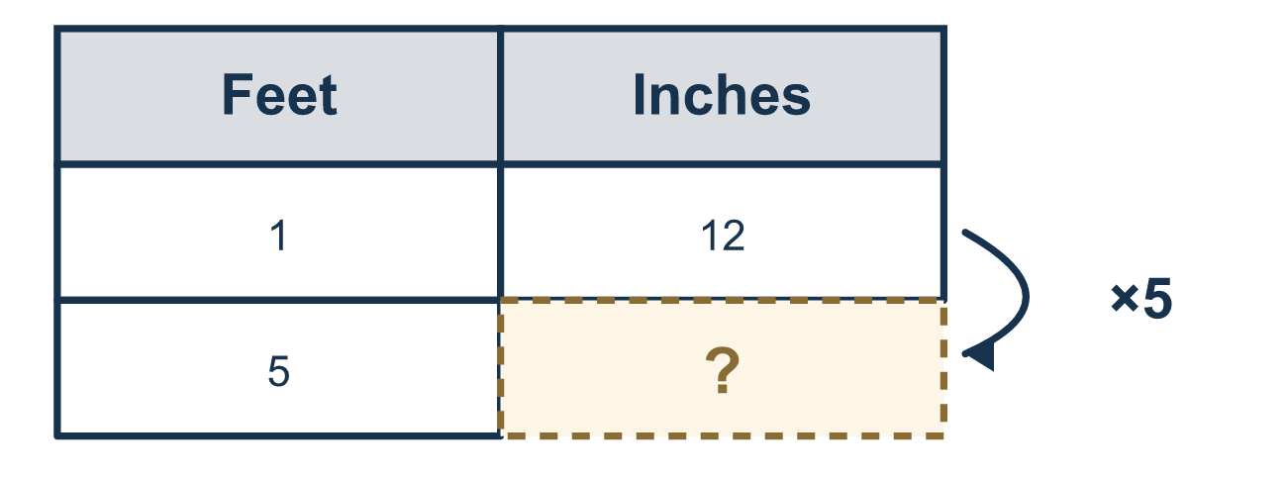
Our class model: the conversion factor

Try it
Work it out on paper. Write one answer on each line.
- How many quarts are in 1 gallon?
A. 2 B. 3 C. 4 D. 8
My answer
- Change 5 gallons to quarts.
A. 9 B. 20 C. 1.25 D. 40
My answer
- Change 12 cups to pints. (1 pint = 2 cups)
A. 24 B. 14 C. 10 D. 6
My answer
- A ribbon is 250 centimeters long. How many millimeters is that? (1 centimeter = 10 millimeters)
A. 25 B. 260 C. 2,500 D. 25,000
My answer
- You change quarts to pints. 1 quart = 2 pints. Which is correct?
A. Multiply, because pints are smaller B. Divide, because pints are smaller C. Multiply, because pints are bigger D. Divide, because pints are bigger
My answer
- A bag weighs 80 ounces. How many pounds is that? (1 pound = 16 ounces)
A. 64 B. 96 C. 1,280 D. 5
My answer

Talk about it
When did you multiply and when did you divide, and how did you decide?

Home mission
Measure a cabinet, shelf, or door with a tape measure. Say its height in feet. Ask your student for the inches. Then try 3 feet. Should the number be bigger or smaller than 3?

If we get stuck, ask
- Which unit is smaller?
- Should your answer be a bigger or smaller number?
- What is the conversion factor for these units?

Do it on a screen

Scan or type the link. Same lesson, with hints. eduwonderlab.com/lessons/3-10/homework.html
How did it feel? (optional) ☐ Tricky ☐ Getting there ☐ Got it

Family Math Studio · For grown-ups Lesson 3.10 · 6.AT.3c

Answers and talk notes
Convert Measurement Units

What your student is learning
Tonight we change one measurement unit into another, like feet into inches, using a conversion factor.

Answers
Ask your student to explain before you look.
- C. 4. 1 gallon = 4 quarts is the conversion factor.
- B. 20. 5 × 4 = 20, so 5 gallons = 20 quarts.
- D. 6. 12 ÷ 2 = 6, so 12 cups = 6 pints.
- C. 2,500. 250 × 10 = 2,500, so 250 centimeters = 2,500 millimeters.
- A. Multiply, because pints are smaller. Multiply, because pints are smaller, so there are more pints than quarts.
- D. 5. 80 ÷ 16 = 5, so 80 ounces = 5 pounds.

Talk about it
When did you multiply and when did you divide, and how did you decide?

When they are stuck, ask
- Which unit is smaller?
- Should your answer be a bigger or smaller number?
- What is the conversion factor for these units?

Try not to say
- Always multiply when you convert.
- The units do not matter, just the number.
- Just look it up on your phone.

Home mission
Measure a cabinet, shelf, or door with a tape measure. Say its height in feet. Ask your student for the inches. Then try 3 feet. Should the number be bigger or smaller than 3?

