Family Math Studio Lesson 3.2 · Session 2 · 6.AT.2

Understand Rates and Unit Rates
Find each unit price as a fraction over 1 and pick the better buy.
Name Date

Tonight's spark
At the corner store, Bag C of rice holds 3 pounds for $5.55. Bag D holds 5 pounds for $8.75. Bag C costs less in total. Is Bag C the better buy? Make a guess first: does the lower total always mean the lower price per pound?
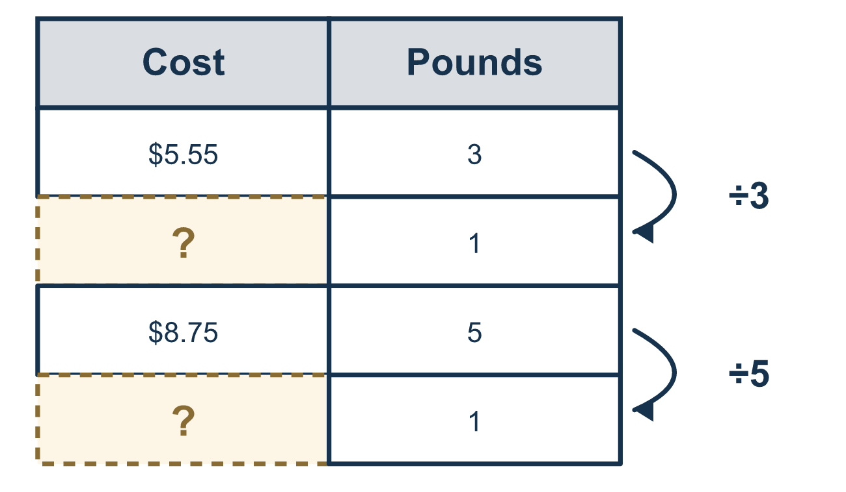
Our class model: cost over amount, divided to 1

Try it
Work it out on paper. Write one answer on each line.
- Bag A holds 4 pounds and costs $7. Which fraction has the total cost on top?
A. 4 lb over $7 B. $7 over 4 lb C. $7 over $4 D. 4 lb over 4 lb
My answer
- Divide the top and bottom of $9 / 3 lb by 3. What is the result?
A. $3 / 1 lb B. $12 / 6 lb C. $27 / 9 lb D. $9 / 1 lb
My answer
- A bag has 5 pounds of rice for $10.00. What is the price for 1 pound?
A. $0.50 B. $5.00 C. $15.00 D. $2.00
My answer
- Bag A costs $1.75 per pound. Bag B costs $1.60 per pound. Which is the better buy?
A. Bag A, because $1.75 is more B. They cost the same C. Bag B, because $1.60 is less
My answer
- Cereal costs $12 for 3 boxes. Divide to find the price for 1 box.
A. $36 B. $4 C. $9 D. $15
My answer

Talk about it
Which option has the lower price for 1 apple, and how do you know?

Home mission
Find two sizes of the same food, like two bags of rice. Read each price and weight. Can your student say each price for 1 pound out loud? Which bag is the better buy?

If we get stuck, ask
- Write the rate as a fraction with cost on TOP and pounds on the BOTTOM. Now divide both parts by the bottom number.
- Write the unit rate in fraction form over 1 (like 1.75 / 1 lb).
- Which unit price is lower?

Do it on a screen

Scan or type the link. Same lesson, with hints. eduwonderlab.com/lessons/3-2-part2/homework.html
How did it feel? (optional) ☐ Tricky ☐ Getting there ☐ Got it

Family Math Studio · For grown-ups Lesson 3.2 · Session 2 · 6.AT.2

Answers and talk notes
Understand Rates and Unit Rates

What your student is learning
Tonight we write each comparison as a fraction, divide both the top and bottom by the bottom number to find the unit rate in fraction form over 1, and compare to find the best buy.

Answers
Ask your student to explain before you look.
- B. $7 over 4 lb. Cost goes on top and pounds on the bottom, so the fraction is $7 over 4 lb.
- A. $3 / 1 lb. 9 ÷ 3 = 3 and 3 ÷ 3 = 1, so the result is $3 / 1 lb.
- D. $2.00. $10.00 ÷ 5 = $2.00 for 1 pound.
- C. Bag B, because $1.60 is less. Bag B, because $1.60 is less per pound than $1.75, is the better buy.
- B. $4. $12 ÷ 3 = $4 for 1 box.

Talk about it
Which option has the lower price for 1 apple, and how do you know?

When they are stuck, ask
- Write the rate as a fraction with cost on TOP and pounds on the BOTTOM. Now divide both parts by the bottom number.
- Write the unit rate in fraction form over 1 (like 1.75 / 1 lb).
- Which unit price is lower?

Try not to say
- The cheaper sticker price is always the better buy.
- Divide the amount of pounds by the dollars.

Home mission
Find two sizes of the same food, like two bags of rice. Read each price and weight. Can your student say each price for 1 pound out loud? Which bag is the better buy?

