Family Math Studio Lesson 3.2 · Session 3 · 6.AT.2

Understand Rates and Unit Rates
Write each comparison as a fraction, divide to a unit rate, and pick the better value.
Name Date

Tonight's spark
Theater A sells 3 tickets for $15. Theater B sells 5 tickets for $20. A friend says A is cheaper because $15 is less than $20. Which theater is the better value? Make a guess first: does the lower total mean the lower price for one ticket?
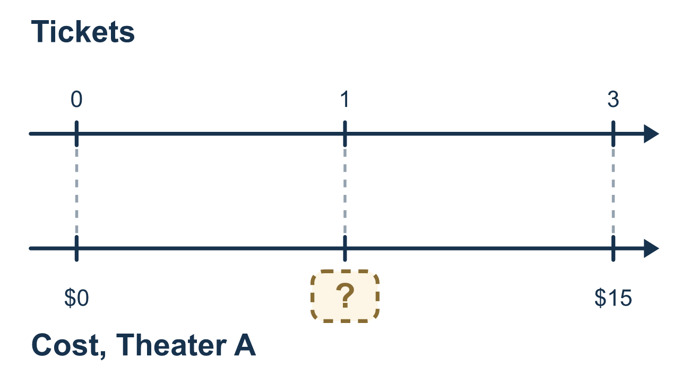
Our class model: the unit rate over 1

Try it
Work it out on paper. Write one answer on each line.
- Which fraction shows $20 for 5 tickets, with the cost on top?
A. 5 tickets / $20 B. $5 / 20 tickets C. $20 / 5 tickets D. $20 / $5
My answer
- A pool charges $24 for 6 visits. What is the cost per visit?
A. $18 B. $144 C. $30 D. $4
My answer
- A runner goes 12 laps in 4 minutes. How many laps is that per minute?
A. 8 B. 16 C. 3 D. 48
My answer
- Station Y sells 4 gallons of fuel for $18. What is the unit rate in dollars per gallon?
A. $4.50 B. $14.00 C. $22.00 D. $72.00
My answer
- Theater A costs $5 per ticket. Theater B costs $4 per ticket. Which is the better value?
A. Theater A, because $5 is the greater amount B. Theater B, because $4 is the lower rate C. They are the same value
My answer
- Plan X is $30 for 10 gigabytes. Plan Y is $56 for 14 gigabytes. Which plan costs less per gigabyte?
A. Plan Y, because it has more gigabytes B. Plan Y, $4 per gigabyte C. Plan X, $3 per gigabyte D. They cost the same per gigabyte
My answer

Talk about it
Which pass has the lower unit rate, and why does that make it the better value?

Home mission
Look at two snack packs at home. Read the price and the count on each. Can your student say the cost of ONE in each pack? Does the lower total always win?

If we get stuck, ask
- Which number goes on TOP of the fraction: the money or the amount?
- Now divide both parts by the bottom number. What is the unit rate over 1?
- State the unit rate in fraction form over 1 (like $5/1 item = $5 per item).

Do it on a screen

Scan or type the link. Same lesson, with hints. eduwonderlab.com/lessons/3-2-part3/homework.html
How did it feel? (optional) ☐ Tricky ☐ Getting there ☐ Got it

Family Math Studio · For grown-ups Lesson 3.2 · Session 3 · 6.AT.2

Answers and talk notes
Understand Rates and Unit Rates

What your student is learning
Tonight we write each comparison as a fraction with the cost on top and the amount on the bottom, divide both parts by the bottom number to find the unit rate in fraction form over 1, and compare unit rates to pick the better value.

Answers
Ask your student to explain before you look.
- C. $20 / 5 tickets. The cost is on top and the tickets are on the bottom: $20 / 5 tickets.
- D. $4. $24 ÷ 6 = $4 per visit.
- C. 3. 12 ÷ 4 = 3, so the unit rate is 3 laps per minute.
- A. $4.50. $18 ÷ 4 = $4.50 per gallon.
- B. Theater B, because $4 is the lower rate. Theater B, because $4 is the lower rate per ticket, is the better value.
- C. Plan X, $3 per gigabyte. Plan X is $30 ÷ 10 = $3 per gigabyte and Plan Y is $56 ÷ 14 = $4, so Plan X, $3 per gigabyte, is lower.

Talk about it
Which pass has the lower unit rate, and why does that make it the better value?

When they are stuck, ask
- Which number goes on TOP of the fraction: the money or the amount?
- Now divide both parts by the bottom number. What is the unit rate over 1?
- State the unit rate in fraction form over 1 (like $5/1 item = $5 per item).

Try not to say
- Just pick the option with the smaller total price.
- The bigger package is always the better value.
- Divide only the top number without dividing the bottom.

Home mission
Look at two snack packs at home. Read the price and the count on each. Can your student say the cost of ONE in each pack? Does the lower total always win?

