Family Math Studio Lesson 3.2 · 6.AT.2

Understand Rates and Unit Rates
Describe a rate with two different units and find a unit rate.
Name Date

Tonight's spark
A train station board says the train goes 150 miles each hour. The next big city is 450 miles away. How many hours is the ride? Make a guess first: is the ride more than 2 hours, or less?
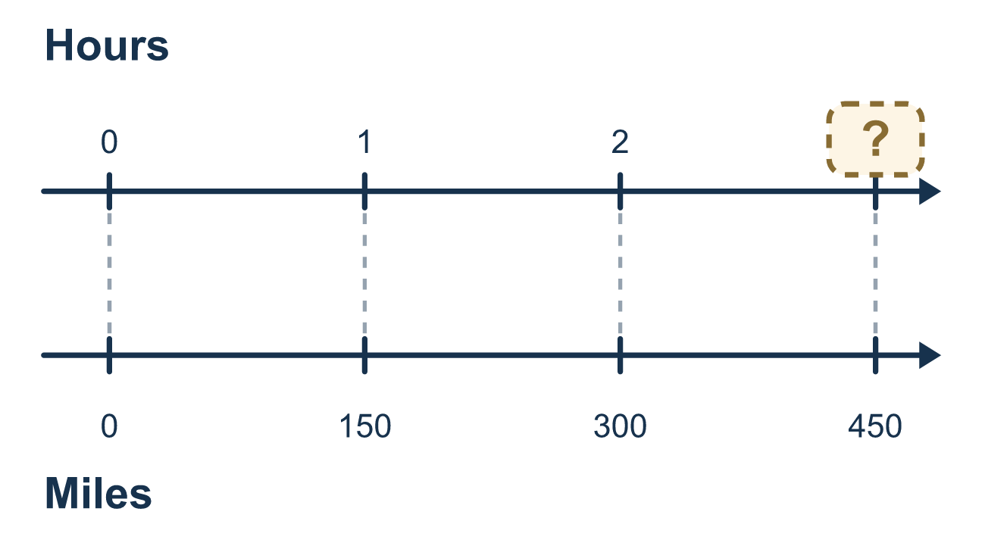
Our class model: the unit rate

Try it
Work it out on paper. Write one answer on each line.
- Which one is a rate?
A. 5 red to 3 blue B. $6 for 3 pounds C. 2 cups to 4 cups D. 7 out of 10
My answer
- A snack costs $12 for 4 bags. What is the unit rate in dollars per bag?
A. $8 B. $48 C. $3 D. $16
My answer
- A train goes 120 miles each hour. How far does it go in 3 hours?
A. 360 miles B. 40 miles C. 123 miles D. 117 miles
My answer
- Grapes cost $2.50 per pound. How much do 4 pounds cost?
A. $0.63 B. $6.50 C. $1.50 D. $10.00
My answer
- Juice A: 4 bottles for $6. Juice B: 5 bottles for $9. Which has the lower price per bottle?
A. Juice B, because it costs more in total B. Juice A, $1.50 per bottle C. Juice B, $1.80 per bottle D. Juice A, because it has fewer bottles
My answer
- A bus goes 45 miles each hour. How many hours does a 180-mile trip take?
A. 4 hours B. 225 hours C. 135 hours D. 8,100 hours
My answer

Talk about it
How far does the train go in 1 hour? In 2 hours?

Home mission
Find a food package at home. Read its price and how many items it holds. Can your student say the price for 1 item? Then say it as "dollars per item."

If we get stuck, ask
- What are the two units in this rate? Say both out loud.
- How much does one hour give us? Now count up one hour at a time.
- Does your answer have a unit on it? Miles, or hours?

Do it on a screen

Scan or type the link. Same lesson, with hints. eduwonderlab.com/lessons/3-2/homework.html
How did it feel? (optional) ☐ Tricky ☐ Getting there ☐ Got it

Family Math Studio · For grown-ups Lesson 3.2 · 6.AT.2

Answers and talk notes
Understand Rates and Unit Rates

What your student is learning
Tonight we connect distance and time. We name both units in a rate, and we use a model to find how long a trip takes.

Answers
Ask your student to explain before you look.
- B. $6 for 3 pounds. $6 for 3 pounds is a rate because it compares two different units, dollars and pounds.
- C. $3. $12 ÷ 4 = $3, so the unit rate is $3 per bag.
- A. 360 miles. 3 hours at 120 miles per hour is 120 × 3 = 360 miles.
- D. $10.00. 4 pounds at $2.50 per pound is 4 × $2.50 = $10.00.
- B. Juice A, $1.50 per bottle. A is $6 ÷ 4 = $1.50 per bottle and B is $9 ÷ 5 = $1.80, so Juice A, $1.50 per bottle is lower.
- A. 4 hours. 180 ÷ 45 = 4, so the trip takes 4 hours.

Talk about it
How far does the train go in 1 hour? In 2 hours?

When they are stuck, ask
- What are the two units in this rate? Say both out loud.
- How much does one hour give us? Now count up one hour at a time.
- Does your answer have a unit on it? Miles, or hours?

Try not to say
- A rate is just one number, so you can drop the units.
- The train goes faster the longer it travels.
- You can compare 10 meters each second with 10 minutes without changing anything.

Home mission
Find a food package at home. Read its price and how many items it holds. Can your student say the price for 1 item? Then say it as "dollars per item."

