Family Math Studio Lesson 3.3 · Session 2 · 6.AT.3a

Determine Equivalent Ratios Using Tables
Find a missing value in a ratio table by multiplying or dividing both numbers.
Name Date

Tonight's spark
An art room mixes orange paint with 4 cups of red for every 3 cups of yellow. Today there are 6 cups of yellow. How many cups of red go in? Make a guess first: will the red be more than 4 cups, or less?
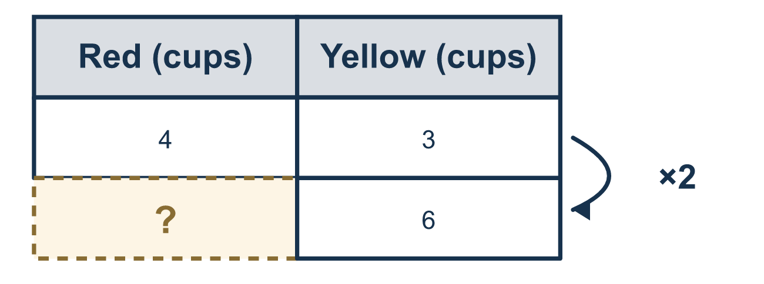
Our class model: the same move on both numbers

Try it
Work it out on paper. Write one answer on each line.
- A table has the row 6:9. Divide both numbers by 3. What is the new row?
A. 3:6 B. 2:6 C. 2:3 D. 3:2
My answer
- The ratio is 5:2. Find the missing number in 20 : ?
A. 17 B. 8 C. 40 D. 4
My answer
- A ratio is 12 red : 8 blue. How many red go with 2 blue?
A. 10 B. 6 C. 3 D. 24
My answer
- Go from 3:4 to 9:?. What is the missing number?
A. 12 B. 10 C. 16 D. 3
My answer
- Go from 9:6 down to 3:?. What is the missing number?
A. 6 B. 3 C. 18 D. 2
My answer
- A table has 3:7 and 6:14. If you multiply the first row by 3, what is the next row?
A. 9:21 B. 9:10 C. 9:14 D. 3:21
My answer

Talk about it
In each row, what did you do to the first number, and did you do the same thing to the second?

Home mission
Pick any recipe with two amounts, like 1 cup of rice to 2 cups of water. Ask your student to make half a batch, then three batches, saying both new amounts out loud.

If we get stuck, ask
- What number was one part of the ratio multiplied or divided by?
- Now do exactly that to the other part.
- Can you check your answer by scaling back to the original ratio?

Do it on a screen

Scan or type the link. Same lesson, with hints. eduwonderlab.com/lessons/3-3-part2/homework.html
How did it feel? (optional) ☐ Tricky ☐ Getting there ☐ Got it

Family Math Studio · For grown-ups Lesson 3.3 · Session 2 · 6.AT.3a

Answers and talk notes
Determine Equivalent Ratios Using Tables

What your student is learning
Tonight we find a missing amount in a ratio table by multiplying or dividing BOTH numbers by the same amount — the same move as yesterday, now used to find a missing value up or down.

Answers
Ask your student to explain before you look.
- C. 2:3. 6 ÷ 3 = 2 and 9 ÷ 3 = 3, so the new row is 2:3.
- B. 8. 5 × 4 = 20, so the second number is 2 × 4 = 8.
- C. 3. 8 ÷ 4 = 2, so divide 12 by 4 too: 12 ÷ 4 = 3 red.
- A. 12. 3 × 3 = 9, so the missing number is 4 × 3 = 12.
- D. 2. 9 ÷ 3 = 3, so the missing number is 6 ÷ 3 = 2.
- A. 9:21. 3 × 3 = 9 and 7 × 3 = 21, so the row is 9:21.

Talk about it
In each row, what did you do to the first number, and did you do the same thing to the second?

When they are stuck, ask
- What number was one part of the ratio multiplied or divided by?
- Now do exactly that to the other part.
- Can you check your answer by scaling back to the original ratio?

Try not to say
- Just add the same amount to both numbers.
- It doesn't matter which direction you scale.
- Only one part of the ratio has to change.

Home mission
Pick any recipe with two amounts, like 1 cup of rice to 2 cups of water. Ask your student to make half a batch, then three batches, saying both new amounts out loud.

