Family Math Studio Lesson 3.3 · 6.AT.3a

Determine Equivalent Ratios Using Tables
Use a ratio table to make equivalent ratios.
Name Date

Tonight's spark
A pancake recipe uses 2 cups of mix and 3 cups of milk. For 2 batches, a helper adds 2 cups to each: 4 cups of mix and 5 of milk. Will it taste the same? Make a guess first: is 5 cups of milk too little, too much, or just right for 4 cups of mix?
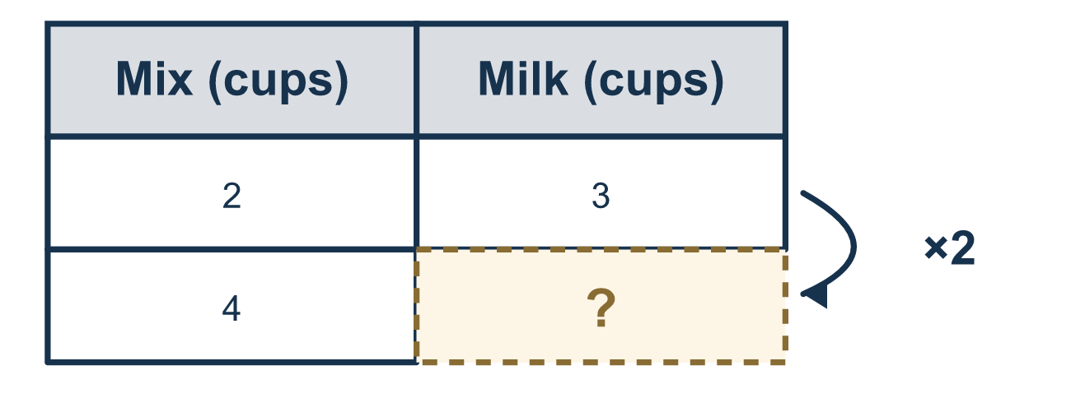
Our class model: the ratio table

Try it
Work it out on paper. Write one answer on each line.
- Row 1 of a ratio table is 2:3. Row 2 is made by multiplying both numbers by 2. What is row 2?
A. 4:5 B. 4:6 C. 2:6 D. 5:6
My answer
- A ratio table has milk and mix. Mix is 1, 2, 3. Milk is 4, 8, and then a missing number. What is the missing number?
A. 7 B. 16 C. 12 D. 11
My answer
- A ratio table has the rows 3:5 and 6:10. Which ratio could be the next row?
A. 9:13 B. 12:15 C. 3:10 D. 9:15
My answer
- What is the scale factor from the row 2:3 to the row 10:15?
A. 5 B. 8 C. 13
My answer
- A row of a ratio table is 12:8. Divide both numbers by 4. What is the new row?
A. 8:4 B. 3:2 C. 4:3 D. 3:4
My answer
- A recipe uses 3 cups of mix for 5 cups of water. How much water goes with 9 cups of mix?
A. 11 B. 15 C. 45 D. 8
My answer

Talk about it
How do the numbers in each new row compare with the first row?

Home mission
Take a drink mix or recipe card. Say both amounts doubled, out loud. Then ask, "If we add 1 cup to each instead, is it the same?"

If we get stuck, ask
- What is our scale factor — the number we multiply both parts by?
- Did we do the SAME thing to both numbers?
- Let's check: does our new row mean the same as the first row?

Do it on a screen

Scan or type the link. Same lesson, with hints. eduwonderlab.com/lessons/3-3/homework.html
How did it feel? (optional) ☐ Tricky ☐ Getting there ☐ Got it

Family Math Studio · For grown-ups Lesson 3.3 · 6.AT.3a

Answers and talk notes
Determine Equivalent Ratios Using Tables

What your student is learning
Tonight we use a ratio table to make bigger batches of a recipe while keeping it tasting the same.

Answers
Ask your student to explain before you look.
- B. 4:6. 2 × 2 = 4 and 3 × 2 = 6, so row 2 is 4:6.
- C. 12. The milk is the mix times 4: 1 × 4, 2 × 4, 3 × 4. The missing number is 3 × 4 = 12.
- D. 9:15. The scale factors are 1, 2, 3, so the next row is 3 × 3 = 9 and 5 × 3 = 15, which is 9:15.
- A. 5. 2 × 5 = 10 and 3 × 5 = 15, so the scale factor is 5.
- B. 3:2. 12 ÷ 4 = 3 and 8 ÷ 4 = 2, so the new row is 3:2.
- B. 15. The scale factor is 9 ÷ 3 = 3, so the water is 5 × 3 = 15 cups.

Talk about it
How do the numbers in each new row compare with the first row?

When they are stuck, ask
- What is our scale factor — the number we multiply both parts by?
- Did we do the SAME thing to both numbers?
- Let's check: does our new row mean the same as the first row?

Try not to say
- Just add the same number to both parts each row.
- Only multiply one of the two numbers.
- You can multiply the two numbers by different scale factors.

Home mission
Take a drink mix or recipe card. Say both amounts doubled, out loud. Then ask, "If we add 1 cup to each instead, is it the same?"

