Family Math Studio Lesson 3.4 · Session 2 · 6.AT.3a

Determine Equivalent Ratios Using Graphs
Read what each point on a ratio graph means.
Name Date

Tonight's spark
A farm stand graph shows bags across and apples up. One dot sits at (3, 18). The first number is bags. How many apples are in just one bag? Make a guess first: does one bag hold more than 10 apples, or fewer?
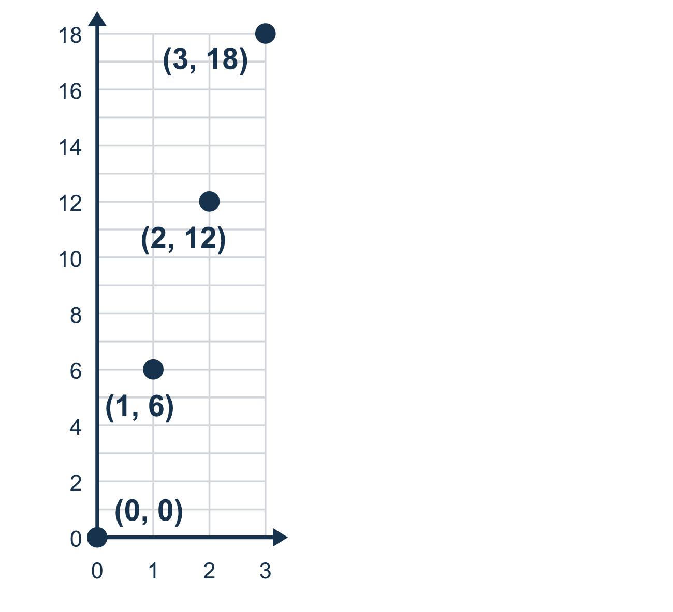
Our class model: the unit rate point

Try it
Work it out on paper. Write one answer on each line.
- The line for minutes (x) and pages (y) passes through (1, 7). How many pages are read in 1 minute?
A. 1 B. 8 C. 7 D. 6
My answer
- The point (5, 30) is on a graph of bags (x) and marbles (y). What does it mean?
A. 5 marbles are in 30 bags B. 5 bags hold 30 marbles C. 30 bags hold 5 marbles D. 5 + 30 = 35 marbles
My answer
- The unit rate is 9 miles per hour. Hours are x and miles are y. Which point is on the line?
A. (9, 1) B. (10, 1) C. (1, 8) D. (1, 9)
My answer
- The unit rate is 6. Which point is on the graph?
A. (4, 24) B. (4, 10) C. (24, 4) D. (6, 4)
My answer
- On a graph of hours (x) and miles (y), what does the point (0, 0) mean?
A. 0 hours go with 1 mile B. 1 hour goes with 0 miles C. 0 hours go with 0 miles
My answer
- A line passes through (1, 5). Use the unit rate to find y when x is 8.
A. 13 B. 40 C. 3 D. 5
My answer

Talk about it
What does the point with x = 1 tell you about this rate?

Home mission
Pretend each bag holds 6 apples. Ask your student to say the point for 4 bags as a sentence. Then ask: what does the point (0, 0) mean?

If we get stuck, ask
- Which quantity is on the x-axis? Read that number first.
- What does the point where x is 1 tell us?
- Can you say this point as a sentence about real things?

Do it on a screen

Scan or type the link. Same lesson, with hints. eduwonderlab.com/lessons/3-4-part2/homework.html
How did it feel? (optional) ☐ Tricky ☐ Getting there ☐ Got it

Family Math Studio · For grown-ups Lesson 3.4 · Session 2 · 6.AT.3a

Answers and talk notes
Determine Equivalent Ratios Using Graphs

What your student is learning
Tonight we read a ratio graph and say out loud what each point MEANS — especially the point (1, r) and the origin (0, 0).

Answers
Ask your student to explain before you look.
- C. 7. The point (1, 7) means 1 minute goes with 7 pages, so 7 pages in 1 minute.
- B. 5 bags hold 30 marbles. In (5, 30) x = 5 bags and y = 30 marbles, so 5 bags hold 30 marbles.
- D. (1, 9). In 1 hour you go 9 miles, so the unit rate point is (1, 9).
- A. (4, 24). y is 6 times x, so for x = 4 the y-value is 4 × 6 = 24, the point (4, 24).
- C. 0 hours go with 0 miles. 0 hours go with 0 miles: in no time you travel no distance.
- B. 40. The unit rate is 5, so y = 8 × 5 = 40.

Talk about it
What does the point with x = 1 tell you about this rate?

When they are stuck, ask
- Which quantity is on the x-axis? Read that number first.
- What does the point where x is 1 tell us?
- Can you say this point as a sentence about real things?

Try not to say
- The order of the two numbers does not really matter.
- The origin is just where the graph starts, it has no meaning.
- Read the bigger number first, it looks neater.

Home mission
Pretend each bag holds 6 apples. Ask your student to say the point for 4 bags as a sentence. Then ask: what does the point (0, 0) mean?

