Family Math Studio Lesson 3.4 · 6.AT.3a

Determine Equivalent Ratios Using Graphs
Graph the pairs from a ratio table as points on the coordinate plane.
Name Date

Tonight's spark
A sundae stand uses 2 ounces of sauce for every sundae. A helper makes a grid: sundaes go across, ounces go up. Dots for 1, 2 and 3 sundaes go on it. What shape will the dots make? Make a guess first: will the dots line up straight, or bend?
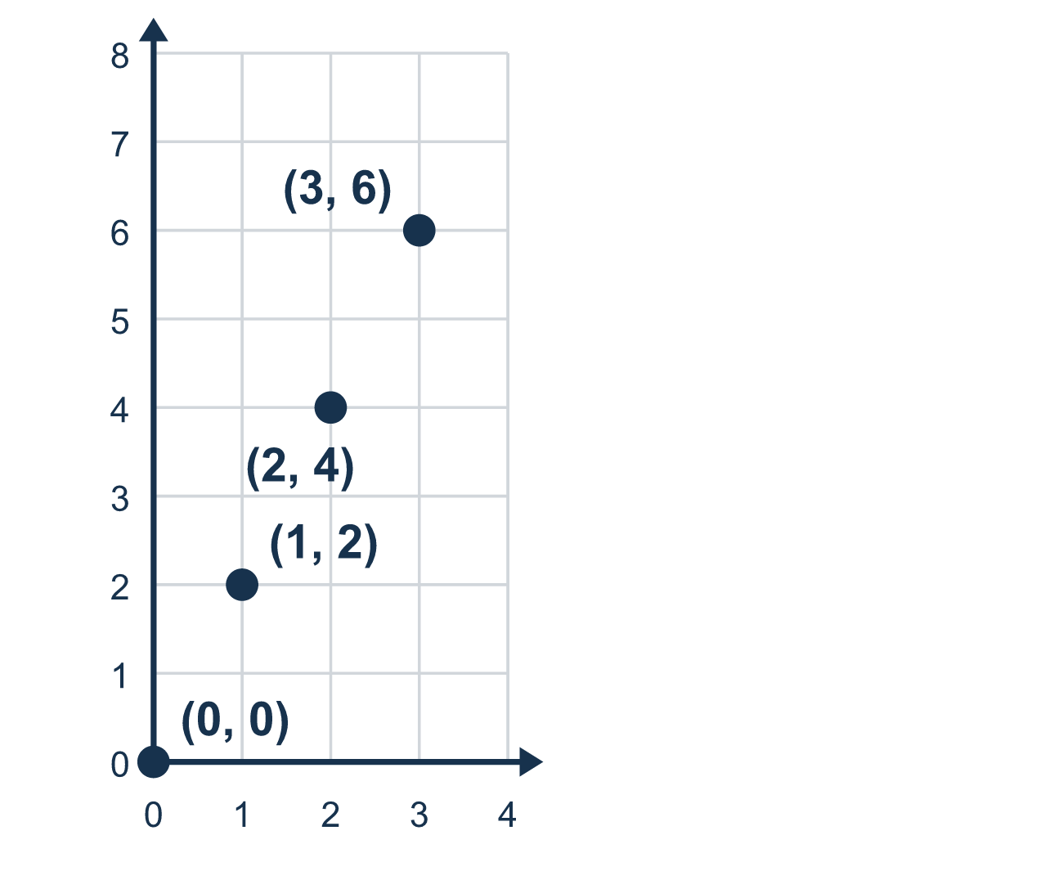
Our class model: the ratio graph

Try it
Work it out on paper. Write one answer on each line.
- A ratio table has the points (1, 3) and (2, 6). What is the next point, (3, ?)
A. (3, 6) B. (3, 9) C. (9, 3) D. (3, 4)
My answer
- To plot the point (2, 5), how do you move from the origin?
A. Up 2, right 5 B. Right 5, up 2 C. Right 2, up 5 D. Left 2, up 5
My answer
- On a ratio graph, x is tickets and y is dollars. Which point means 3 tickets cost $12?
A. (3, 15) B. (12, 3) C. (9, 12) D. (3, 12)
My answer
- Which point is the origin?
A. (1, 1) B. (0, 0) C. (0, 1) D. (1, 0)
My answer
- The points (1, 4), (2, 8) and (3, 12) are plotted. What do they look like?
A. A straight line through (0, 0) B. A curve that bends upward C. Scattered dots with no pattern D. A straight line that starts at (0, 4)
My answer

Talk about it
What shape do the points make, and what point would it pass through if you kept going backward?

Home mission
Use a sheet of paper. Its bottom edge shows sundaes and its left edge shows ounces. Say the rule: 2 ounces of sauce for every sundae. Ask your student to point to where 3 sundaes belong. Then ask: where do 0 sundaes belong?

If we get stuck, ask
- Which number tells us to go right, and which tells us to go up?
- Does the line start at the origin, (0, 0)?
- Do all the points line up straight, or is one off the line?

Do it on a screen

Scan or type the link. Same lesson, with hints. eduwonderlab.com/lessons/3-4/homework.html
How did it feel? (optional) ☐ Tricky ☐ Getting there ☐ Got it

Family Math Studio · For grown-ups Lesson 3.4 · 6.AT.3a

Answers and talk notes
Determine Equivalent Ratios Using Graphs

What your student is learning
Tonight we plot the values from a ratio table as points on a grid and see they make a straight line.

Answers
Ask your student to explain before you look.
- B. (3, 9). The y-value is 3 times the x-value, so the next point is (3, 9).
- C. Right 2, up 5. Right 2, up 5 is correct. In (2, 5) the first number is how far right and the second is how far up.
- D. (3, 12). Tickets are x and dollars are y, so 3 tickets and $12 is the point (3, 12).
- B. (0, 0). The origin is where both axes meet, the point (0, 0).
- A. A straight line through (0, 0). A straight line through (0, 0) is correct, because equal ratios make a straight line through the origin.

Talk about it
What shape do the points make, and what point would it pass through if you kept going backward?

When they are stuck, ask
- Which number tells us to go right, and which tells us to go up?
- Does the line start at the origin, (0, 0)?
- Do all the points line up straight, or is one off the line?

Try not to say
- Go up first, then right — the order does not matter.
- To find the up number, just add to the right number.
- Any points that go up to the right make a proportional line.

Home mission
Use a sheet of paper. Its bottom edge shows sundaes and its left edge shows ounces. Say the rule: 2 ounces of sauce for every sundae. Ask your student to point to where 3 sundaes belong. Then ask: where do 0 sundaes belong?

