Family Math Studio Lesson 3.5 · Session 2 · 6.AT.3

Compare Ratio Relationships
Compare two rates by scaling both to the same benchmark amount.
Name Date

Tonight's spark
Two runners train on the rec-center track. Runner A does 9 laps in 6 minutes. Runner B does 12 laps in 9 minutes. Who is faster? Make a guess first: is the runner with more laps the faster one?
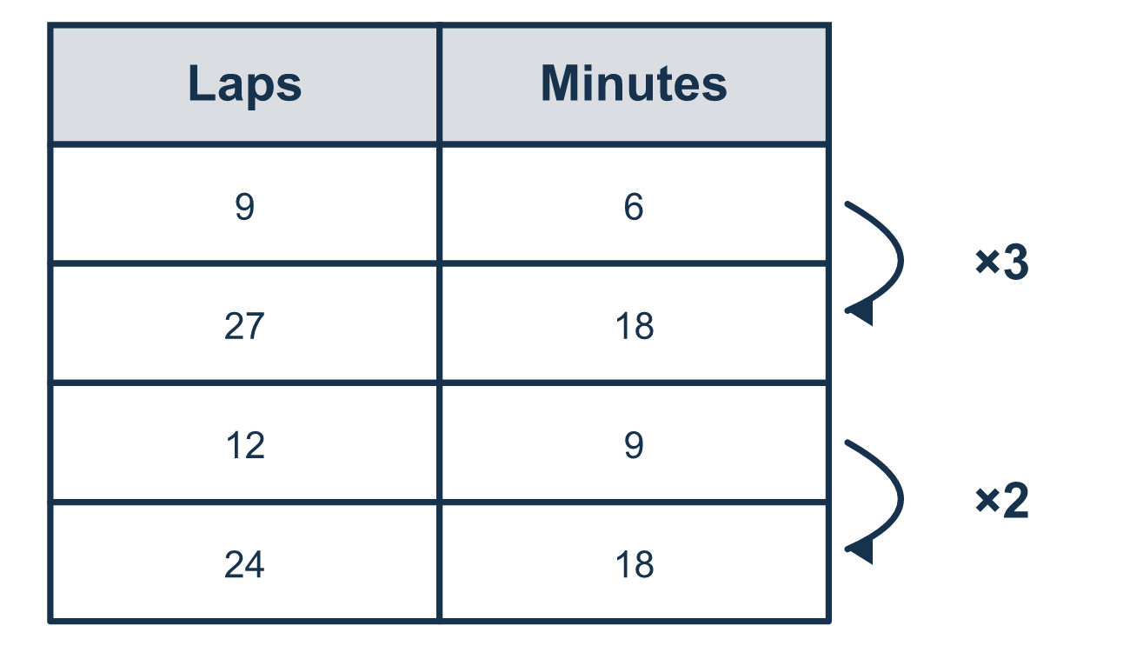
Our class model: the benchmark

Try it
Work it out on paper. Write one answer on each line.
- Store A sells 4 pounds for $10. To compare with a 12-pound offer, scale A to 12 pounds. What is the scale factor?
A. 8 B. 6 C. 3 D. 12
My answer
- Scale 4 pounds for $10 up to 12 pounds. How much does it cost?
A. $18 B. $30 C. $40
My answer
- What is the least number that both 6 and 4 divide into evenly?
A. 10 B. 24 C. 12 D. 2
My answer
- Car A goes 150 miles in 3 hours. Scale it to 12 hours. How far does it go?
A. 600 miles B. 159 miles C. 450 miles D. 50 miles
My answer
- Machine A fills 5 bottles in 2 minutes. Machine B fills 12 bottles in 4 minutes. Scaled to 4 minutes, which fills faster?
A. Machine A, because it takes fewer minutes B. Machine B, 12 bottles is more than 10 in 4 minutes C. They fill at the same speed D. Machine A, because 5 is smaller
My answer

Talk about it
Why did you pick 12 lemons as the amount to compare?

Home mission
Pretend one pizza shop sells 2 slices for $3. Another sells 3 slices for $5. Ask your student to pick a benchmark both deals can reach. Which shop is the better deal at that benchmark?

If we get stuck, ask
- What number can both of these reach?
- Did both numbers in the rate get multiplied by the same factor?
- Now that one quantity matches, which one wins?

Do it on a screen

Scan or type the link. Same lesson, with hints. eduwonderlab.com/lessons/3-5-part2/homework.html
How did it feel? (optional) ☐ Tricky ☐ Getting there ☐ Got it

Family Math Studio · For grown-ups Lesson 3.5 · Session 2 · 6.AT.3

Answers and talk notes
Compare Ratio Relationships

What your student is learning
Tonight we compare two rates by scaling BOTH of them to the same amount — a benchmark — instead of dividing.

Answers
Ask your student to explain before you look.
- C. 3. 4 × 3 = 12, so the scale factor is 3.
- B. $30. The scale factor is 3, so the cost is $10 × 3 = $30.
- C. 12. 12 ÷ 6 = 2 and 12 ÷ 4 = 3, and no smaller number works for both, so the answer is 12.
- A. 600 miles. 3 × 4 = 12, so the distance is 150 × 4 = 600 miles.
- B. Machine B, 12 bottles is more than 10 in 4 minutes. Machine A in 4 minutes fills 10 bottles, so Machine B, 12 bottles is more than 10 in 4 minutes, fills faster.

Talk about it
Why did you pick 12 lemons as the amount to compare?

When they are stuck, ask
- What number can both of these reach?
- Did both numbers in the rate get multiplied by the same factor?
- Now that one quantity matches, which one wins?

Try not to say
- The bigger number is the faster one.
- You can compare them just as they are.
- Scale one of them and leave the other alone.

Home mission
Pretend one pizza shop sells 2 slices for $3. Another sells 3 slices for $5. Ask your student to pick a benchmark both deals can reach. Which shop is the better deal at that benchmark?

