Family Math Studio Lesson 3.5 · 6.AT.3

Compare Ratio Relationships
Compare two ratios by making one amount match or by finding unit rates.
Name Date

Tonight's spark
Chef Reyes makes cocoa with 3 tablespoons of cocoa for 5 ounces of milk. Chef Tran uses 4 tablespoons for 7 ounces of milk. Whose cocoa is more chocolatey? Make a guess first: does Chef Tran win because 4 is more than 3?
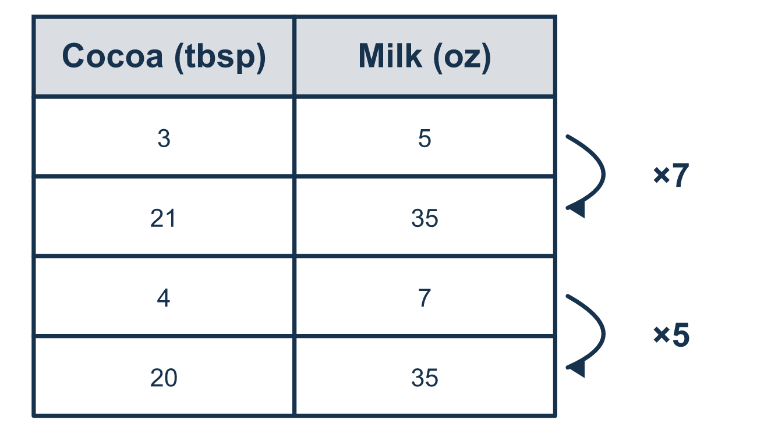
Our class model: make the milk match

Try it
Work it out on paper. Write one answer on each line.
- Which ratio is equivalent to 2:3 and has 12 in the second part?
A. 8:12 B. 6:12 C. 2:12 D. 12:18
My answer
- Recipe A uses 2 tablespoons of cocoa for 4 ounces of milk. Recipe B uses 3 tablespoons for 4 ounces. Which is more chocolatey?
A. Recipe A B. Recipe B C. They are the same
My answer
- 12 cookies are shared equally among 4 children. How many cookies does 1 child get?
A. 8 B. 16 C. 3 D. 48
My answer
- Store X: 3 pens for $6. Store Y: 4 pens for $12. Which store charges less per pen?
A. Store Y, $3 per pen B. Store Y, because $12 is more C. Store X, $6 per pen D. Store X, $2 per pen
My answer
- To compare 3:5 and 4:7 by making the second parts equal, which number can both 5 and 7 scale to?
A. 12 B. 35 C. 57 D. 2
My answer

Talk about it
Why do the nut amounts have to match before you compare the raisins?

Home mission
Say Chef Reyes's mix out loud: 3 spoons of cocoa for 5 of milk. Ask your student: how much cocoa goes with 10 spoons of milk? With 15? Then ask: why can't we compare Chef Tran's 4 for 7 yet?

If we get stuck, ask
- Are the other amounts the same yet? If not, let's make them equal first.
- Can we find the amount for just 1 by dividing?
- Now that they match, which number is bigger?

Do it on a screen

Scan or type the link. Same lesson, with hints. eduwonderlab.com/lessons/3-5/homework.html
How did it feel? (optional) ☐ Tricky ☐ Getting there ☐ Got it

Family Math Studio · For grown-ups Lesson 3.5 · 6.AT.3

Answers and talk notes
Compare Ratio Relationships

What your student is learning
Tonight we compare two cocoa recipes. Which one has more cocoa for the same amount of milk?

Answers
Ask your student to explain before you look.
- A. 8:12. 3 × 4 = 12, so multiply 2 by 4 too: 2 × 4 = 8, and the ratio is 8:12.
- B. Recipe B. The milk is the same, 4 ounces, and 3 is more than 2, so Recipe B is more chocolatey.
- C. 3. 12 ÷ 4 = 3, so each child gets 3 cookies.
- D. Store X, $2 per pen. Store X is $6 ÷ 3 = $2 per pen and Store Y is $12 ÷ 4 = $3 per pen, so Store X, $2 per pen, is lower.
- B. 35. 5 × 7 = 35 and 7 × 5 = 35, so both second parts can scale to 35.

Talk about it
Why do the nut amounts have to match before you compare the raisins?

When they are stuck, ask
- Are the other amounts the same yet? If not, let's make them equal first.
- Can we find the amount for just 1 by dividing?
- Now that they match, which number is bigger?

Try not to say
- The bigger top number always wins, no matter the other amount.
- You can compare 3:5 and 4:7 just by looking at them.
- More items always means a lower price per item.

Home mission
Say Chef Reyes's mix out loud: 3 spoons of cocoa for 5 of milk. Ask your student: how much cocoa goes with 10 spoons of milk? With 15? Then ask: why can't we compare Chef Tran's 4 for 7 yet?

