Family Math Studio Lesson 3.6 · Session 2 · 6.AT.3c

Ratio Reasoning: Convert Measurements within the Same System
Convert metric units with powers of ten and check that the answer makes sense.
Name Date

Tonight's spark
A team cooler holds 6 liters of water. The coach's cups are marked in milliliters. One liter is 1,000 milliliters. How many milliliters does the cooler hold? Make a guess first: is it closer to 60, 600 or 6,000?
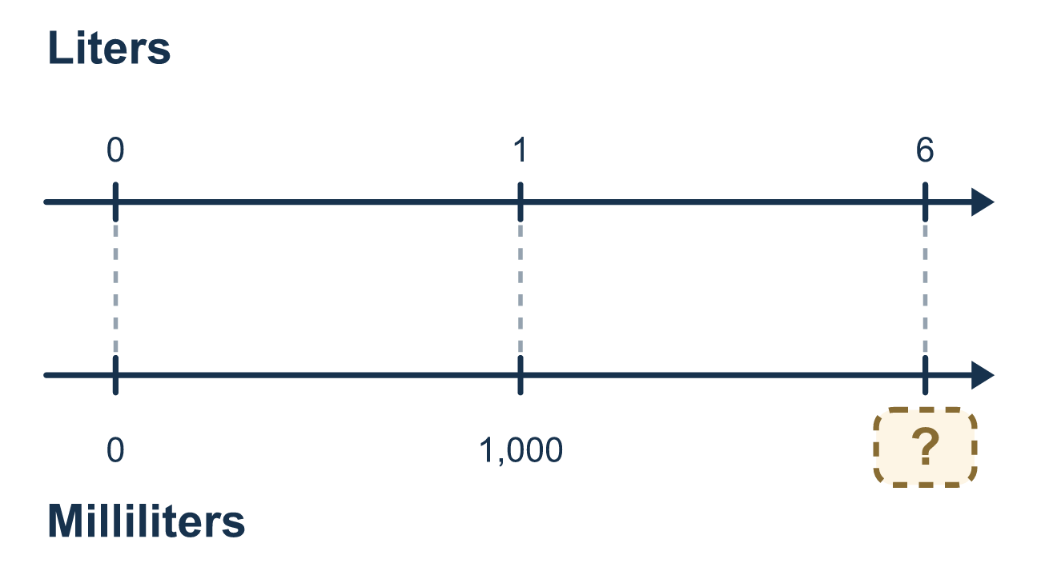
Our class model: the power of ten jump

Try it
Work it out on paper. Write one answer on each line.
- How many meters are in 1 kilometer?
A. 10 B. 100 C. 1,000 D. 10,000
My answer
- 5 kilometers = ? meters
A. 5,000 B. 50 C. 500 D. 0.005
My answer
- Change 3,000 grams to kilograms. (1 kilogram = 1,000 grams)
A. 30 B. 3 C. 300 D. 3,000,000
My answer
- How many centimeters are in 4 meters? (1 meter = 100 centimeters)
A. 0.04 B. 40 C. 404 D. 400
My answer
- Convert 2 liters to milliliters.
A. 2,000 B. 200 C. 20 D. 0.002
My answer
- Convert 650 millimeters to meters. (1 meter = 1,000 millimeters)
A. 650,000 B. 6.5 C. 0.65 D. 65
My answer

Talk about it
Are you changing to a smaller unit or a bigger unit, and what does that tell you to do?

Home mission
Find a bottle labeled 1 L or 1,000 mL. Say: "The cooler holds 6 liters." Ask your student how many bottles like this fill it. Then ask how many milliliters that is in all.

If we get stuck, ask
- Which unit is smaller — the one we have, or the one we want?
- Will there be more of them or fewer of them?
- Does the answer look reasonable for that unit?

Do it on a screen

Scan or type the link. Same lesson, with hints. eduwonderlab.com/lessons/3-6-part2/homework.html
How did it feel? (optional) ☐ Tricky ☐ Getting there ☐ Got it

Family Math Studio · For grown-ups Lesson 3.6 · Session 2 · 6.AT.3c

Answers and talk notes
Ratio Reasoning: Convert Measurements within the Same System

What your student is learning
Tonight we convert metric units — meters, grams, liters — using powers of ten, and check the answer makes sense.

Answers
Ask your student to explain before you look.
- C. 1,000. The prefix kilo means 1,000, so 1 kilometer = 1,000 meters.
- A. 5,000. 5 × 1,000 = 5,000, so 5 kilometers = 5,000 meters.
- B. 3. 3,000 ÷ 1,000 = 3, so 3,000 grams = 3 kilograms.
- D. 400. 4 × 100 = 400, so 4 meters = 400 centimeters.
- A. 2,000. 2 × 1,000 = 2,000, so 2 liters = 2,000 milliliters.
- C. 0.65. 650 ÷ 1,000 = 0.65, so 650 millimeters = 0.65 meters.

Talk about it
Are you changing to a smaller unit or a bigger unit, and what does that tell you to do?

When they are stuck, ask
- Which unit is smaller — the one we have, or the one we want?
- Will there be more of them or fewer of them?
- Does the answer look reasonable for that unit?

Try not to say
- Just multiply, that is how conversions work.
- Move the decimal two places, it is usually two.
- Do not worry about whether the answer makes sense.

Home mission
Find a bottle labeled 1 L or 1,000 mL. Say: "The cooler holds 6 liters." Ask your student how many bottles like this fill it. Then ask how many milliliters that is in all.

