Family Math Studio Lesson 3.6 · 6.AT.3c

Ratio Reasoning: Convert Measurements within the Same System
Use a unit ratio to change a measurement into another unit in the same system.
Name Date

Tonight's spark
A ride sign says riders must be at least 44 inches tall. A child is 4 feet tall. The sign uses inches and the child's height uses feet. Can the child ride? Make a guess first: is 4 feet more than 44 inches, or less?
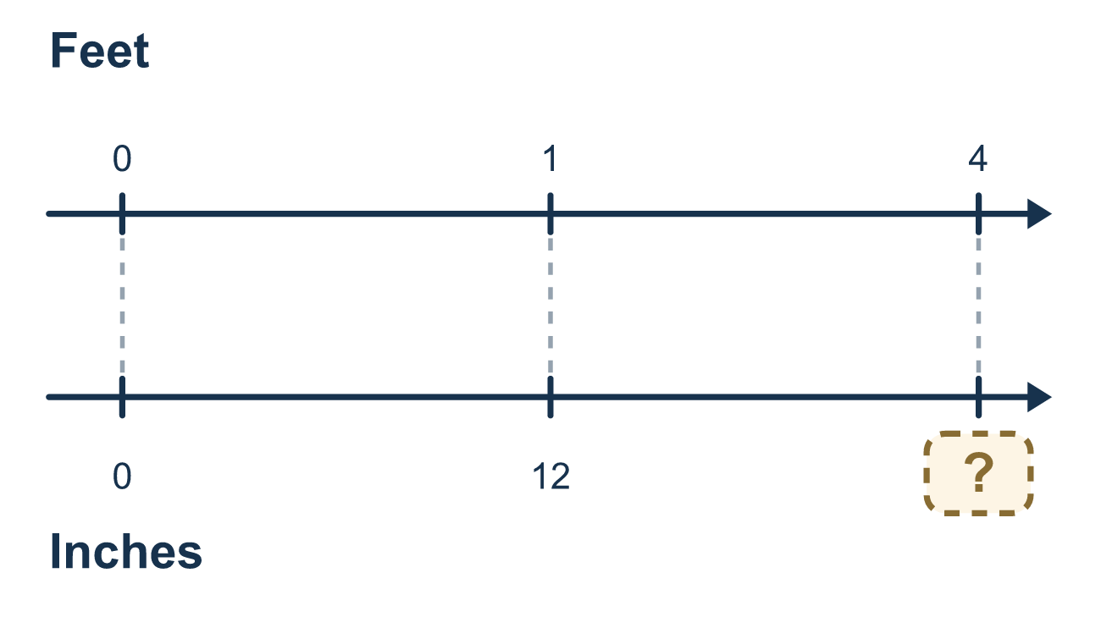
Our class model: the unit ratio 12 : 1

Try it
Work it out on paper. Write one answer on each line.
- Which conversion factor is correct?
A. 1 foot = 10 inches B. 1 foot = 12 inches C. 1 foot = 3 inches D. 1 foot = 100 inches
My answer
- Change 4 feet to inches.
A. 16 B. 40 C. 48 D. 8
My answer
- 3 yards = ? feet
A. 1 B. 6 C. 12 D. 9
My answer
- Change 48 ounces to pounds. (1 pound = 16 ounces)
A. 3 B. 32 C. 64 D. 768
My answer
- Which is true when you change feet to inches?
A. Multiply by 12, because inches are smaller B. Divide by 12, because inches are smaller C. Multiply by 12, because inches are bigger D. Divide by 12, because inches are bigger
My answer

Talk about it
Will the number of inches be bigger or smaller than the number of feet, and why?

Home mission
Find a ruler that is one foot long. Say the ride rule: riders must be at least 44 inches tall. A cousin is 3 feet tall. Can the cousin ride? Ask your student which unit changed and why they multiplied.

If we get stuck, ask
- Are we changing to a smaller unit or a bigger unit?
- Smaller unit means more pieces, so do we multiply or divide?
- What is the conversion factor between these two units?

Do it on a screen

Scan or type the link. Same lesson, with hints. eduwonderlab.com/lessons/3-6/homework.html
How did it feel? (optional) ☐ Tricky ☐ Getting there ☐ Got it

Family Math Studio · For grown-ups Lesson 3.6 · 6.AT.3c

Answers and talk notes
Ratio Reasoning: Convert Measurements within the Same System

What your student is learning
Tonight we convert one measurement unit into another within the same system, like feet into inches, using a unit ratio.

Answers
Ask your student to explain before you look.
- B. 1 foot = 12 inches. 1 foot = 12 inches is the correct conversion factor.
- C. 48. 4 × 12 = 48, so 4 feet = 48 inches.
- D. 9. 1 yard = 3 feet, so 3 yards = 3 × 3 = 9 feet.
- A. 3. 48 ÷ 16 = 3, so 48 ounces = 3 pounds.
- A. Multiply by 12, because inches are smaller. Multiply by 12, because inches are smaller, so there are more inches than feet.

Talk about it
Will the number of inches be bigger or smaller than the number of feet, and why?

When they are stuck, ask
- Are we changing to a smaller unit or a bigger unit?
- Smaller unit means more pieces, so do we multiply or divide?
- What is the conversion factor between these two units?

Try not to say
- Always multiply when you convert units.
- The number stays the same, only the unit name changes.
- Just guess whether to multiply or divide.

Home mission
Find a ruler that is one foot long. Say the ride rule: riders must be at least 44 inches tall. A cousin is 3 feet tall. Can the cousin ride? Ask your student which unit changed and why they multiplied.

