Family Math Studio Lesson 3.7 · Session 2 · 6.AT.3c

Ratio Reasoning: Convert Measurements Between Systems
Solve a two-step problem: convert to the unit the rate uses, then apply the rate.
Name Date

Tonight's spark
A pet medicine label says 6 milligrams for every 1 kilogram. A cat weighs 11 pounds. Math fact: 1 kilogram is about 2.2 pounds. About how many milligrams is the dose? Make a guess first: is the dose more than 66 mg, or less?
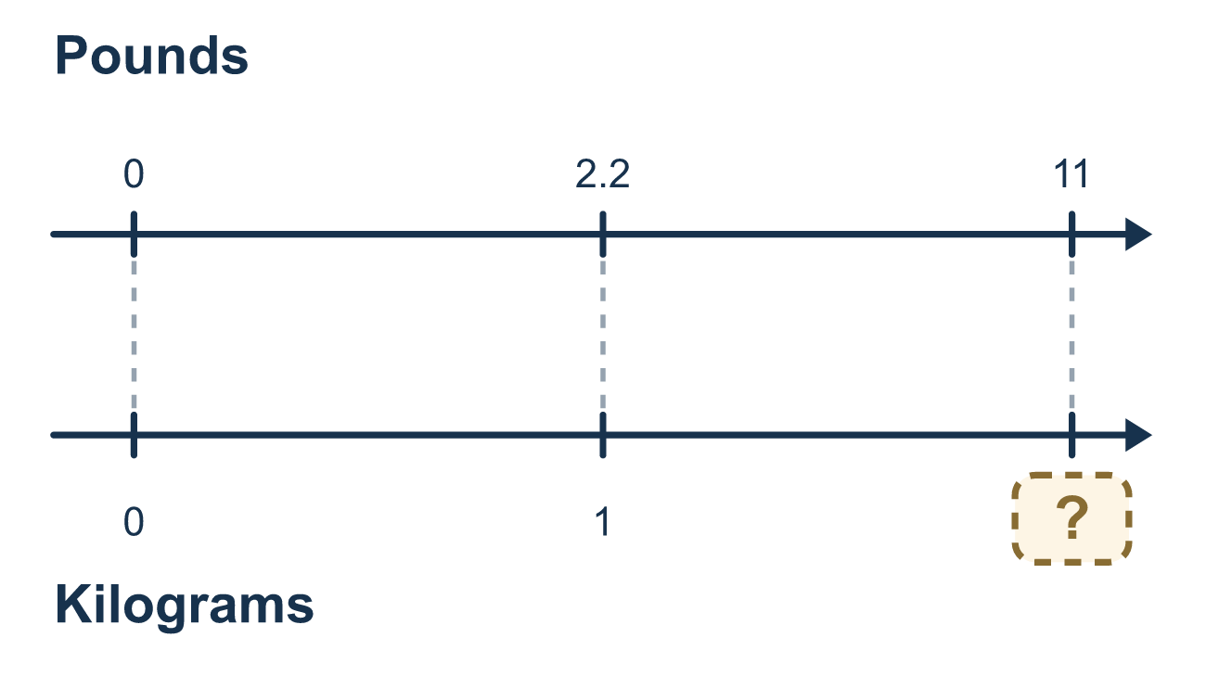
Our class model: convert first, then use the rate

Try it
Work it out on paper. Write one answer on each line.
- A dose is 3 mg for every 1 kg. A child weighs 20 kg. How many mg is the dose?
A. 23 B. 17 C. 6.7 D. 60
My answer
- Use 1 kg ≈ 2.2 lb. About how many kilograms is 44 pounds?
A. 20 B. 96.8 C. 41.8 D. 2
My answer
- A dog weighs 55 pounds. The dose is 5 mg per kilogram, and 1 kg ≈ 2.2 lb. What do you do first?
A. Multiply 55 by 5 B. Change 55 pounds to kilograms C. Divide 5 by 2.2 D. Add 55 and 5
My answer
- A dog weighs 33 pounds. Use 1 kg ≈ 2.2 lb. How many kilograms is that?
A. 72.6 B. 30.8 C. 15 D. 35.2
My answer
- A child weighs 25 kg. The dose is 2 mg per kg. How many mg is the dose?
A. 50 B. 27 C. 23 D. 12.5
My answer

Talk about it
Why must you change the unit before you use the rate?

Home mission
Find a bag of rice or flour labeled in pounds. Pretend a made-up rate: 2 mg for every 1 kilogram. Ask your student which step comes first. Real doses always come from a vet or doctor.

If we get stuck, ask
- What unit does the rate use? Are we in that unit yet?
- Which step has to come first, and why?
- What unit does your final answer have?

Do it on a screen

Scan or type the link. Same lesson, with hints. eduwonderlab.com/lessons/3-7-part2/homework.html
How did it feel? (optional) ☐ Tricky ☐ Getting there ☐ Got it

Family Math Studio · For grown-ups Lesson 3.7 · Session 2 · 6.AT.3c

Answers and talk notes
Ratio Reasoning: Convert Measurements Between Systems

What your student is learning
Tonight we solve problems that need TWO steps in order: convert to the unit the rate uses, and only then apply the rate.

Answers
Ask your student to explain before you look.
- D. 60. 20 × 3 = 60, so the dose is 60 mg.
- A. 20. 44 ÷ 2.2 = 20, so 44 pounds is about 20 kilograms.
- B. Change 55 pounds to kilograms. Change 55 pounds to kilograms first, because the rate is per kilogram.
- C. 15. 33 ÷ 2.2 = 15, so the dog weighs about 15 kilograms.
- A. 50. 25 × 2 = 50, so the dose is 50 mg.

Talk about it
Why must you change the unit before you use the rate?

When they are stuck, ask
- What unit does the rate use? Are we in that unit yet?
- Which step has to come first, and why?
- What unit does your final answer have?

Try not to say
- Multiply by the rate first, convert at the end.
- 5 kilometers and 5 miles are about the same thing.
- Leave off the unit, everyone knows what it is.

Home mission
Find a bag of rice or flour labeled in pounds. Pretend a made-up rate: 2 mg for every 1 kilogram. Ask your student which step comes first. Real doses always come from a vet or doctor.

