Family Math Studio Lesson 3.7 · 6.AT.3c

Ratio Reasoning: Convert Measurements Between Systems
Use a conversion factor to change a measurement between the customary and metric systems.
Name Date

Tonight's spark
On a road trip in Canada, a highway sign says 100 kilometers per hour. Back home, the sign says miles. Is 100 kilometers per hour faster or slower than 100 miles per hour? Make a guess first: which is longer, a mile or a kilometer?
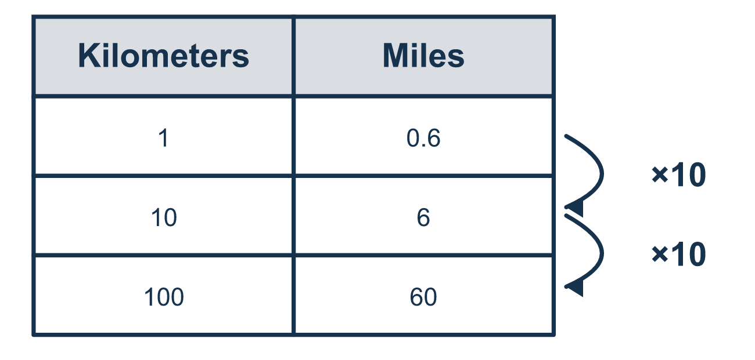
Our class model: the factor 1 km ≈ 0.6 mile

Try it
Work it out on paper. Write one answer on each line.
- 1 inch = 2.54 centimeters. How many centimeters is 2 inches?
A. 5.08 B. 1.27 C. 4.54 D. 2.54
My answer
- Use 1 kilometer ≈ 0.6 mile. About how many miles is 20 kilometers?
A. 20.6 B. 120 C. 12 D. 0.6
My answer
- Use 1 kilogram ≈ 2.2 pounds. About how many pounds is 5 kilograms?
A. 7.2 B. 11 C. 2.2 D. 110
My answer
- Use 1 gallon ≈ 3.8 liters. About how many liters is 2 gallons?
A. 5.8 B. 7.6 C. 3.8 D. 1.9
My answer
- Which conversion is rounded, so it needs the ≈ symbol?
A. 1 foot and 12 inches B. 1 yard and 3 feet C. 1 inch and 2.54 centimeters D. 1 kilometer and 0.6 mile
My answer
- Use 1 meter ≈ 3.3 feet. About how many feet is 10 meters?
A. 33 B. 13.3 C. 3.3 D. 330
My answer

Talk about it
Is the number of miles bigger or smaller than the number of kilometers, and how do you know?

Home mission
Find a ruler with inches on one edge and centimeters on the other. Ask your student: which unit is longer? Link it to the road sign. A mile is longer than a kilometer. Should the number of miles be smaller or bigger?

If we get stuck, ask
- Which system is each measurement from?
- Which unit is bigger?
- Should your answer be a bigger or smaller number?

Do it on a screen

Scan or type the link. Same lesson, with hints. eduwonderlab.com/lessons/3-7/homework.html
How did it feel? (optional) ☐ Tricky ☐ Getting there ☐ Got it

Family Math Studio · For grown-ups Lesson 3.7 · 6.AT.3c

Answers and talk notes
Ratio Reasoning: Convert Measurements Between Systems

What your student is learning
Tonight we convert measurements between the customary system (miles, pounds, quarts) and the metric system (kilometers, kilograms, liters).

Answers
Ask your student to explain before you look.
- A. 5.08. 2 × 2.54 = 5.08, so 2 inches = 5.08 centimeters.
- C. 12. 20 × 0.6 = 12, so 20 kilometers is about 12 miles.
- B. 11. 5 × 2.2 = 11, so 5 kilograms is about 11 pounds.
- B. 7.6. 2 × 3.8 = 7.6, so 2 gallons is about 7.6 liters.
- D. 1 kilometer and 0.6 mile. 1 kilometer and 0.6 mile is rounded: 1 kilometer ≈ 0.6 mile.
- A. 33. 10 × 3.3 = 33, so 10 meters is about 33 feet.

Talk about it
Is the number of miles bigger or smaller than the number of kilometers, and how do you know?

When they are stuck, ask
- Which system is each measurement from?
- Which unit is bigger?
- Should your answer be a bigger or smaller number?

Try not to say
- Same number means same amount.
- Write = instead of ≈; it's close enough.
- Just guess which one is bigger.

Home mission
Find a ruler with inches on one edge and centimeters on the other. Ask your student: which unit is longer? Link it to the road sign. A mile is longer than a kilometer. Should the number of miles be smaller or bigger?

