Family Math Studio Lesson 3.8 · Session 2 · 6.AT.2

Solve Problems with Unit Rates
Write cost over quantity, find the unit rate, and choose the better seller.
Name Date

Tonight's spark
A team needs 12 notebooks. Shop A sells 4 notebooks for $10.00. Shop B sells 6 notebooks for $13.80. Which shop costs less for 12 notebooks? Make a guess first: is Shop A or Shop B cheaper?
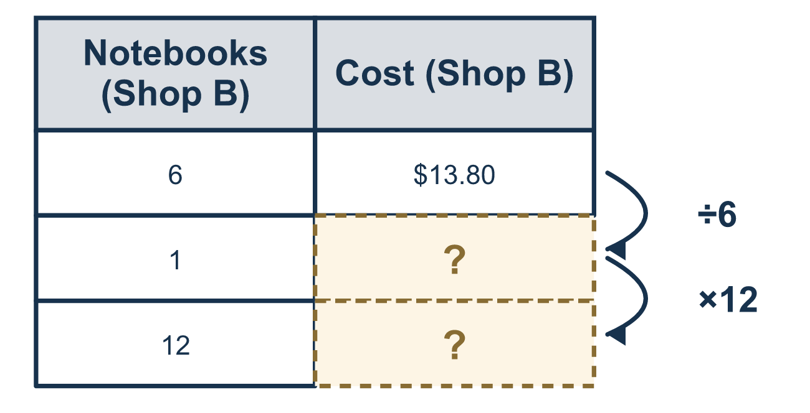
Our class model: cost on top, quantity on the bottom

Try it
Work it out on paper. Write one answer on each line.
- A sub shop sells 2 subs for $13. What is the cost of 1 sub?
A. $11 B. $26 C. $6.50 D. $15
My answer
- A team needs 12 water bottles at $1.25 each. How much do 12 bottles cost?
A. $15 B. $13.25 C. $9.60 D. $10.75
My answer
- Seller 1 charges $3.50 per hat. Seller 2 charges $18 for 6 hats. Which seller is the better deal?
A. Seller 1, because $3.50 is less than $18 B. Seller 2, $3 per hat C. Seller 1, $3.50 per hat D. They are the same
My answer
- The better seller charges $0.35 per pencil. What is the total for 20 pencils?
A. $0.02 B. $20.35 C. $7.00 D. $70.00
My answer
- 8 melons cost $20. Divide both parts by 8. What is the cost of 1 melon?
A. $12 B. $160 C. $0.40 D. $2.50
My answer

Talk about it
Which seller has the lower unit rate, and how did you use it to price the whole order?

Home mission
Find two shelf tags for the same item in different sizes. Write each as cost over amount, like $13.80 over 6. Divide the top and the bottom by the bottom number. Which is cheaper for 1?

If we get stuck, ask
- Cost on TOP, amount on the BOTTOM. Now divide both parts by the bottom number.
- The unit rate is a fraction over 1 (like 2.50/1). What does each number tell us?
- Why can the bigger total still be the cheaper deal per item?

Do it on a screen

Scan or type the link. Same lesson, with hints. eduwonderlab.com/lessons/3-8-part2/homework.html
How did it feel? (optional) ☐ Tricky ☐ Getting there ☐ Got it

Family Math Studio · For grown-ups Lesson 3.8 · Session 2 · 6.AT.2

Answers and talk notes
Solve Problems with Unit Rates

What your student is learning
Tonight we write comparisons with cost on top and quantity on bottom, divide both parts by the bottom number to find the unit rate in fraction form over 1, and choose the better seller.

Answers
Ask your student to explain before you look.
- C. $6.50. $13 ÷ 2 = $6.50 for 1 sub.
- A. $15. 12 × $1.25 = $15 for 12 bottles.
- B. Seller 2, $3 per hat. Seller 2 is $18 ÷ 6 = $3 per hat, so Seller 2, $3 per hat, is the better deal than $3.50.
- C. $7.00. 20 × $0.35 = $7.00 for 20 pencils.
- D. $2.50. $20 ÷ 8 = $2.50 for 1 melon.

Talk about it
Which seller has the lower unit rate, and how did you use it to price the whole order?

When they are stuck, ask
- Cost on TOP, amount on the BOTTOM. Now divide both parts by the bottom number.
- The unit rate is a fraction over 1 (like 2.50/1). What does each number tell us?
- Why can the bigger total still be the cheaper deal per item?

Try not to say
- Pick the one with the smaller total price.
- Divide the number of items by the price.
- Divide only the top number without dividing the bottom.

Home mission
Find two shelf tags for the same item in different sizes. Write each as cost over amount, like $13.80 over 6. Divide the top and the bottom by the bottom number. Which is cheaper for 1?

