Family Math Studio Lesson 3.8 · 6.AT.2

Solve Problems with Unit Rates
Use a unit rate, the cost for 1, to solve real problems and compare deals.
Name Date

Tonight's spark
A supply shop sells 500 game tokens for $60. The rec center wants to compare this deal with other shops. How much does just 1 token cost? Make a guess first: does 1 token cost more than $1, or less?
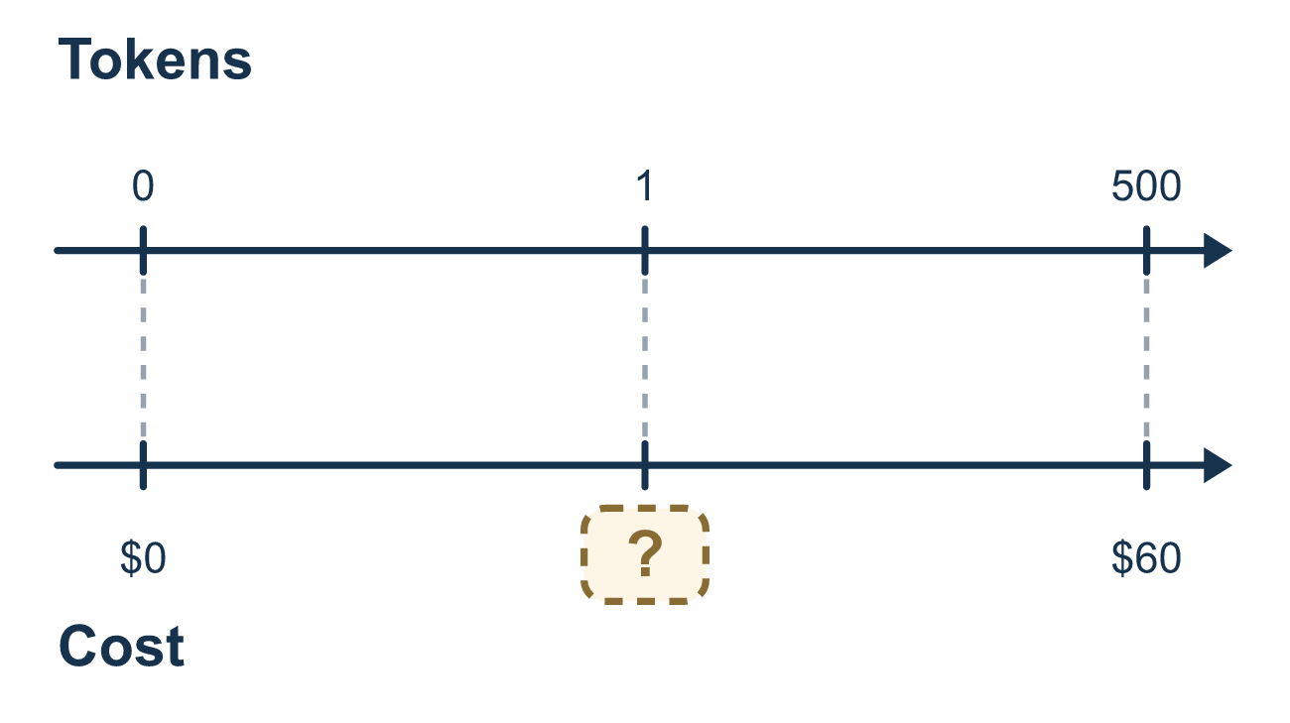
Our class model: find the cost for 1, then multiply

Try it
Work it out on paper. Write one answer on each line.
- 100 stickers cost $25. What is the cost of 1 sticker?
A. $4.00 B. $0.25 C. $125 D. $75
My answer
- A store sells 4 notebooks for $10. What is the price of 1 notebook?
A. $6.00 B. $14.00 C. $40.00 D. $2.50
My answer
- The unit rate is $3 per pound. How much do 7 pounds cost?
A. $21 B. $10 C. $0.43 D. $4
My answer
- Brand X: 3 cans for $2.40. Brand Y: 5 cans for $3.50. Which brand costs less per can?
A. Brand X, $0.80 per can B. Brand Y, $0.70 per can C. Brand Y, $3.50 per can D. They cost the same
My answer
- Rulers cost $0.75 each. How many rulers can you buy with $6?
A. 0.125 B. 4.5 C. 6.75 D. 8
My answer
- A truck uses 12 gallons of fuel for 300 miles. How many miles is that per gallon?
A. 288 B. 3,600 C. 25 D. 0.04
My answer

Talk about it
Can 1 token cost more than the whole $60 deal?

Home mission
Find a small box and a big box of the same food, like cereal. Read each price and amount. Ask your student: which costs less for just 1 ounce? Which is the better buy?

If we get stuck, ask
- What is the amount for just 1? Let's divide to find it.
- Now that we know the rate for 1, do we multiply or add to find the total?
- Does our answer make sense for that amount?

Do it on a screen

Scan or type the link. Same lesson, with hints. eduwonderlab.com/lessons/3-8/homework.html
How did it feel? (optional) ☐ Tricky ☐ Getting there ☐ Got it

Family Math Studio · For grown-ups Lesson 3.8 · 6.AT.2

Answers and talk notes
Solve Problems with Unit Rates

What your student is learning
Tonight we solve real-world rate problems by finding the unit rate — the cost or amount for just 1 — and then using it.

Answers
Ask your student to explain before you look.
- B. $0.25. $25 ÷ 100 = $0.25, so 1 sticker costs $0.25.
- D. $2.50. $10 ÷ 4 = $2.50 for 1 notebook.
- A. $21. 7 × $3 = $21 for 7 pounds.
- B. Brand Y, $0.70 per can. Brand X is $2.40 ÷ 3 = $0.80 and Brand Y, $0.70 per can, is $3.50 ÷ 5, so Brand Y costs less.
- D. 8. $6 ÷ $0.75 = 8, so you can buy 8 rulers.
- C. 25. 300 ÷ 12 = 25, so the truck goes 25 miles per gallon.

Talk about it
Can 1 token cost more than the whole $60 deal?

When they are stuck, ask
- What is the amount for just 1? Let's divide to find it.
- Now that we know the rate for 1, do we multiply or add to find the total?
- Does our answer make sense for that amount?

Try not to say
- After finding the unit rate, add the number of items to it.
- It does not matter which number you divide by which.
- Just memorize the steps without thinking about what each number means.

Home mission
Find a small box and a big box of the same food, like cereal. Read each price and amount. Ask your student: which costs less for just 1 ounce? Which is the better buy?

