Family Math Studio Lesson 3.9 · Session 2 · 6.AT.3

Equivalent Ratios
Find the scale factor that grows a recipe and keeps the ratio the same.
Name Date

Tonight's spark
A lemonade recipe uses 3 cups of water for every 2 cups of juice. A team fills a cooler with 18 cups of water. How many cups of juice do they need? Make a guess first: more than 10 cups of juice, or fewer?
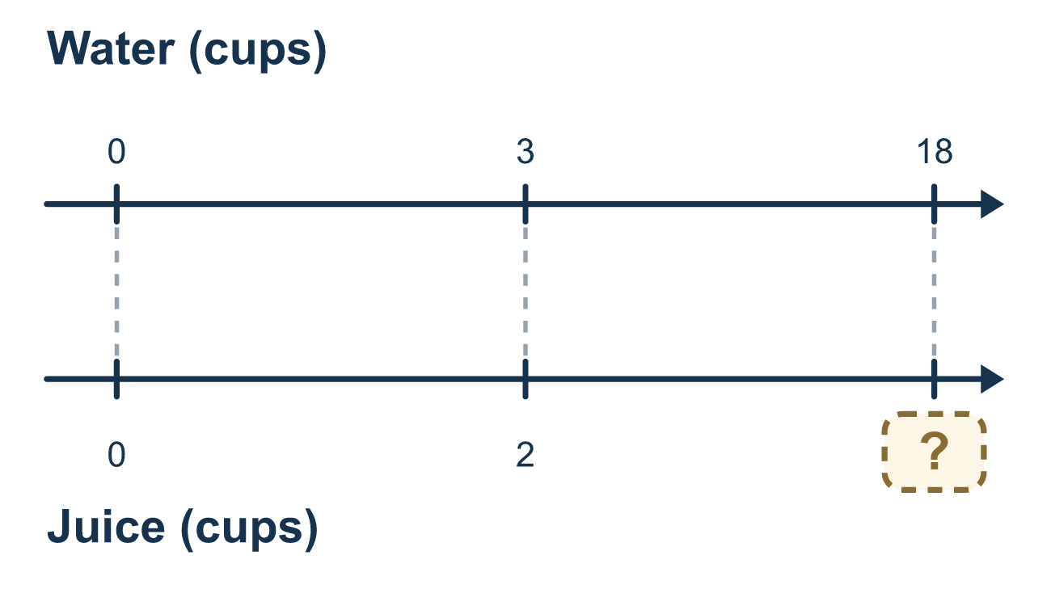
Our class model: the scale factor

Try it
Work it out on paper. Write one answer on each line.
- A recipe uses 3 eggs. You want to use 12 eggs. What is the scale factor?
A. 9 B. 4 C. 15 D. 36
My answer
- Rice to water is 1:2. You use 6 cups of rice. How many cups of water?
A. 12 B. 8 C. 3 D. 6
My answer
- A smoothie uses 2 bananas and 5 strawberries. With 8 bananas, how many strawberries?
A. 13 B. 10 C. 20 D. 40
My answer
- Which action keeps a recipe tasting the same when you make 3 times as much?
A. Add 3 to each amount B. Multiply only one amount by 3 C. Subtract 3 from each amount D. Multiply every amount by 3
My answer
- Lemonade is 3 lemons for 6 cups of water. How many lemons for 24 cups of water?
A. 18 B. 21 C. 12 D. 4
My answer
- Divide both numbers of 18:24 by 6. What ratio do you get?
A. 12:18 B. 3:4 C. 4:3 D. 3:24
My answer

Talk about it
What is the scale factor, and how did you use it on the second ingredient?

Home mission
Use a pitcher and a cup. Pretend a drink needs 3 cups of water for 2 cups of juice. Ask your student: how much juice for 9 cups of water? What number did you multiply by?

If we get stuck, ask
- What number do we multiply the first term by to reach the new amount?
- Did the other term get multiplied by that same number?
- Does the new ratio simplify back to the old one?

Do it on a screen

Scan or type the link. Same lesson, with hints. eduwonderlab.com/lessons/3-9-part2/homework.html
How did it feel? (optional) ☐ Tricky ☐ Getting there ☐ Got it

Family Math Studio · For grown-ups Lesson 3.9 · Session 2 · 6.AT.3

Answers and talk notes
Equivalent Ratios

What your student is learning
Tonight we scale a recipe up while keeping the ratio the same — and we find the scale factor that makes it work.

Answers
Ask your student to explain before you look.
- B. 4. 3 × 4 = 12, so the scale factor is 4.
- A. 12. The scale factor is 6, so the water is 2 × 6 = 12 cups.
- C. 20. The scale factor is 8 ÷ 2 = 4, so the strawberries are 5 × 4 = 20.
- D. Multiply every amount by 3. Multiply every amount by 3 keeps the same ratio, so the taste stays the same.
- C. 12. 6 × 4 = 24, so the lemons are 3 × 4 = 12.
- B. 3:4. 18 ÷ 6 = 3 and 24 ÷ 6 = 4, so the ratio is 3:4.

Talk about it
What is the scale factor, and how did you use it on the second ingredient?

When they are stuck, ask
- What number do we multiply the first term by to reach the new amount?
- Did the other term get multiplied by that same number?
- Does the new ratio simplify back to the old one?

Try not to say
- Add the scale factor to both numbers.
- Only the ingredient the question asks about has to change.
- Close enough is fine for a recipe.

Home mission
Use a pitcher and a cup. Pretend a drink needs 3 cups of water for 2 cups of juice. Ask your student: how much juice for 9 cups of water? What number did you multiply by?

